Communication Toolkit for Traumatic Brain Injury Model System Staff
Model Systems Knowledge Translation Center (MSKTC)

Introduction
The MSKTC designed this Communication Toolkit with various resources and customizable templates to support Traumatic Brain Injury Model System (TBIMS) staff (e.g., investigators, research coordinators, and data collectors) in sharing free, research-based TBI resources from the Model Systems Knowledge Translation Center (MSKTC; https://msktc.org/) and promote the TBIMS research.
The toolkit contains the following topics (you can use the hyperlinks to go directly to the topic of your interest):
- MSKTC and TBIMS social media platforms  - Sample social media posts  - Customizable social media templates  - QR codes  - Sample email message with links to all MSKTC TBI resources  - An email signature banner | - Resource Badges  - Customizable name tags  - Resource buttons  - Virtual Background  - Resource slides  - Resource posters  - A sample newsletter story  - Tips for using MSKTC and TBIMS resources  - Additional resources to support your knowledge translation efforts

MSKTC and TBIMS Social Media Platforms
MSKTC and TBIMS are active on several social media platforms, including Facebook, Instagram, X (formerly Twitter), and LinkedIn. Be sure to follow us, interact with our posts, and tag us when you share MSKTC resources.

- Traumatic Brain Injury Model Systems | - @msktc_insights | - Traumatic Brain Injury Model Systems | - Model Systems Knowledge Translation Center

Social Media Posts

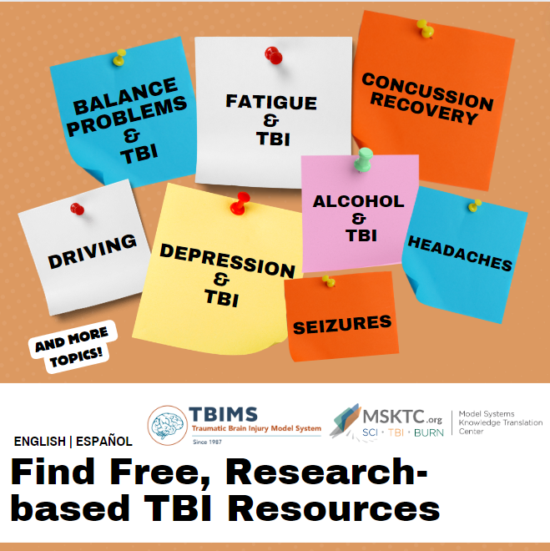 | #MSKTC and #TBIMS have a wide range of #researchbased resources to help those #livingwithTBI. To learn more about how to manage #TBI symptoms such as fatigues, memory loss, depression, etc., visit https://msktc.org/tbi
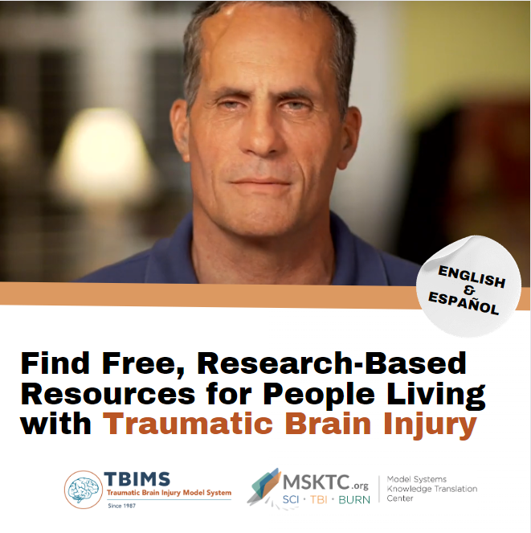 | Do you have questions about [insert topic from MSKTC website] after #TBI?  #MSKTC and #TBIMS have a wide range of #researchbased resources to help those with #TBI. Check out [name of the resource]: [insert link to resource]
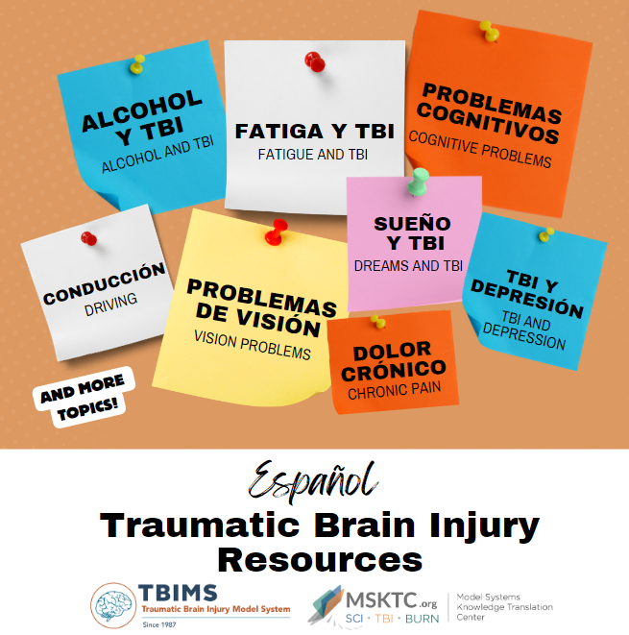 | #MSKTC and #TBIMS offer resources in Spanish to support people with traumatic brain injury and their families. #TBI https://msktc.org/tbi/recursos-en-espanol
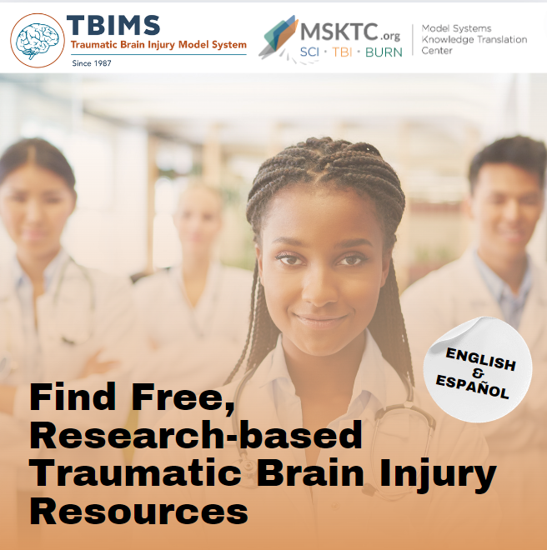 | Healthcare providers, looking for resources on traumatic brain injuries to educate and support your patients and families? #MSKTC and #TBIMS have many resources to help manage #TBI. https://msktc.org/tbi

Customizable Message Only Templates
These templates provide sample language for you to customize to promote your TBIMS research and publications.
Promote New Publications | I'm thrilled to announce the publication of my latest research on [insert topic/title]. This work dives deep into [briefly describe key points or findings], offering new insights and perspectives on [relevant field or subject].  Read the full paper here: [insert link]  [Suggested hashtags: #TBIMS, #MSKTC, #TBI #BrainInjuries]
Promote Conference Presentations | Honored to present my research on [topic] at [Conference Name]! Excited to discuss our findings and connect with fellow researchers. If you're attending, let's connect!  [Suggested hashtags: #TBIMS, #MSKTC, #TBI #BrainInjuries]
Promote Research Activities | Excited to share some updates on my latest research. We're delving into [brief description of the research topic]. Grateful for the support from [institution or collaborators]. Stay tuned for more insights and findings!  [Suggested hashtags: #TBIMS, #MSKTC, #TBI #BrainInjuries]
Recruit Participants | Are you [description of target participants]? We're conducting a new research study on [brief description of the study's focus], and we need your help.  Who can participate?  - [Eligibility criteria]  - [Eligibility criteria]  Why join?  - Contribute to important research  - [Potential benefits, e.g., learning opportunities, etc.]  Interested?  - Sign up here: [link]  - Or DM us for more details!  Share this post to spread the word and tag others who might be interested.  [Suggested hashtags: #TBIMS, #MSKTC, #TBI #BrainInjuries]
Promote an Event | Join us for [Event Name], where we'll dive into [specific topic/field]!  Date: [Event Date]  Time: [Event Time]  Location: [Event Location]  Online Access: [Link/Details]  Whether you're a seasoned expert or just curious about [topic], this event promises valuable insights and opportunities for all.  [Registration Link/More Info]  [Suggested hashtags: #TBIMS, #MSKTC, #TBI #BrainInjuries]

QR Codes

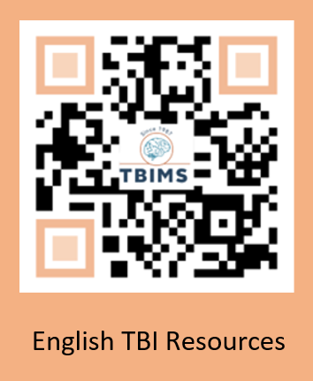 | 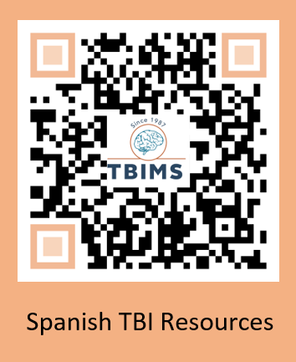

Sample Email Message to Share With Research Participants and Colleagues

Dear [NAME],
[ADJUST WORDING BASED ON RECIPIENT] I’d like to share the free, research-based resources for people living with traumatic brain injury (TBI) and their families from the federally funded Model Systems Knowledge Translation Center (MSKTC: http://msktc.org/). MSKTC works with TBI Model System centers to develop resources that cover various TBI rehabilitation topics (http://msktc.org/tbi). Tailored to the diverse learning styles of individuals with TBI and their families, these resources are in multiple formats (video, audio, and print) including factsheets, infocomics (information presented in a comic-styled storyboard format), videos, podcasts, narrated slideshows, and quick reviews. MSKTC resources are available in both English and Spanish. MSKTC and TBI Model Systems are funded by the National Institute on Disability, Independent Living, Administration for Community Living, U.S. Department of Health and Human Services. I am including links to these resources below. Please feel free to share with others who may benefit from them.
*MSKTC TBI Resources*
- The MSKTC TBI resources cover a wide range of topics. Currently, the MSKTC provides resources on 31 rehabilitation topics to support individuals with TBI and their families such as: understanding a TBI, alcohol use after TBI, memory, couples’ relationship after TBI, acute inpatient rehabilitation, balance problems, behavior changes, caregiver’s guide to disorders of consciousness, chronic pain, cognitive problems, concussion recovery, depression, driving, emotional problems, fatigue, headaches, irritability, anger and aggression, loss of smell or taste, obstructive sleep apnea, parenting with TBI, returning to school, seizures, severe TBI, sexuality, sleep, social skills, spasticity, stress management for TBI caregivers, vegetative and minimally conscious states, vision problems, and voting tips.
- TBI resources in Spanish
  - https://msktc.org/tbi/recursos-en-espanol
- Factsheets
  - http://www.msktc.org/tbi/factsheets
- Videos
  - http://www.msktc.org/tbi/videos

- Infocomics
  - https://msktc.org/tbi/infocomics
- Slideshows
  - http://www.msktc.org/tbi/slideshows
- Hot Topic Modules
  - http://www.msktc.org/tbi/Hot-Topics
- Plain Language Summaries of Research
  - http://www.msktc.org/tbi/Quick-Reviews
- Research Resources
  - TBI Systematic Reviews: http://www.msktc.org/tbi/research/systematic-reviews
  - TBI Model System Directory: http://www.msktc.org/tbi/model-system-centers
  - TBI Model System Publications Database: http://www.msktc.org/publications?sys=T
- Model System and Model System Database
  - https://msktc.org/about-model-systems/tbi
- Knowledge Translation Toolkit
  - https://msktc.org/knowledge-translation
- Learn about the MSKTC TBI ambassador program
  - https://msktc.org/tbi/ambassador-program
- Share and promote MSKTC.org resources using website's HTML codes
  - https://msktc.org/share-and-promote
- Learn about MSKTC awards
  - https://msktc.org/share-and-promote

*Please note that the MSKTC resources may be reproduced and distributed freely with appropriate attribution. Prior permission must be obtained for inclusion in fee-based materials.

Please take a quick survey and share thoughts to help the MSKTC better serve you: https://websurveyor2.airws.org/se/2511374533213674.
Sincerely,
[SIGNER’S NAME]

TBIMS/MSKTC Email Signature Logo
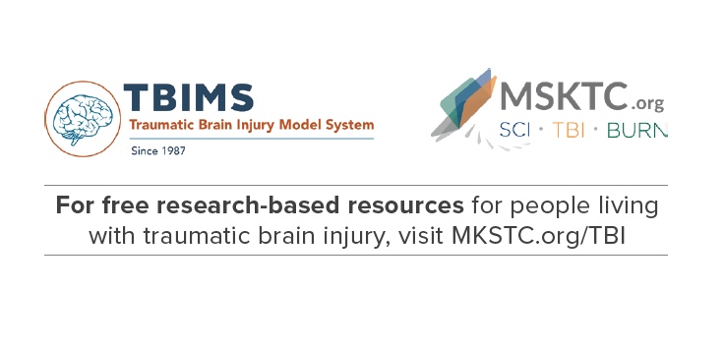
TBIMS staff can use this email signature line to share MSKTC resources. Please have the image link to https://msktc.org/tbi to take email recipients to the TBI resource landing page on MSKTC.org. You can find detailed instructions on how to add this signature line and hyperlink here: https://msktc.org/node/4670

TBIMS/MSKTC Resource Badge
Use this resource badge to easily share MSKTC TBI resources while in clinic and/or at events. To request badges, please contact MSKTC@air.org.

Customizable Name Tags
TBIMS staff can use customizable name tags to promote the use of MSKTC TBI resources. The name tags have different sizes that you can choose based on your preference and/or the size of the name tag holder you already have. You can download and print the customizable name tags here: https://msktc.org/node/4653 | 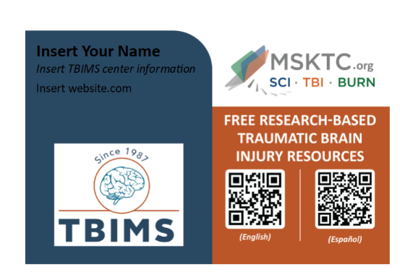

TBIMS and MSKTC Buttons
You can wear the TBIMS and MSKTC buttons in the clinic, at conferences, and at other events to share MSKTC TBI resources. To request buttons, please email MSKTC@air.org. | 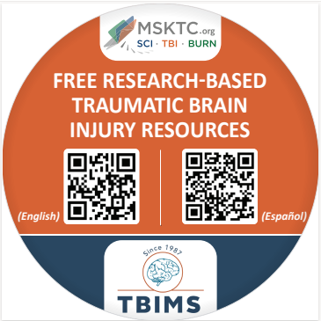

Virtual Meeting Background
Enhance your virtual meetings with our TBIMS virtual meeting background.  Download the graphic from the MSKTC website to your computer and upload when using your preferred virtual meeting platform. Visit: https://msktc.org/node/5369. | 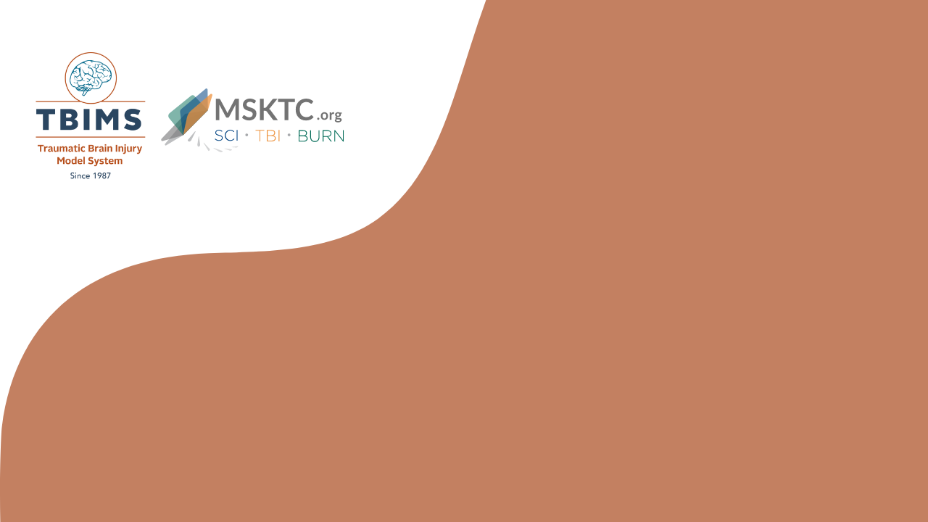

MSKTC Resource Slides for Conference Presentations
Help promote TBIMS program, TBIMS database, and MSKTC resources using the MSKTC resource slides at conferences.  The MSKTC updates the slides when new resources are available. Please make sure to check the website for most updated slides here. | 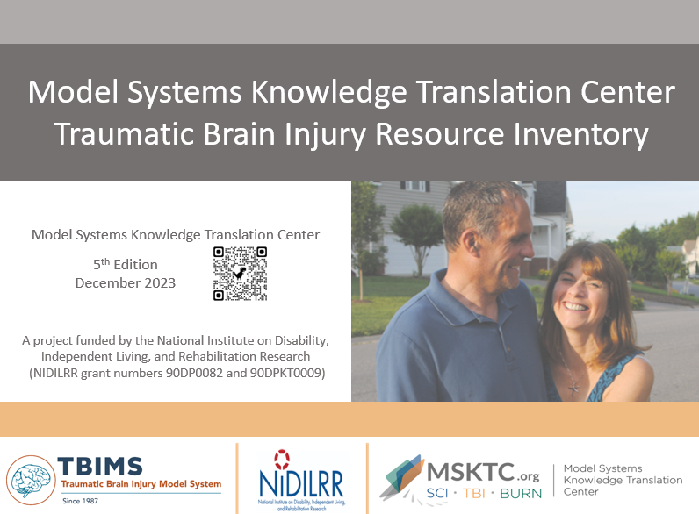

Resource Posters

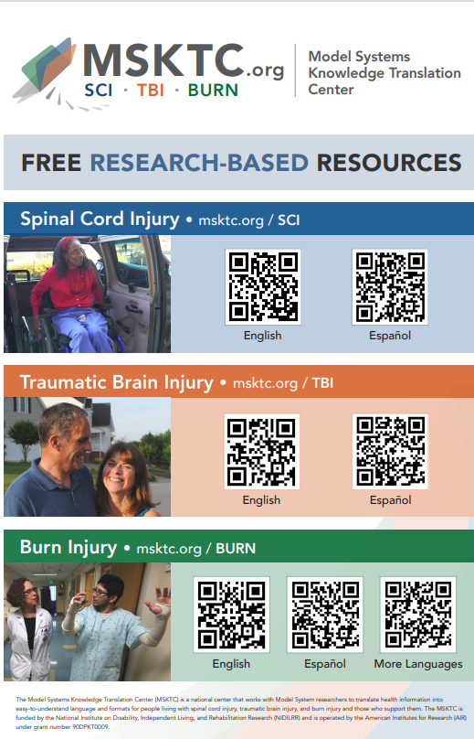 | 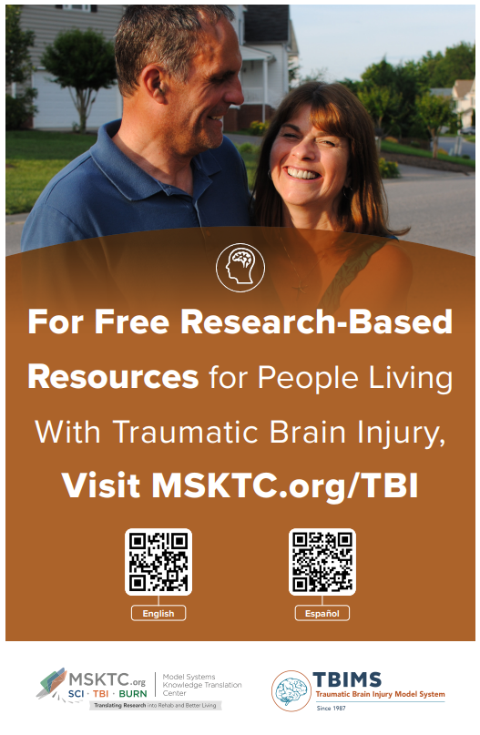
The Model Systems Knowledge Translation Center (MSKTC) has developed a poster to promote the use of free research-based resources for people living with spinal cord injury (SCI), traumatic brain injury (TBI) and burn injury. The poster size is 11x17 inches. You can print the poster using a regular printer or a professional printer.  Download the poster and view printing instructions: https://msktc.org/node/5361 | The MSKTC has developed a poster to promote the use of our free research-based resources for people living with TBI. The poster size is 11x17 inches with English and Spanish resource QR codes. You can print the poster using a regular printer or a professional printer.  Download the poster and view printing instructions: https://msktc.org/node/4698.

Sample Newsletter Story

Title: Free, Research-Based, User-friendly Resources for People Living With Traumatic Brain Injury, Spinal Cord Injury, and Burn Injury

The Model Systems Knowledge Translation Center (MSKTC; https://msktc.org/) offers free, research-based, user-friendly information resources to support individuals living with traumatic brain injury (TBI; https://msktc.org/tbi) as well as spinal cord injury (SCI; https://msktc.org/sci) or burn injury (https://msktc.org/burn) . The MSKTC collaborates with researchers from TBI Model System centers and from SCI and Burn Model System centers to develop resources that cover a wide variety of topics and are available in various formats, such as factsheets (in both English and Spanish), infocomics, videos, and podcasts. MSKTC resources may be reproduced and distributed freely with appropriate attribution; prior permission must be obtained for inclusion in fee-based materials. Both the MSKTC and Model System centers are funded by the National Institute on Disability, Independent Living, and Rehabilitation Research, Administration for Community Living, U.S. Department of Health and Human Services. For questions about MSKTC resources, please contact msktc@air.org.

Tips for Sharing MSKTC Resources in Your Model Systems Centers
- Include MSKTC resources in patient discharge packages.
- Display MSKTC QR code and print resources in patient waiting rooms.
- Include MSKTC resources in clinician education.
- Use MSKTC resources for patient education.
- Share MSKTC resources with support groups.
- Wear TBIMS and MSKTC buttons, nametags, and badges in clinics, at conferences, and at any other events.
- Include MSKTC TBI resources in your presentations using slides from the MSKTC TBI Resource Inventory.
- Integrate MSKTC resources in camps.
- Use MSKTC resources for social media content.
- Adapt MSKTC resources for newsletters.
- Include MSKTC resources in an electronic medical record system.
- Sign up for the MSKTC newsletter (the newsletter sign-up box is located in the footer section of all pages on https://msktc.org/).
- Become an MSKTC ambassador by applying at https://msktc.org/tbi/ambassador-program.
- Link to MSTKC resources on your website: https://msktc.org/share-and-promote.
- Be creative and develop other ways to share MSKTC resources.

Additional Knowledge Translation Resources
MSKTC has developed knowledge translation (KT) tools to help researchers engage with the media and use social media. Please access our KT tools using the links below.
- Engage the Media – MSKTC Online Knowledge Translation Toolkit:
  - Developing Key Messages for Effective Communication
  - Press Release Template and Instructions
  - Responding to Media Requests
  - Working with Your Communications/Public Affairs Office
- Use Social Media – MSKTC Online Knowledge Translation Toolkit:
  - Getting Started with Social Media Advertising: Facebook & Instagram Ads
  - Guide for Developing an MSKTC Social Media Plan
  - How to Use Social Media Advertising for Research
  - MSKTC Social Media Development Workbook
  - Social Media Development Content Calendar
  - Using Social Media to Promote Research
  - Web Clinic: Social Media Analytics

The contents of this resource were developed with funding from the National Institute on Disability, Independent Living, and Rehabilitation Research (NIDILRR grant number 90DPKT0009). NIDILRR is a Center within the Administration for Community Living (ACL), U.S. Department of Health and Human Services (HHS). The contents of this resource do not necessarily represent the policy of NIDILRR, ACL, or HHS, and you should not assume endorsement by the federal government.

