Communication Toolkit for Ambassadors
Model Systems Knowledge Translation Center

Introduction
This Communication Toolkit supports ambassadors in the sharing of free, research-based spinal cord injury (SCI) resources from the Model Systems Knowledge Translation Center (MSKTC; https://msktc.org/). It includes sample social media posts, QR codes, an email message, and a newsletter story that ambassadors can modify and share with people who may benefit from MSKTC resources. MSKTC is funded by the National Institute on Disability, Independent Living, and Rehabilitation Research (NIDILRR grant number 90DPKT0009), Administration for Community Living, U.S. Department of Health and Human Services.

Part 1: Sample Social media messages
We have provided example posts, but you likely know what resources people within your network are looking for. We encourage you to look through the MSKTC’s resources and create other posts highlighting different topics. We have included a basic template that you can use as to get you going.

- Social Media Handles
  - Facebook: @MSKTCSCI
  - Twitter: @SCI_MS

- Sample Social Media Posts
  - The [Facebook: @MSKTCSCI / Twitter: @SCI_MS] has a wide range of #researchbased resources to help those #livingwithSCI. To learn about the ways #SCI impacts depression, bowel function, sexuality, and more, visit https://msktc.org/sci
  - Looking for free, #researchbased tools about #SCI available in Spanish? [Facebook: @MSKTCSCI / Twitter: @SCI_MS] has many resources that explain different aspects of living with #spinalcordinjury and how to #stayhealthy here: https://msktc.org/sci-resources-spanish
  - Bowel function can be a challenge for those with #SCI. Help them #stayhealthy with [Facebook: @MSKTCSCI / Twitter: @SCI_MS]’s wide range of multi-media and print resources available here https://msktc.org/sci/infocomics

- Social Media Message Templates
  - Do you have questions about [insert topic from MSKTC website] after #SCI? The [Facebook: @MSKTCSCI / Twitter: @SCI_MS] has a wide range of #researchbased resources to help those with #spinalcordinjury. Check out [name of the resource]: [insert link to resource]
  - [PERSONALIZE AS NEEDED] As many of you know, I am an advocate for SCI supports. [Facebook: @MSKTCSCI / Twitter: @SCI_MS] has provided me with a wide range of #researchbased resources that have helped [my/family member’s] recover process. Learn more here https://msktc.org/sci
  - [ADJUST ACCORDING TO EVENT SENT TO YOU BY MSKTC] [Last week], [Facebook: @MSKTCSCI / Twitter: @SCI_MS] attended [name of conference] hosted by [name of organization]. The event explored [brief description of topics covered]. A recording of the event can be accessed here: [link]

- Useful hashtags
  - #SCIawareness
  - #spinalcordinjuryresearch
  - #rehabilitation
  - #spinalcordinjury
  - #SCI

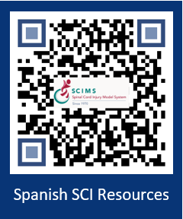
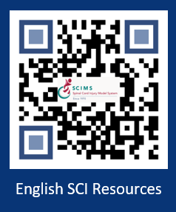

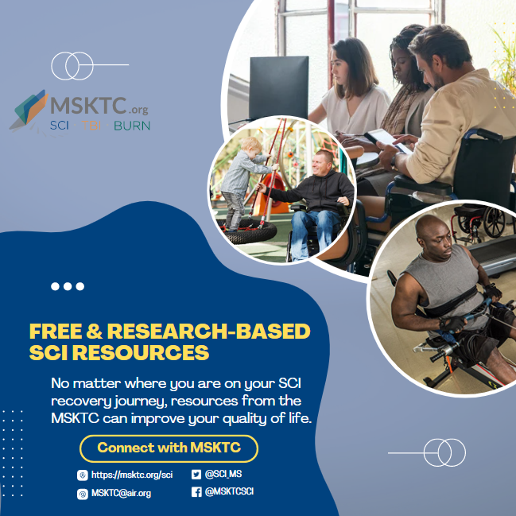

Part 2: Sample email message
Dear [NAME],
[ADJUST WORDING BASED ON RECIPIENT] I recently became an ambassador for the federally funded Model Systems Knowledge Translation Center (MSKTC: http://msktc.org/), which offers free, research-based resources for people living with SCI and their families. MSKTC covers over 20 rehabilitation topics (https://msktc.org/sci). Tailored to the diverse learning styles of individuals with SCI and their families, these resources are in multiple formats (print, audio, and video) including factsheets, infocomics (information presented in a comic-styled storyboard format), infographics, videos, podcasts, narrated slideshows, and quick reviews. MSKTC factsheets and infocomics are available in both English and Spanish. MSKTC is funded by the National Institute on Disability, Independent Living, Administration for Community Living, U.S. Department of Health and Human Services. I am including links to these resources below. Please feel free to share with others who may benefit from them.
*MSKTC SCI Resources*
- The MSKTC SCI resources cover a wide range of topics. Currently, the MSKTC provides resources on 25 rehabilitation topics to support individuals with SCI and their families such as adaptive sports and recreation, adjusting to life, aging & SCI, autonomic dysreflexia, bladder management, bone loss after SCI, depression & SCI, driving, employment after SCI, exercise & fitness after SCI, gait training & SCI, managing bowel function, managing pain after SCI, opioids and SCI, personal care attendants, pregnancy and SCI, respiratory health, safe transfer techniques, sexuality, skin care & pressure sores, spasticity & SCI, surgical & reconstructive treatment, understanding SCI, urinary tract infection, and wheelchair information.
- Factsheets on topics ranging from acute inpatient rehabilitation to returning to school in both English and Spanish
  - https://msktc.org/sci/factsheets
- Videos
  - https://msktc.org/sci/videos
- Infocomics
  - https://msktc.org/sci/infocomics
- Infographics
  - https://msktc.org/sci/infographics
- Slideshows
  - https://msktc.org/sci/slideshows
- Hot Topic Modules
  - https://msktc.org/sci/Hot-Topics

- Plain Language Summaries of Research
  - https://msktc.org/sci/quick-reviews
- Research Resources
  - SCI Systematic Reviews: https://msktc.org/sci/research/systematic-reviews
  - SCI Model System Directory: https://msktc.org/sci/model-system-centers
  - SCI Model System Publications Database: https://msktc.org/sci/publications
- Model System and Model System Database
  - https://msktc.org/about-model-systems/sci

*Please note that the MSKTC resources may be reproduced and distributed freely with appropriate attribution. Prior permission must be obtained for inclusion in fee-based materials.

Please take a quick survey and share thoughts to help the MSKTC better serve you: https://websurveyor2.airws.org/se/2511374533213674.
Sincerely,
[SIGNER’S NAME]

Part 3: Sample newsletter story

Title: Free Research-based User-friendly Resources for People Living With Spinal Cord Injury, Traumatic Brain Injury, and Burn Injury

The Model Systems Knowledge Translation Center (MSKTC; https://msktc.org/) offers free research-based user-friendly information resources to support individuals living with spinal cord injury (SCI; https://msktc.org/sci), traumatic brain injury (TBI; https://msktc.org/tbi), and burn injury (https://msktc.org/burn). MSKTC collaborates with researchers from the SCI, TBI and Burn Model System Programs to develop resources that cover a wide range of topics and are available in various formats such as factsheets (in both English and Spanish), infocomics, videos, and podcasts. MSKTC resources may be reproduced and distributed freely with appropriate attribution; prior permission must be obtained for inclusion in fee-based materials. Both the MSKTC and Model System Programs are funded by the National Institute on Disability, Independent Living, and Rehabilitation Research, Administration for Community Living, US Department of Health and Human Services. For questions about MSKTC resources, please contact msktc@air.org.

Disclaimer: The contents of this resource were developed with funding from the National Institute on Disability, Independent Living, and Rehabilitation Research (NIDILRR grant number 90DPKT0). NIDILRR is a Center within the Administration for Community Living (ACL), U.S. Department of Health and Human Services (HHS). The contents of this resource do not necessarily represent the policy of NIDILRR, ACL, or HHS, and you should not assume endorsement by the federal government.

