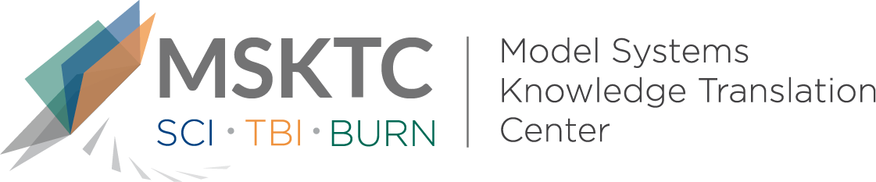

Quick Review of
Model System Research

Strategies of successful and unsuccessful simulators coached to feign traumatic brain injury¹

What is the study about?
Differentiating genuine traumatic brain injury (TBI) from faked neurocognitive impairment is essential to correctly provide resources in legal and healthcare systems. This study assessed the strategies used by healthy adults who were coached to simulate traumatic brain injury (TBI) during neuropsychological evaluation.

Who participated in the study?
Participants (n=58) were healthy adults between the ages 18-62 who had an education that ranged from 10-18 years.

How was the study conducted?
Participants were instructed to simulate TBI while completing several performance validity tests (PVT’s), neuropsychological tests, a self-report scale of functional independence, and a debriefing survey about strategies used to fake TBI.

What did the study find?
Participants who successfully simulated TBI used a targeted, systematic strategy for each test by applying the information provided about TBI. Additionally, they had more years of education and a higher estimated IQ when compared to participants who were unsuccessful in simulating TBI.

Kassner, Robert J, Rapport, Lisa J, Bashem, Jessie R., Billings, Nia M., Hanks, RobertA., Axelrod, Bradley N., Miller, Justin B. (2017). Strategies of successful and unsuccessful simulators coached to feign traumatic brain injury. The Clinical Neuropsychologist, 31(3), 644-653.

The contents of this quick review were developed under a grant from the National Institute on Disability, Independent Living, and Rehabilitation Research (NIDILRR grant number 90DP0082). NIDILRR is a Center within the Administration for Community Living (ACL), Department of Health and Human Services (HHS). The contents of this quick review do not necessarily represent the policy of NIDILRR, ACL, HHS, and you should not assume endorsement by the Federal Government.

