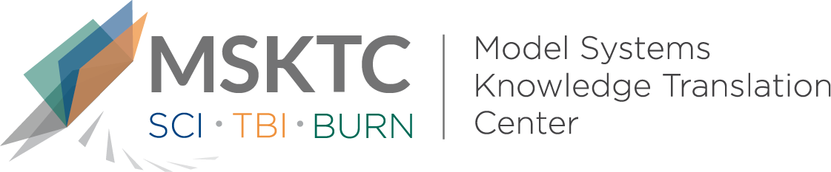

` Quick Review of
Model System Research

Outcome Heterogeneity and Bias in Acute Experimental Spinal Cord Injury: A Meta-Analysis

What is the study about?

This study examines experimental spinal cord injury (SCI) studies in animals to help assess whether bias in the design and reporting of these studies can overestimate the effectiveness and hence, their value for clinical translation.

What did the study find?
This study found evidence of bias in the design and reporting of pre-clinical, animal studies of SCI. Forms of bias identified include publication bias (i.e., favoring a study because it has positive findings) and evaluation bias (i.e., tendency to favor one point of view over another equally valid point of view), not having enough animals in studies to properly answer the question and not “blinding” the investigators to the treatments. Both publication and evaluation bias can lead to overestimation of treatment effectiveness.

Who participated in the study?
This study looked at data from experimental SCI studies (n=549) from the Collaborative Approach to Meta-Analysis and Review of Animal Data From Experimental Studies database. This database includes animal data for different diseases such as stroke, SCI, heart attack, and nerve pain.

How was the study conducted?
This quantitative study used a statistical analysis to investigate the main research question. This analytic approach looks at multiple studies at once within an analysis to see if treatment results were consistent across studies.

How can people use the results?

Individuals with SCI and their families can use the results of this study to better understand how study design can affect how study results are translated into SCI therapies. Practitioners can use these findings when interpreting study results and applying them to their clinical work. Practitioners can also use these results for future studies on SCI therapies and purposefully account for bias within their experimental design and interpretation of findings.

Reference
Watzlawick, R., Antonic, A., Sena, E. S., Kopp, M. A., Rind, J., Dirnagl, U., Macleod M., Howells, D. W., Schwab, J. M. (2019). Outcome heterogeneity and bias in acute experimental spinal cord injury: A meta-analysis. Neurology, 93(1), e40-e51.
Disclaimer

The contents of this quick review were developed under a grant from the National Institute on Disability, Independent Living, and Rehabilitation Research (NIDILRR grant number 90DP0082). NIDILRR is a Center within the Administration for Community Living (ACL), Department of Health and Human Services (HHS). The contents of this quick review do not necessarily represent the policy of NIDILRR, ACL, HHS, and you should not assume endorsement by the Federal Government.

