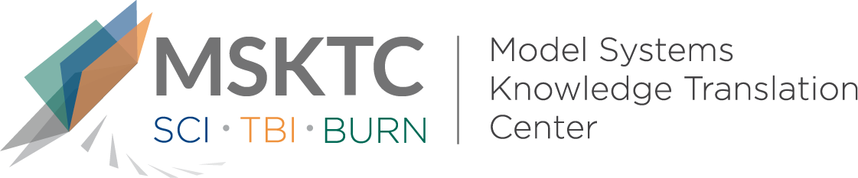

` Quick Review of
Model System Research

Modified PRISM and SCI-SET Spasticity Measures for Persons With Traumatic Spinal Cord Injury: Results of Rasch Analyses

What is the study about?

This study aims to evaluate how valid (reliable) and efficient two measures are that are used in evaluating people with spinal cord injury. The measures are the Spinal Cord Injury Spasticity Evaluation Tool (SCI-SET) and Patient-Reported Impact of Spasticity Measure (PRISM). The SCI-SET and PRISM are commonly seen as the most useful instruments for measuring the effect of spasticity but have not been examined using current methods. Having good measures of spasticity help with managing this difficult problem.

What did the study find?
This study found that a modification of the SCI-SET and PRISM improved its validity and efficiency from the modification. The authors recommend use of the Modified SCI-SET and Modified PRISM measures in future studies.

Who participated in the study?
Individuals with SCI (N=1239) who were recruited to complete the survey through multiple online and in-person approaches, such as through email, advertisements, sports groups, and flyers posted at participating SCI rehabilitation centers.

How was the study conducted?
This study analyzed data collected as part of a collaborative research project of the SCI Model Systems Centers.

How can people use the results?

Individuals with SCI and their families can use the results of this study to better understand tools used to measure spasticity and learn of the improved measurement for spasticity. Practitioners can use the modified instruments for measuring spasticity and consider the recommendations for future research.

Reference
Sweatman, W.M., Heinemann, A.W., Furbish, C.L., & Field-Fote, E.C. (2020). Modified PRISM and SCI-SET spasticity measures for persons with traumatic spinal cord injury: Results of a Rasch analyses. Archives of Physical Medicine and Rehabilitation 101, 1570-1579.
Disclaimer
The contents of this quick review were developed under a grant from the National Institute on Disability, Independent Living, and Rehabilitation Research (NIDILRR grant number 90DP0082). NIDILRR is a Center within the Administration for Community Living (ACL), Department of Health and Human Services (HHS). The contents of this quick review do not necessarily represent the policy of NIDILRR, ACL, HHS, and you should not assume endorsement by the Federal Government.
This version of the quick review has not been reviewed by the authors.

