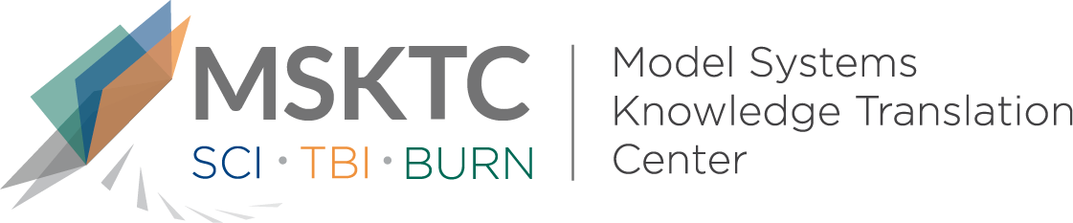

` Quick Review of
Model System Research

Volunteering and Its Association With Participation and Life Satisfaction Following Traumatic Brain Injury

What is the study about?

This study aims to describe those who volunteer after moderate-severe traumatic brain injury (TBI), and to examine the links between volunteering and participation and life satisfaction after TBI. Returning to a productive and satisfying life after TBI can be difficult. Wellbeing and participation in social and community activities are important signs that a person is functioning following TBI. Volunteering is one way for TBI survivors to stay active in their community and to feel a sense of purpose.

What did the study find?
This study found that there was a positive relationship between volunteering and participation in community activities and social relations. There was no significant association (a relationship was not found) with productivity (i.e., returning to employment). The results also suggest that that those who volunteer have significantly higher life satisfaction than those who did not volunteer, after controlling for important covariates (i.e., characteristics of participants like age or gender).

Who participated in the study?
Individuals with TBI (n=725) from a single site contributing to the Traumatic Brain Injury Model Systems National Database (TBIMS-NDB).

How was the study conducted?
This study was a retrospective analysis (looking back at events that have already taken place) that compared outcomes of those who volunteered and those who did not volunteer.

How can people use the results?

Individuals with TBI and their families can use the results of this study to better understand for whom and how volunteering can have positive effects on those with moderate-severe TBI. Practitioners can use these findings to better support TBI survivors and their families; and to pursue future research in investigating the barriers and promoters of volunteering to improve the wellbeing of TBI survivors.

Reference
Philippus, A., Ketchum, J. M., Payne, L., & Harrison-Felix, C. (2019). Volunteering and its association with participation and life satisfaction following traumatic brain injury. Brain Injury, 34 (1), 52-61.
Disclaimer
The contents of this quick review were developed under a grant from the National Institute on Disability, Independent Living, and Rehabilitation Research (NIDILRR grant number 90DP0082). NIDILRR is a Center within the Administration for Community Living (ACL), Department of Health and Human Services (HHS). The contents of this quick review do not necessarily represent the policy of NIDILRR, ACL, HHS, and you should not assume endorsement by the Federal Government.

