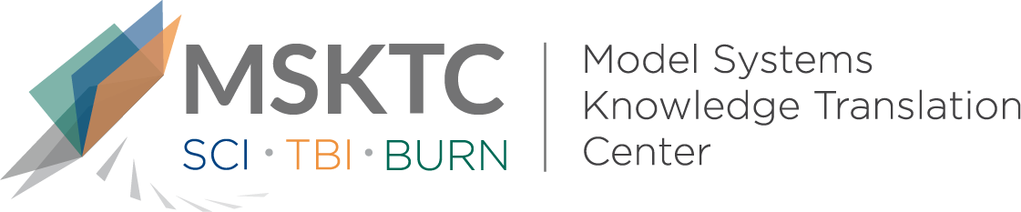

` Quick Review of
Model System Research

The Association Between Community Participation and Social Internet Use Among Adults With Traumatic Brain Injury

What is the study about?

This study aims to examine the association between social Internet use and real-world societal participation, in survivors of moderate-severe traumatic brain injury (TBI). Participation includes employment, leaisure activities, and social interactions. Participation is associated with health, quality of life, and wellbeing in the general population. However, people with disabilities often have difficulties overcoming environmental, social, logistical, and disability-related barriers to participation.

What did the study find?
This study found that people with TBI do not use social media as an alternative to real-world socialization. In fact, people who use social media are more likely to also be out and about and participate in real-world activities. Individuals with moderate-severe TBI who are both depressed and do not use the Internet for social contact may have particularly limited activity in their community. It is likely that similar barriers affect both online and real-world social participation following TBI.

Who participated in the study?
Individuals aged 16 years or older (n=331) who received care within 72 hours of injury at a Traumatic Brain Injury Model Systems affiliated trauma center, sustained a moderate/severe TBI, and were transferred to an inpatient rehabilitation unit within 72 hours of discharge from acute care.

How was the study conducted?
This study was a prospective cross-sectional observational study. It used a survey on Internet use and follow-up interviews during any year postinjury between April 2015 and March 2015.

How can people use the results?

Individuals with TBI and their families can use the results of this study to better understand the barriers to social participation and social Internet use among adults with moderate-severe TBI. Practitioners can use these findings to think about how to assess clients’ experience and expertise with social media, and to assess their emotional functioning, which may be a barrier to virtual and real participation. Treatments that alleviate barriers to community participation may be useful to people with moderate-severe TBI.

Reference
Ketchum, J.M., Sevigny, M., Hart, T., O’Neil-Pirozzi, T.M., Sander, A.M., Juengst, S.B., Bergquist, T.F., Dreer, L.E., & Whiteneck, G.G. (2020). The association between community participation and social Internet use among adults with traumatic brain injury. Journal of Head Trauma Rehabilitation, 35(4), 254-261.
Disclaimer
The contents of this quick review were developed under a grant from the National Institute on Disability, Independent Living, and Rehabilitation Research (NIDILRR grant number 90DP0082). NIDILRR is a Center within the Administration for Community Living (ACL), Department of Health and Human Services (HHS). The contents of this quick review do not necessarily represent the policy of NIDILRR, ACL, HHS, and you should not assume endorsement by the Federal Government.

