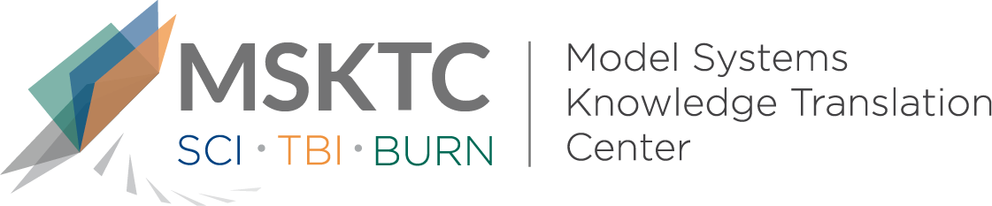

` Quick Review of
Model System Research

An Examination of Follow-up Services Received by Vulnerable Burn Populations: A Burn Model System National Database Study

What is the study about?

This study aims to assess differences in health service use, including long-term occupational or physical therapy (OT/PT) and psychological services, between vulnerable and nonvulnerable groups of burn survivors. The vulnerable group included participants who were in one or more of these categories: 65 years of age or older, nonwhite, no insurance or Medicaid insurance, preinjury receipt of psychological therapy or counseling, preinjury alcohol and/or drug misuse, or preexisting disability.

What did the study find?
This study found no significant differences in the use of OT/PT and psychological services between vulnerable and nonvulnerable groups of burn survivors. However, significantly more health services were used by people with these profiles: burn survivors who received psychological therapy or counseling before their injury, those with a preexisting disability, and those who were 65 years of age or older. This study also found that a large portion of the burn population are considered vulnerable.

Who participated in the study?
Data were collected from the Burn Model Systems National Database (n=1,136) over a 9-year period (2006-2015). There were 692 (61%) individuals categorized in the vulnerable group and 444 (39%) categorized in the nonvulnerable group.

How was the study conducted?
This study was a longitudinal observational study using data at 6, 12, and 24 months post injury.

How can people use the results?

Individuals with burn injury and their families can use the results of this study to better understand subgroups of vulnerable burn populations and the importance of their long-term care. Practitioners can use the results of this study to develop studies to futher examine the adequacy of long-term care of the diverse burn population.

Reference
Benavides, L., Shie, V., Yee, B., Yelvington, M., Simko, L.C., Wolfe, A.E., McMullen, K., Epp, J., Parry, I., Shon, R., Holavanahalli, R., Herndon, D., Rosenberg, M., Rosenberg, L., Meyer, W., Gibran, N., Wiechman, S., Ryan, C.M., & Schneider, J.C. (2020). An examination of follow-up services received by vulnerable burn populations: A Burn Model System National Database study. Journal of Burn Care & Research, 41 (2), 377-383. doi:10.1093/jbcr/irz185
Disclaimer
The contents of this quick review were developed under a grant from the National Institute on Disability, Independent Living, and Rehabilitation Research (NIDILRR grant number 90DP0082). NIDILRR is a Center within the Administration for Community Living (ACL), Department of Health and Human Services (HHS). The contents of this quick review do not necessarily represent the policy of NIDILRR, ACL, HHS, and you should not assume endorsement by the Federal Government.

