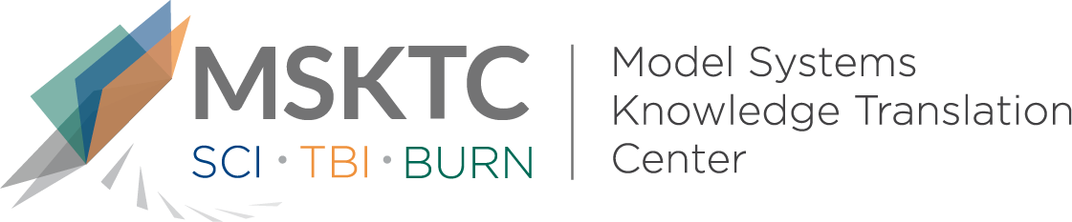

Quick Review of
Model System Research

Reliability & Validity of the LIBRE Profile

What is the study about?

The Life Impact Burn Recovery Evaluation (LIBRE) Profile was developed to measure social participation after a burn injury using a computer adaptive test. The goal of this study was to determine the reliability and validity of the LIBRE Profile.

What did the study find?

This study provides psychometric evidence supporting the validity and reliability of the LIBRE Profile as a patient reported outcome measure that assesses the social engagement of individuals with burn injury.

Who participated in the study?

Two-hundred and fifty-nine individuals with burn injury participated in this study. The participants had to be 18 years or older, have a total body surface area burned of 5% or greater, able to read and understand English, and have access to email.

How was the study conducted?
The six LIBRE profile domains were administered to participants via survey to examine their validity and reliability. These six profiles included 1) relationships with family and friends, 2) social interactions, 3) social activities, 4) work and employment, 5) romantic relationships, and 6) sexual relationships. Multiple scales were used to assess the six profiles. They were compared to well established legacy assessments for these domains and found to correlate quite well.

How can people use the results?
Clinicians can use the results of this study to help guide selection of an assessment that is psychometrically sound and measures social participation after burn injury.

Reference
Dore, E. C., Marino, M., Ni, P., Lomelin-Gascon, J., Sonis, L., Amaya, F., . . . Kazis, L. E. (2018). Reliability & validity of the LIBRE Profile. Burns, 44(7), 1750-1758. doi:10.1016/j.burns.2018.04.001

Disclaimer
The contents of this quick review were developed under a grant from the National Institute on Disability, Independent Living, and Rehabilitation Research (NIDILRR grant number 90DP0082). NIDILRR is a Center within the Administration for Community Living (ACL), Department of Health and Human Services (HHS). The contents of this quick review do not necessarily represent the policy of NIDILRR, ACL, HHS, and you should not assume endorsement by the Federal Government.

