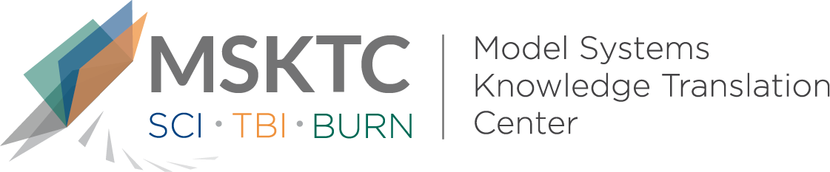

Quick Review of
Model System Research

The Impact of Electrical Injuries on Long-Term Outcomes: A Burn Model System National Database Study

What is the study about?

The aim of this is study was to compare longterm outcomes for inviduals with electrical injuries and fire/flame injury with respect to life satisfaction, physical, mental functioning, and work status following burn injury.

What did the study find?
The study found that individuals with electrical injuries were more likely to be males that were injured at work. Long-term physical functioning outcomes for individuals with electrical injuries were found to be significantly worse at 24 months post-injury compared to individuals with fire/flame injuries. In addition, individuals with electrical injuries were half as likely to be employed at 24 months post-injury than those with fire/flame injuries. Life satisfaction and mental functioning did not differ between the two comparison groups.

Who particpated in the study?
Participants were individuals with fire/flame injuries (n=1036) and electrical injuries (n=111).

How was the study conducted?
The study collected and examined data from the Burn Model System National Database between 1996 and 2015. The Satisfaction With Life Scale, Short Form-12 Physical Composite Score, Short Form-12 Mental Composite Score, and employment status were examined at 24 months post-injury.

How can people use the results?
Practitioners, individuals with electrical injuries, and their families can use the results of this study to better understand how the support and rehabilitation needs for this population may differ from individuals with fire/flame injuries overtime.

Reference
Stockly, O.R., Wolfe, A.W., Espinoza, L.F., Simko, L.C., Kowalske, K., Carrougher, G.J., Gibran, N., Bamer, A.M., Meyer, W., Rosenberg, M., Rosenberg, L., Kazis, L.E., Ryan, C.M., & Schneider, J.C. (2019). The impact of electrical injuries on long-term outcomes: A Burn Model System National Database study. Burns. doi: 10.1016/j.burns.2019.07.030

Disclaimer
The contents of this quick review were developed under a grant from the National Institute on Disability, Independent Living, and Rehabilitation Research (NIDILRR grant number 90DP0082). NIDILRR is a Center within the Administration for Community Living (ACL), Department of Health and Human Services (HHS). The contents of this quick review do not necessarily represent the policy of NIDILRR, ACL, HHS, and you should not assume endorsement by the Federal Government.

