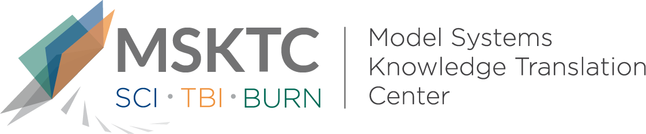

` Quick Review of
Model System Research

Can the Electrically Stimulated Manual Muscle Test Differentiate Upper From Lower Motor Neuron Injury in Persons with Acute SCI

What is the study about?

This study aims to determine if the motor response on the stimulated manual muscle test (SMMT) in muscles with a grade 0 motor score on the muscle test (MMT) can distinguish lower motor neuron (LMN) from upper motor neuron (UMN) injury, based on the presence of spontaneous activity (SA) with a needle EMG. Restoration of arm and hand function for individuals with cervical spinal cord injury (SCI) is a key factor in improving quality of life. The early assessment and differentiation of LMN from UMN injury can provide unique information to identify time-critical management options to improve upper extremity (UE) function.

What did the study find?
This study found that 70% of the muscles with an SMMT motor response of zero and 72% with an SMMT motor response greater than or equal to one demonstrated SA on an EMG. The use of the SMMT as a clinical measure to differentiate LMN from UMN integrity may be limited when applied. These results suggest that the usefulness of common clinical measures of denervation may be limited, and caution should be used in interpreting the results – especially when considering management options for patients with acute SCI.

Who participated in the study?
Individuals with acute traumatic cervical SCI (N=21).

How was the study conducted?
This study was a retrospective study where individuals with new traumatic cervical SCI were studied at a median of 27 (range of 5-66 days) days after injury. UE International Standards for the Neurological Classification of Spinal Cord Injury (ISNCSCI) evaluation was completed on all subjects. A needle EMG and an electrically stimulated manual muscle test (SMMT) were completed on all upper extremity muscles with an MMT motor score of zero.

How can people use the results?

Individuals with SCI and their families can use this study's results to understand better how SMMT and MMT testing methods work. Practitioners can use the results of this study when determining treatment options with cervical SCI patients and consider how the limitations of this study can inform future research on this topic.

Reference
de Padua, A., Renfro, C., Grabnar, M., Kilgore, K., Bryden, A., Roach, M. J., & Nemunaitis, G. (2020). Can the electrically stimulated manual muscle test differentiate upper from lower motor neuron injury in persons with acute SCI? Neurological Research. doi: 10.1080/01616412.2020.1824417.
Disclaimer
The contents of this quick review were developed under a grant from the National Institute on Disability, Independent Living, and Rehabilitation Research (NIDILRR grant number 90DP0082). NIDILRR is a Center within the Administration for Community Living (ACL), Department of Health and Human Services (HHS). The contents of this quick review do not necessarily represent the policy of NIDILRR, ACL, HHS, and you should not assume endorsement by the Federal Government.

