KT for PTs Course
Sample Social Media Messages and Graphics

Introduction
This document contains sample social media messages and graphics to promote a new knowledge translation (KT) course: KT for PTs: Supporting Evidence-Based Practices course. The course introduces the basic concepts of knowledge translation as it relates to the practice of physical therapy. It is designed for physical therapy students, instructors, and new physical therapists. The course presents various definitions of knowledge translation, introduces a model for knowledge translation research and application activities, and helps clarify the role of physical therapists in the knowledge translation process.

Please share these messages to let your networks know about the free, self-paced online KT for PTs: Supporting Evidence-Based Practices course. Find flyers to promote this new course here.

General Message
- This free, online course from #MSKTC introduces the basic concepts of #knowledgetranslation as it relates to the practice of #physicaltherapy. It is designed for PT students, instructors, and #physicaltherapists. https://msktc.org/kt-for-pt
- Check out this free, online course from #MSKTC! It presents various definitions of #knowledgetranslation, introduces a model for KT research and application activities, and helps clarify the role of PTs in the KT process. https://msktc.org/kt-for-pt

Messages and Graphic for PT Students
- Learn how #knowledgetranslation (KT) can help #physicaltherapy (PT) #students learn and implement evidence-based practices that lead to improved patient outcomes. Access the free course here: https://msktc.org/kt-for-pt
- The Model System Knowledge Translation Center (#MSKTC) developed a new, free #knowledgetranslation course for #physicaltherapy #students! Access KT for PT here: https://msktc.org/kt-for-pt
- Check out this new, free #knowledgetranslation course for #physicaltherapy #students developed by the Model System Knowledge Translation Center (#MSKTC). Access it here: https://msktc.org/kt-for-pt
- Attention #physicaltherapy #students! This free course from #MSKTC explains #knowledgetranslation (KT), introduces a model for KT research and application activities, and helps clarify the role of #PTs in the KT process. Access it here: https://msktc.org/kt-for-pt

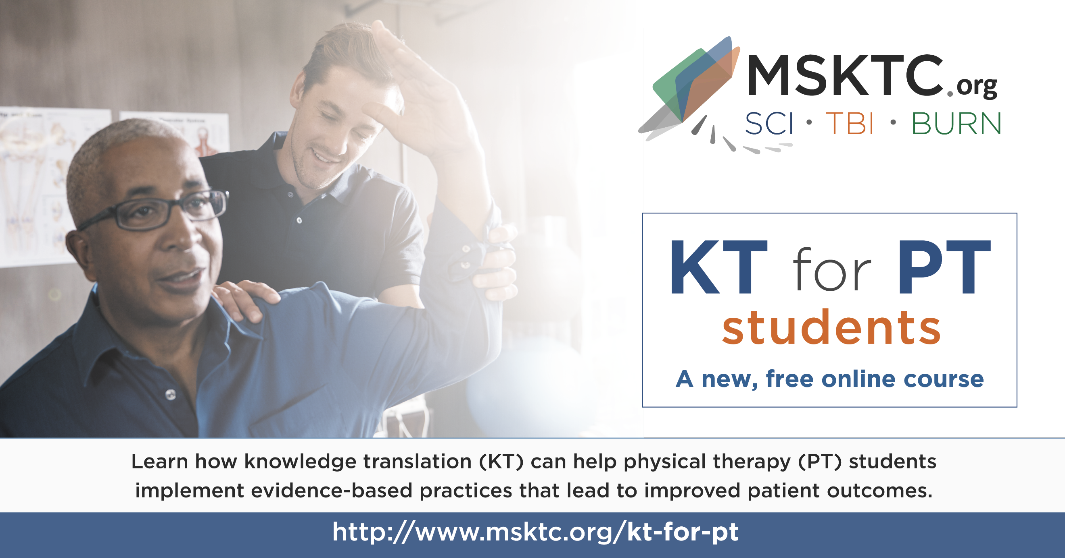

Messages and Graphic for PT Professionals
- The Model System Knowledge Translation Center (#MSKTC) has developed a new, free #knowledgetranslation course for #physicaltherapists! Access the online course here: https://msktc.org/kt-for-pt
- Check out the new, free #knowledgetranslation course for #physicaltherapists developed by the Model System Knowledge Translation Center (#MSKTC). Access it here: https://msktc.org/kt-for-pt
- Learn how #knowledgetranslation (KT) can help #physicaltherapists (PTs) implement evidence-based practices that lead to improved patient outcomes. New, free online course available here: https://msktc.org/kt-for-pt
- This new, free course from #MSKTC presents various definitions of #knowledgetranslation (KT), introduces a model for KT research and application activities, and helps clarify the role of #physicaltherapists in the KT process. Access it here: https://msktc.org/kt-for-pt

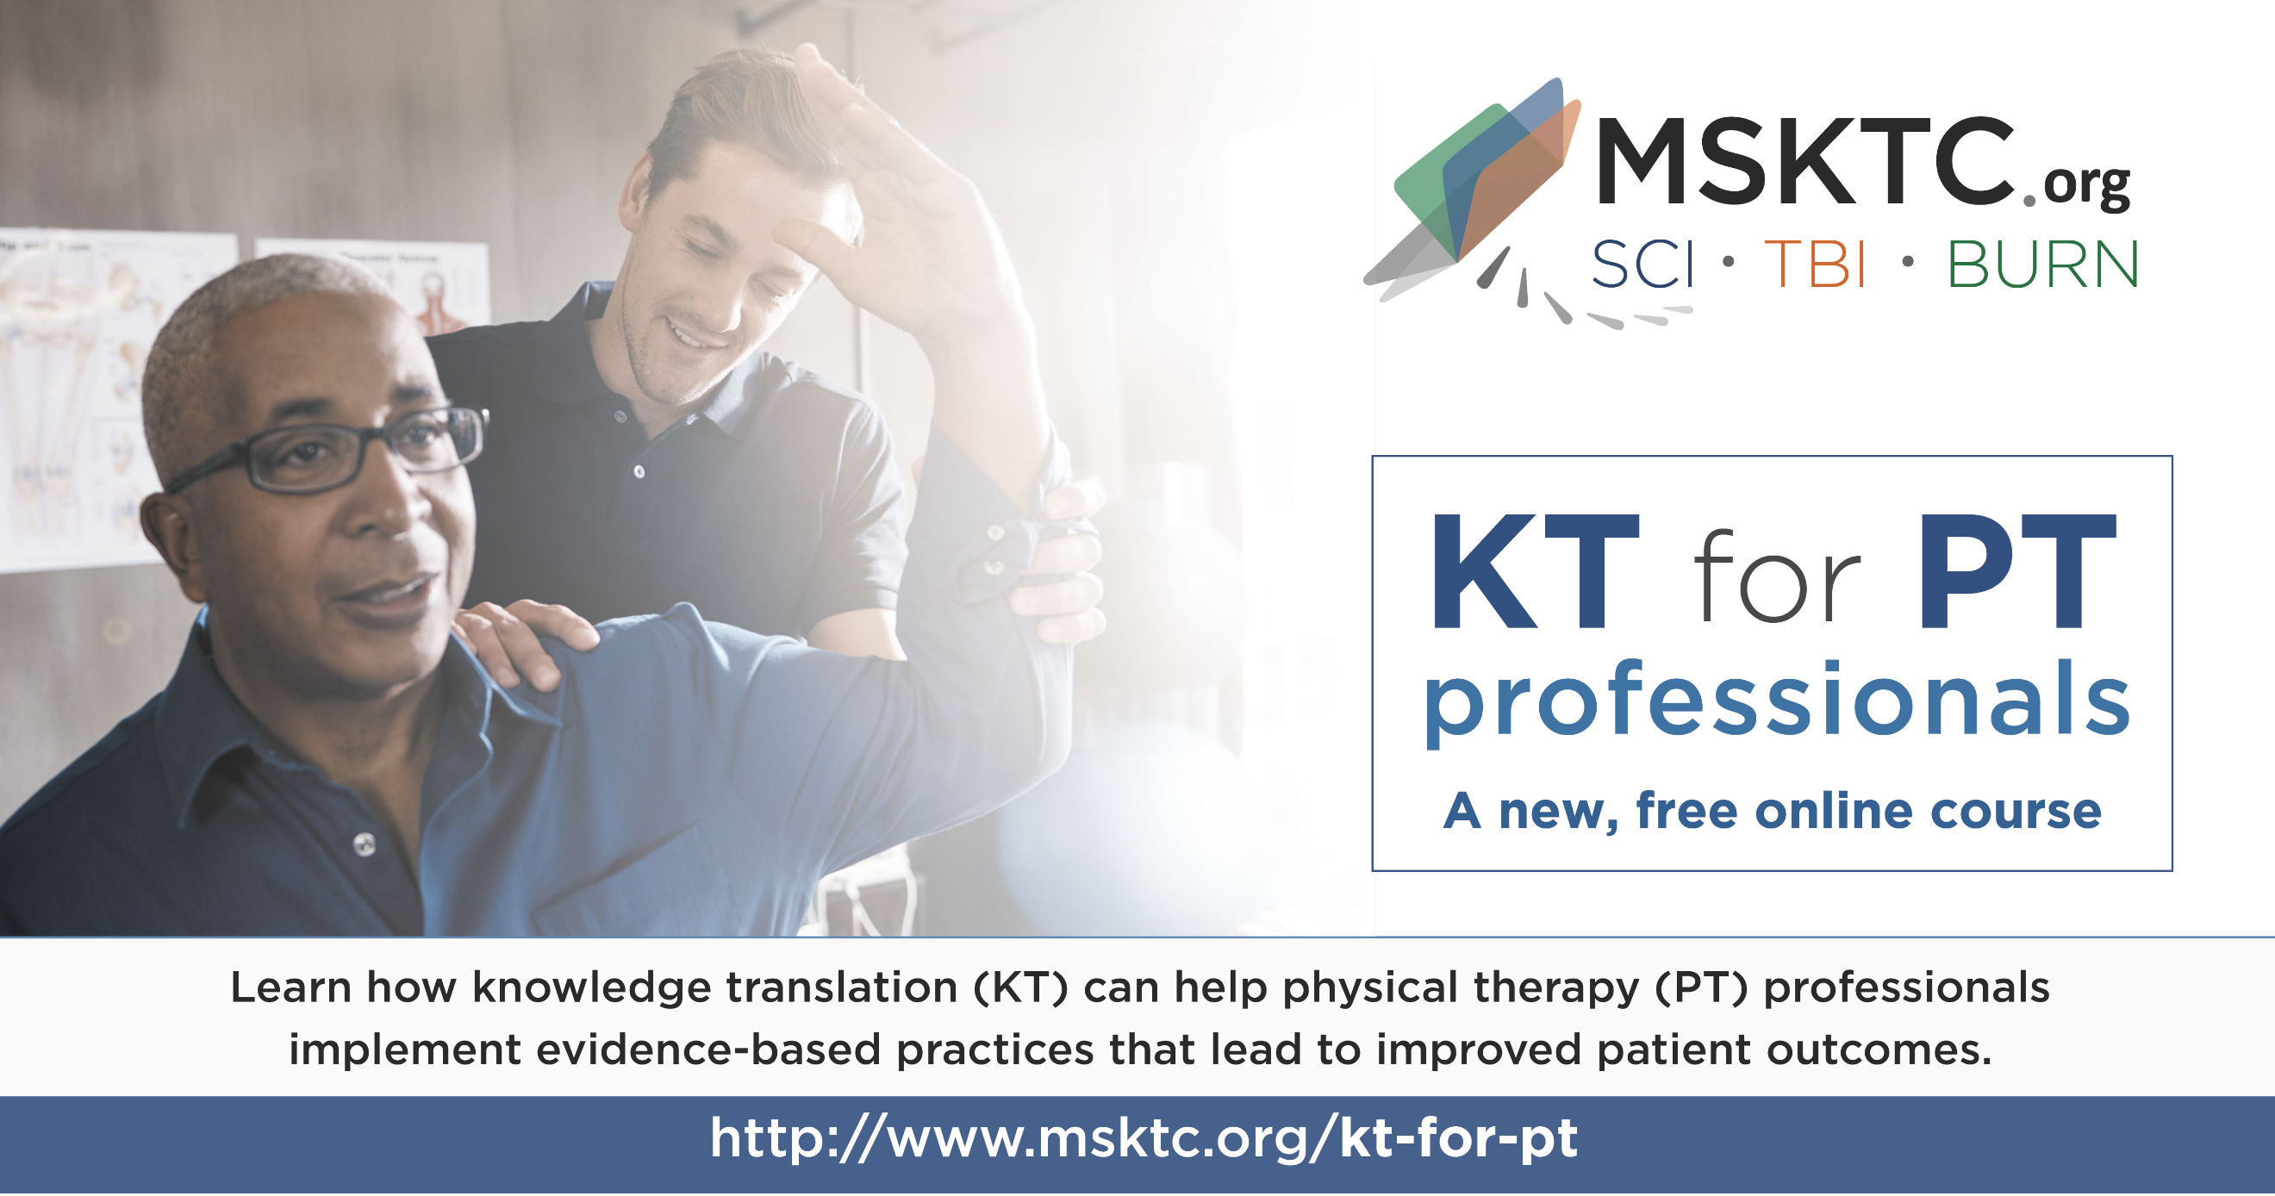

Messages and Graphic for PT Instructors
- The #MSKTC has developed a new, free #knowledgetranslation course for #physicaltherapists! The course includes an instructor guide to support #PT instructors who assign the online course to students. Access the online course here: https://msktc.org/kt-for-pt
- Check out the new, free #knowledgetranslation course for #physicaltherapists developed by the #MSKTC. The course includes an instructor guide to support #PT instructors who assign the online course to students. Access the online course here: https://msktc.org/kt-for-pt
- Attention #PT #instructors! The #MSKTC has developed a new, free #knowledgetranslation (KT) course for PTs! The course includes an instructor guide to support PT instructors who assign the online course to students. Access the online course here: https://msktc.org/kt-for-pt
