KT for SLPs Course
Sample Social Media Messages and Graphics

Introduction
This document contains sample social media messages and graphics to promote a new knowledge translation (KT) course: KT for SLPs: Supporting Evidence-Based Practices course. The course introduces the basic concepts of knowledge translation as it relates to the practice of speech language pathology. It is designed for speech language pathology students, instructors, and new speech language pathologists. The course presents various definitions of knowledge translation, introduces a model for knowledge translation research and application activities, and helps clarify the role of speech language pathologists in the knowledge translation process.

Please share these messages to let your networks know about the free, self-paced online KT for SLPs: Supporting Evidence-Based Practices course. Find flyers to promote this new course here.

General Message
- This free, online course from #MSKTC introduces the basic concepts of #knowledgetranslation as it relates to the practice of #speechlanguagepathology (SLP). It is designed for #SLP students, instructors, and #speechlanguagepathologists. www.msktc.org/kt-for-slp
- Check out this free, online course from #MSKTC! It presents various definitions of #knowledgetranslation (KT), introduces a model for KT research and application activities, and helps clarify the role of #speechlanguagepathologists in the KT process. www.msktc.org/kt-for-slp

Messages and Graphic for SLP Students
- Learn how #knowledgetranslation can help #speechlanguagepathology (#SLP) #students learn and implement evidence-based practices that lead to improved patient outcomes. Access the free course here: www.msktc.org/kt-for-slp
- The Model System Knowledge Translation Center (#MSKTC) developed a new, free #knowledgetranslation (KT) course for #speechlanguagepathology #students! Access KT for #SLP here: www.msktc.org/kt-for-slp
- Check out this new, free #knowledgetranslation course for #speechlanguagepathology #students developed by the Model System Knowledge Translation Center (#MSKTC). Access it here: www.msktc.org/kt-for-slp
- Attention #speechlanguagepathology (SLP) #students! This free course from #MSKTC explains #knowledgetranslation (KT), introduces a model for KT research and application activities, and helps clarify the role of #SLPs in the KT process. Access it here: www.msktc.org/kt-for-slp

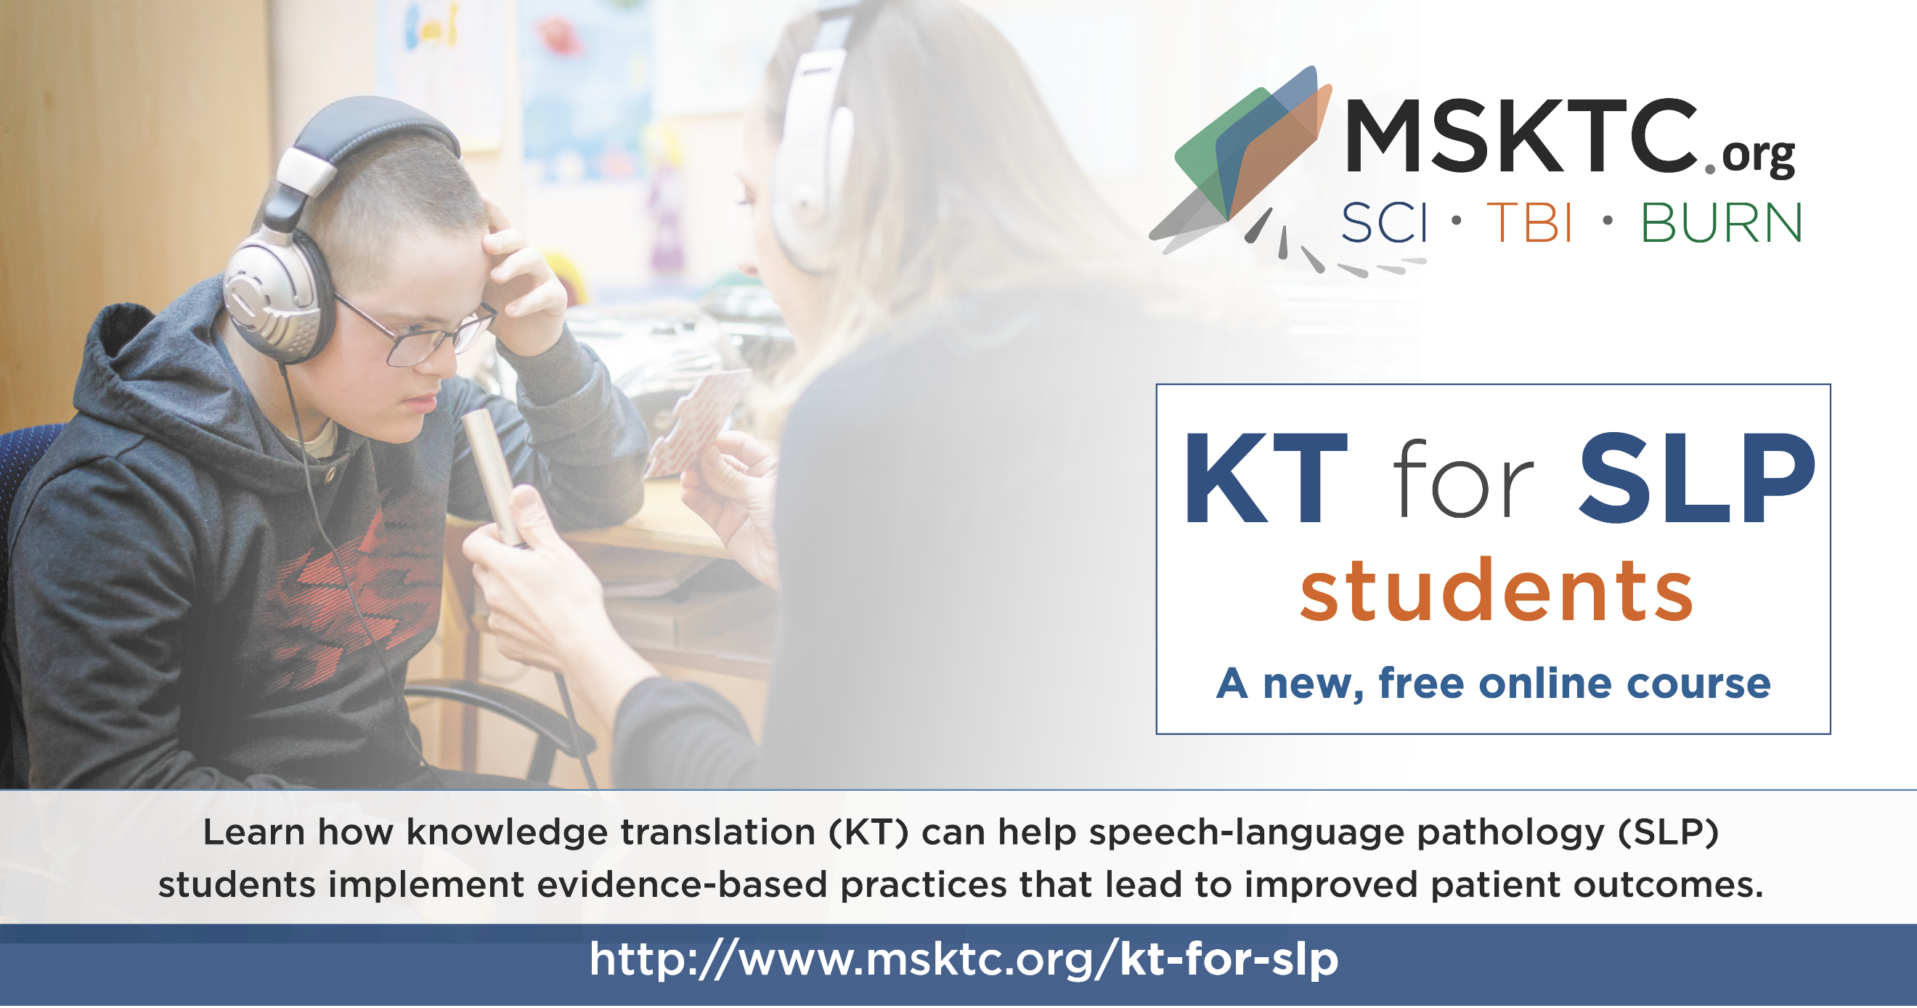

Messages and Graphic for SLP Professionals
- The Model System Knowledge Translation Center (#MSKTC) has developed a new, free #knowledgetranslation course for #speechlanguagepathologists! Access the online course here: www.msktc.org/kt-for-slp
- Check out the new, free #knowledgetranslation course for #speechlanguagepathologists developed by the Model System Knowledge Translation Center (#MSKTC). Access it here: www.msktc.org/kt-for-slp
- Learn how #knowledgetranslation can help #speechlanguagepathologists implement evidence-based practices that lead to improved patient outcomes. New, free online course available here: www.msktc.org/kt-for-slp
- This new, free course from #MSKTC presents various definitions of #knowledgetranslation (KT), introduces a model for KT research and application activities, and helps clarify the role of #speechlanguagepathologists in the KT process. Access it here: www.msktc.org/kt-for-slp
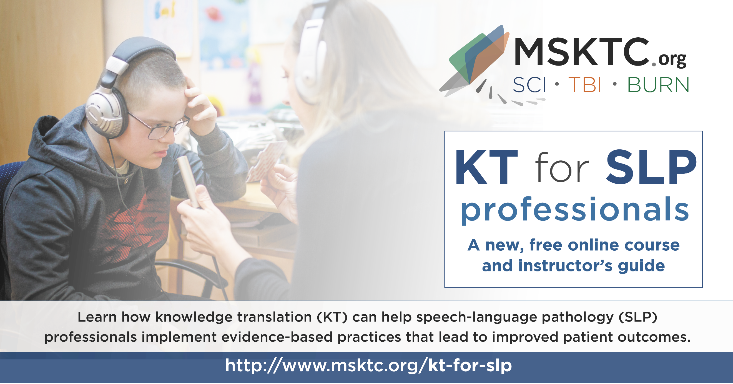

Messages and Graphic for SLP Instructors
- The #MSKTC has developed a new, free #knowledgetranslation course for #speechlanguagepathologists (SLPs)! The course includes an instructor guide to support #SLP instructors who assign the online course to students. Access the online course here: www.msktc.org/kt-for-slp
- Check out the new, free #knowledgetranslation course for #speechlanguagepathologists (SLP) developed by the #MSKTC. The course includes an instructor guide to support #SLP instructors who assign the online course to students. Access the online course here: www.msktc.org/kt-for-slp
- Attention #SLP #instructors! The #MSKTC has developed a new, free #knowledgetranslation (KT) course for SLPs! The course includes an instructor guide to support SLP instructors who assign the online course to students. Access the online course here: www.msktc.org/kt-for-slp

