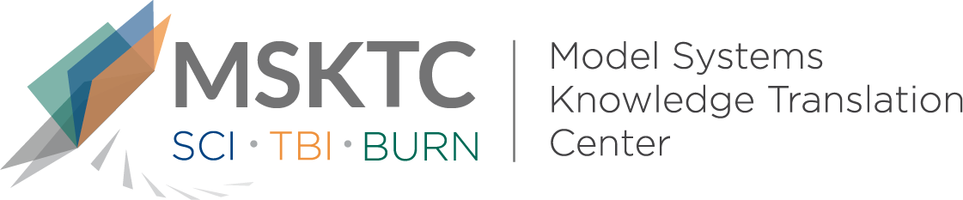

` Quick Review of
Model System Research

Comparative Effectiveness of Sleep Apnea Screening Instruments During Inpatient Rehabilitation Following Moderate to Severe TBI

What is the study about?

This study aims to examine the utility of common screening tools for sleep apnea (a disorder of interrupted breathing while sleeping) by examining how they compare to one another. These are tools used during inpatient rehabilitation for individuals with moderate to severe traumatic brain injury (TBI). Common screening methods for obstructive sleep apnea (OSA) have not been evaluated for how accurate they are in detecting sleep apnea in hospitalized TBI patients. Sleep apnea has the potential for negative effects in nervous system recovery. An early and accurate assessment of sleep apnea can help practitioners choose the best course of treatment.

What did the study find?
This study found that when comparing three different screening tools for sleep apnea, the STOPBANG and MAPI were shown as more effective compared to the Berlin Questionnaire during inpatient rehabilitation for TBI. This study is the first to provide clinicians with data to support a choice for which sleep apnea screening tool is best to use.

Who participated in the study?
Individuals who were consecutive patients at six rehabilitation center sites over 19 months (n=248) enrolled in the TBI Model Systems Traumatic Brain Injury (TBIMS) program.

How was the study conducted?
This study was a prospective assessment of tools used to measure sleep apnea to learn which one(s) were best able to identify the problem.

How can people use the results?

Individuals with TBI and their families can use the results of this study to identify which sleep apnea screening tools are most effective to use with TBI during inpatient rehabilitation. Practitioners can use these results to learn which sleep apnea screening tools are best to use with TBI during inpatient rehabilitation.

Reference
Nakase-Richardson, R., Schwartz, D.J., Drasher- Phillips, L., Ketchum, J.M., Calero, K., Dahdah, M.N., Monden, K.R, Bell, K., Magalang, U., Hoffman, J.M., Whyte, J., Bogner, J., Zeitzer, J.M. (2020). Comparative effectiveness of sleep apnea screening instruments during inpatient rehabilitation following moderate to severe TBI. Archives of Physical Medicine and Rehabilitation 101, 283-296.
Disclaimer
The contents of this quick review were developed under a grant from the National Institute on Disability, Independent Living, and Rehabilitation Research (NIDILRR grant number 90DP0082). NIDILRR is a Center within the Administration for Community Living (ACL), Department of Health and Human Services (HHS). The contents of this quick review do not necessarily represent the policy of NIDILRR, ACL, HHS, and you should not assume endorsement by the Federal Government.

