Communication Toolkit for Burn Model System Staff
Model Systems Knowledge Translation Center

Introduction
This Communication Toolkit contains various resources and customizable templates to support Burn Model System (BMS) staff (e.g., investigators, research coordinators, and data collectors) in sharing free, research-based burn resources from the Model Systems Knowledge Translation Center (MSKTC; https://msktc.org/) and promote your BMS research.
The toolkit contains the following topics (you can use the hyperlinks to go directly to the topic of your interest) :
- MSKTC and BMS social media platforms  - Sample social media posts  - Customizable social media templates  - QR codes  - Sample email message with links to all MSKTC burn resources  - An email signature banner  - Resource Badges  - Customizable name tags | - Resource buttons  - Virtual meeting background  - MSKTC resource slides  - MSKTC and BMS resource posters  - A sample newsletter story  - Tips for using MSKTC and BMS resources  - Additional resources to support your knowledge translation efforts

MSKTC Social Media Platforms
MSKTC and BMS is active on several social media platforms, including Facebook, Instagram, X (formerly Twitter), and LinkedIn. Be sure to follow us, interact with our posts, and tag us when you share MSKTC resources.

 |  |  | 
- Burn Injury Model Systems | - @msktc_insights | - Burn Model Systems | - Model Systems Knowledge Translation Center

Social Media Posts

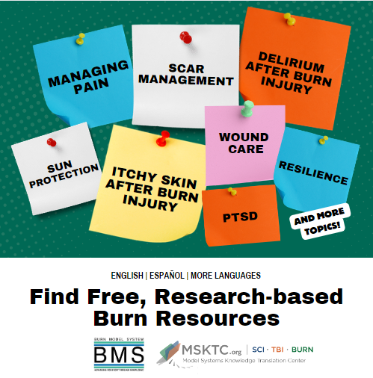 | #MSKTC and #BMS have a wide variety of #researchbased resources to help #burnsurvivors. To learn about how to manage #burninjury such as healthy eating, exercise, mental health, and more, visit https://msktc.org/burn.
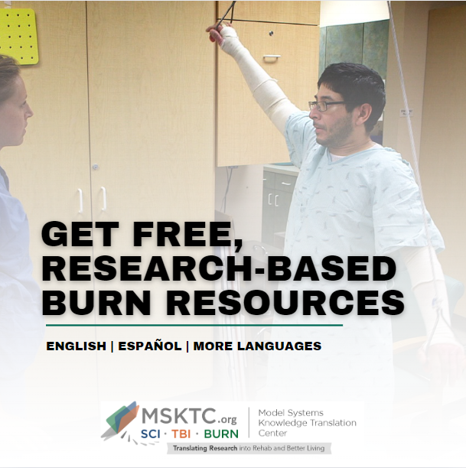 | Do you have questions about [insert topic from MSKTC website] after #burninjury?  #MSKTC and #BMS have a wide range of #researchbased resources to help those with #burninujry Check out [name of the resource]: [insert link to resource]
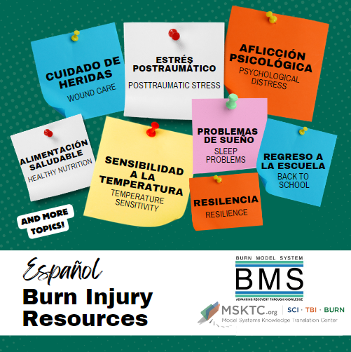 | Looking for free, #researchbased tools about #burninjury available in Spanish? #MSKTC and #BMS have many resources that explain different aspects of living with burn injury and how to #StayHealthy here: https://msktc.org/burn/recursos-en-espanol.
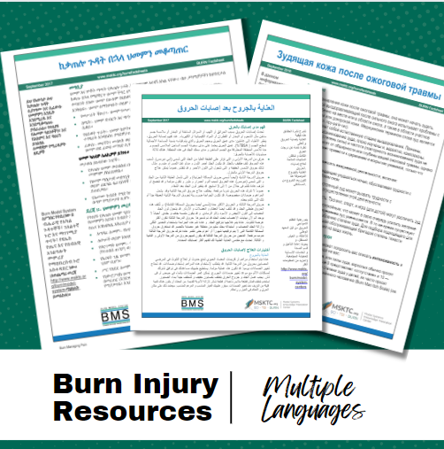 | Looking for free, #researchbased tools about #burninjury available in multiple languages? #MSKTC and #BMS have you covered. https://msktc.org/burn/foreign-languages
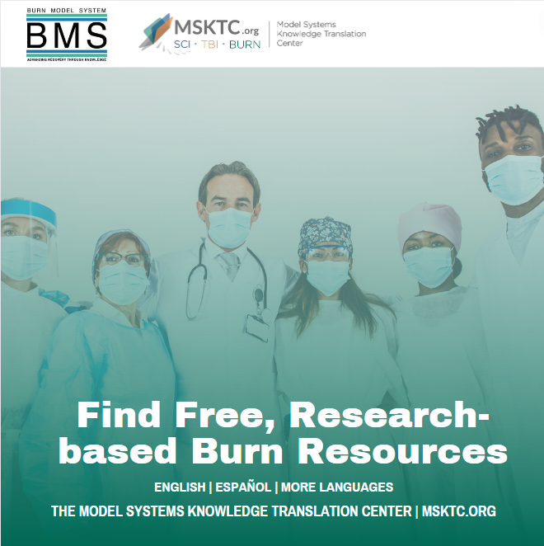 | Healthcare providers, looking for resources on burn injuries to educate and support your patients and families? #MSKTC and #BMS have many resources to help manage burn injuries. https://msktc.org/BURN

Message Only Templates
Instructions: These templates provide sample language for you to customize to promote your burn model system research and publications.
Promote New Publications | I'm thrilled to announce the publication of my latest research on [insert topic/title]. This work dives deep into [briefly describe key points or findings], offering new insights and perspectives on [relevant field or subject].  Read the full paper here: [insert link]  [Suggested hashtags: #BMS, #MSKTC, #Burn #BurnInjuries]
Promote Conference Presentations | Honored to present my research on [topic] at [Conference Name]! Excited to discuss our findings and connect with fellow researchers. If you're attending, let's connect!  [Suggested hashtags: #BMS, #MSKTC, #Burn #BurnInjuries]
Promote Research Activities | Excited to share some updates on my latest research. We're delving into [brief description of the research topic]. Grateful for the support from [institution or collaborators]. Stay tuned for more insights and findings!  [Suggested hashtags: #BMS, #MSKTC, #Burn #BurnInjuries]
Recruit Participants | Are you [description of target participants]? We're conducting a new research study on [brief description of the study's focus], and we need your help.  Who can participate?  - [Eligibility criteria]  - [Eligibility criteria]  Why join?  - Contribute to important research  - [Potential benefits, e.g., incentives, learning opportunities, etc.]  Interested?  - Sign up here: [link]  - Or DM us for more details!  Share this post to spread the word and tag others who might be interested.  [Suggested hashtags: #BMS, #MSKTC, #Burn #BurnInjuries]
Promote an Event | Join us for [Event Name], where we'll dive into [specific topic/field]!  Date: [Event Date]  Time: [Event Time]  Location: [Event Location]  Online Access: [Link/Details]  Whether you're a seasoned expert or just curious about [topic], this event promises valuable insights and opportunities for all.  [Registration Link/More Info]  [Suggested hashtags: #BMS, #MSKTC, #Burn #BurnInjuries]

QR Codes
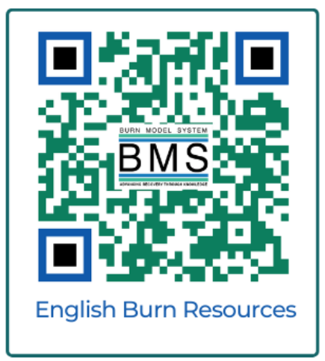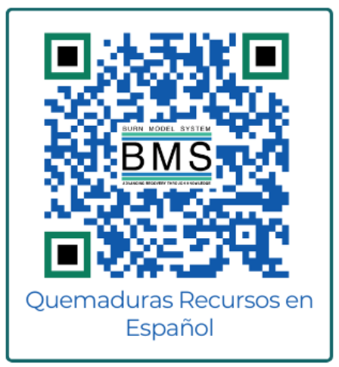

Sample Email Message to Share with Research Participants and Colleagues
Dear [NAME],
[ADJUST WORDING BASED ON RECIPIENT] I’d like to share the free, research-based resources for people living with burn injury and their families from the federally funded Model Systems Knowledge Translation Center (MSKTC: http://msktc.org/). MSKTC works with Burn Model System centers to develop burn resources that cover various rehabilitation topics (https://msktc.org/burn). Tailored to the diverse learning styles of individuals with burn injury and their families, these resources are in multiple formats (print, audio, and video), including factsheets, videos, infocomics, infographics, podcasts, narrated slideshows, and quick reviews. MSKTC burn resources are available in English, Spanish and more languages. MSKTC and Burn Model Systems are funded by the National Institute on Disability, Independent Living, and Rehabilitation Research (NIDILRR), Administration for Community Living, U.S. Department of Health and Human Services. I am including links to these resources below. Please feel free to share with others who may benefit from them.

MSKTC Burn Resources
- MSKTC burn resources cover a wide variety of topics. Currently, MSKTC provides resources on 20 rehabilitation topics to support individuals with burn injury and their families, such as delirium after burn injury, employment after burn injury, exercise after burn injury, healthy eating after burn injury–for adults, healthy eating after burn injury–for kids, itchy skin after burn injury, managing pain, outpatient opioid management for adult burn survivors, psychological distress, PTSD, resilience, return to school, scar management, sexuality and intimacy, sleep problems, social interaction after burn injury, sun protection after burn injury, understanding and improving body image after burn injury, understanding burn injury, and wound care.
- Burn resources in Spanish
  - https://msktc.org/burn/recursos-en-espanol
- Burn resources in more languages
  - https://msktc.org/burn/foreign-languages
- Factsheets
  - https://msktc.org/burn/factsheets
- Videos
  - https://msktc.org/burn/videos
- Infocomics
  - https://msktc.org/burn/infocomics
- Infographics
  - https://msktc.org/burn/infographics
- Slideshows
  - https://msktc.org/burn/slideshows
- Hot topic modules
  - https://msktc.org/burn/Hot-Topics
- Plain language summaries of research
  - https://msktc.org/burn/quick-reviews
- MSKTC Burn Ambassador Program
  - https://msktc.org/burn/ambassador-program
- Share and promote MSKTC.org resources using the website’s HTML codes
  - https://msktc.org/share-and-promote
- Research resources
  - Burn Model System Directory: https://msktc.org/burn/model-system-centers
  - Model System Publications Database: https://msktc.org/burn/publications
- Model System and Model System Database
  - https://msktc.org/about-model-systems/burn
- Knowledge Translation Toolkit
  - https://msktc.org/knowledge-translation
- Learn about MSKTC awards
  - https://msktc.org/share-and-promote
* MSKTC resources may be reproduced and distributed freely with appropriate attribution. Permission must be obtained to include them in fee-based materials.
Please take a quick survey and share your thoughts to help the MSKTC better serve you: https://websurveyor2.airws.org/se/2511374533213674.
Sincerely,
[SIGNER’S NAME]

BMS/MSKTC Email Signature Logo
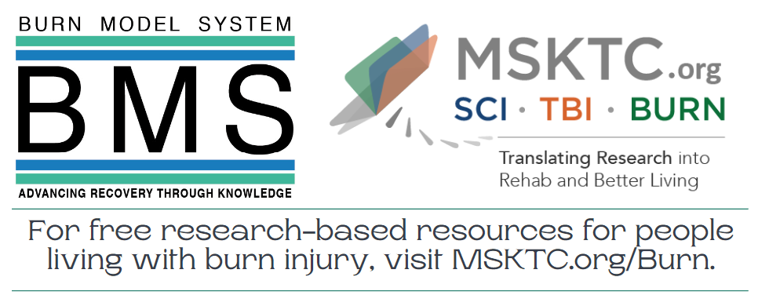
BMS staff can use this email signature line to share MSKTC burn resources. Please have the image link to https://msktc.org/BURN to take email recipients to the burn resource landing page on MSKTC.org. You can find detailed instructions on how to add this signature line and hyperlink here: https://msktc.org/node/4671.

BMS/MSKTC Resource Badge
Use this resource badge to easily promote burn injury resources while in clinics or at events. To request badges, please email MSKTC@air.org. |   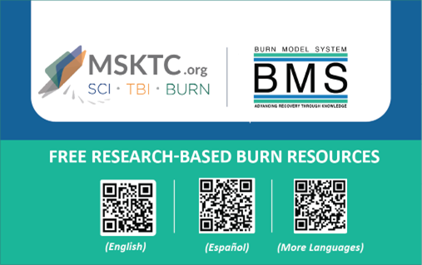

Name Tags
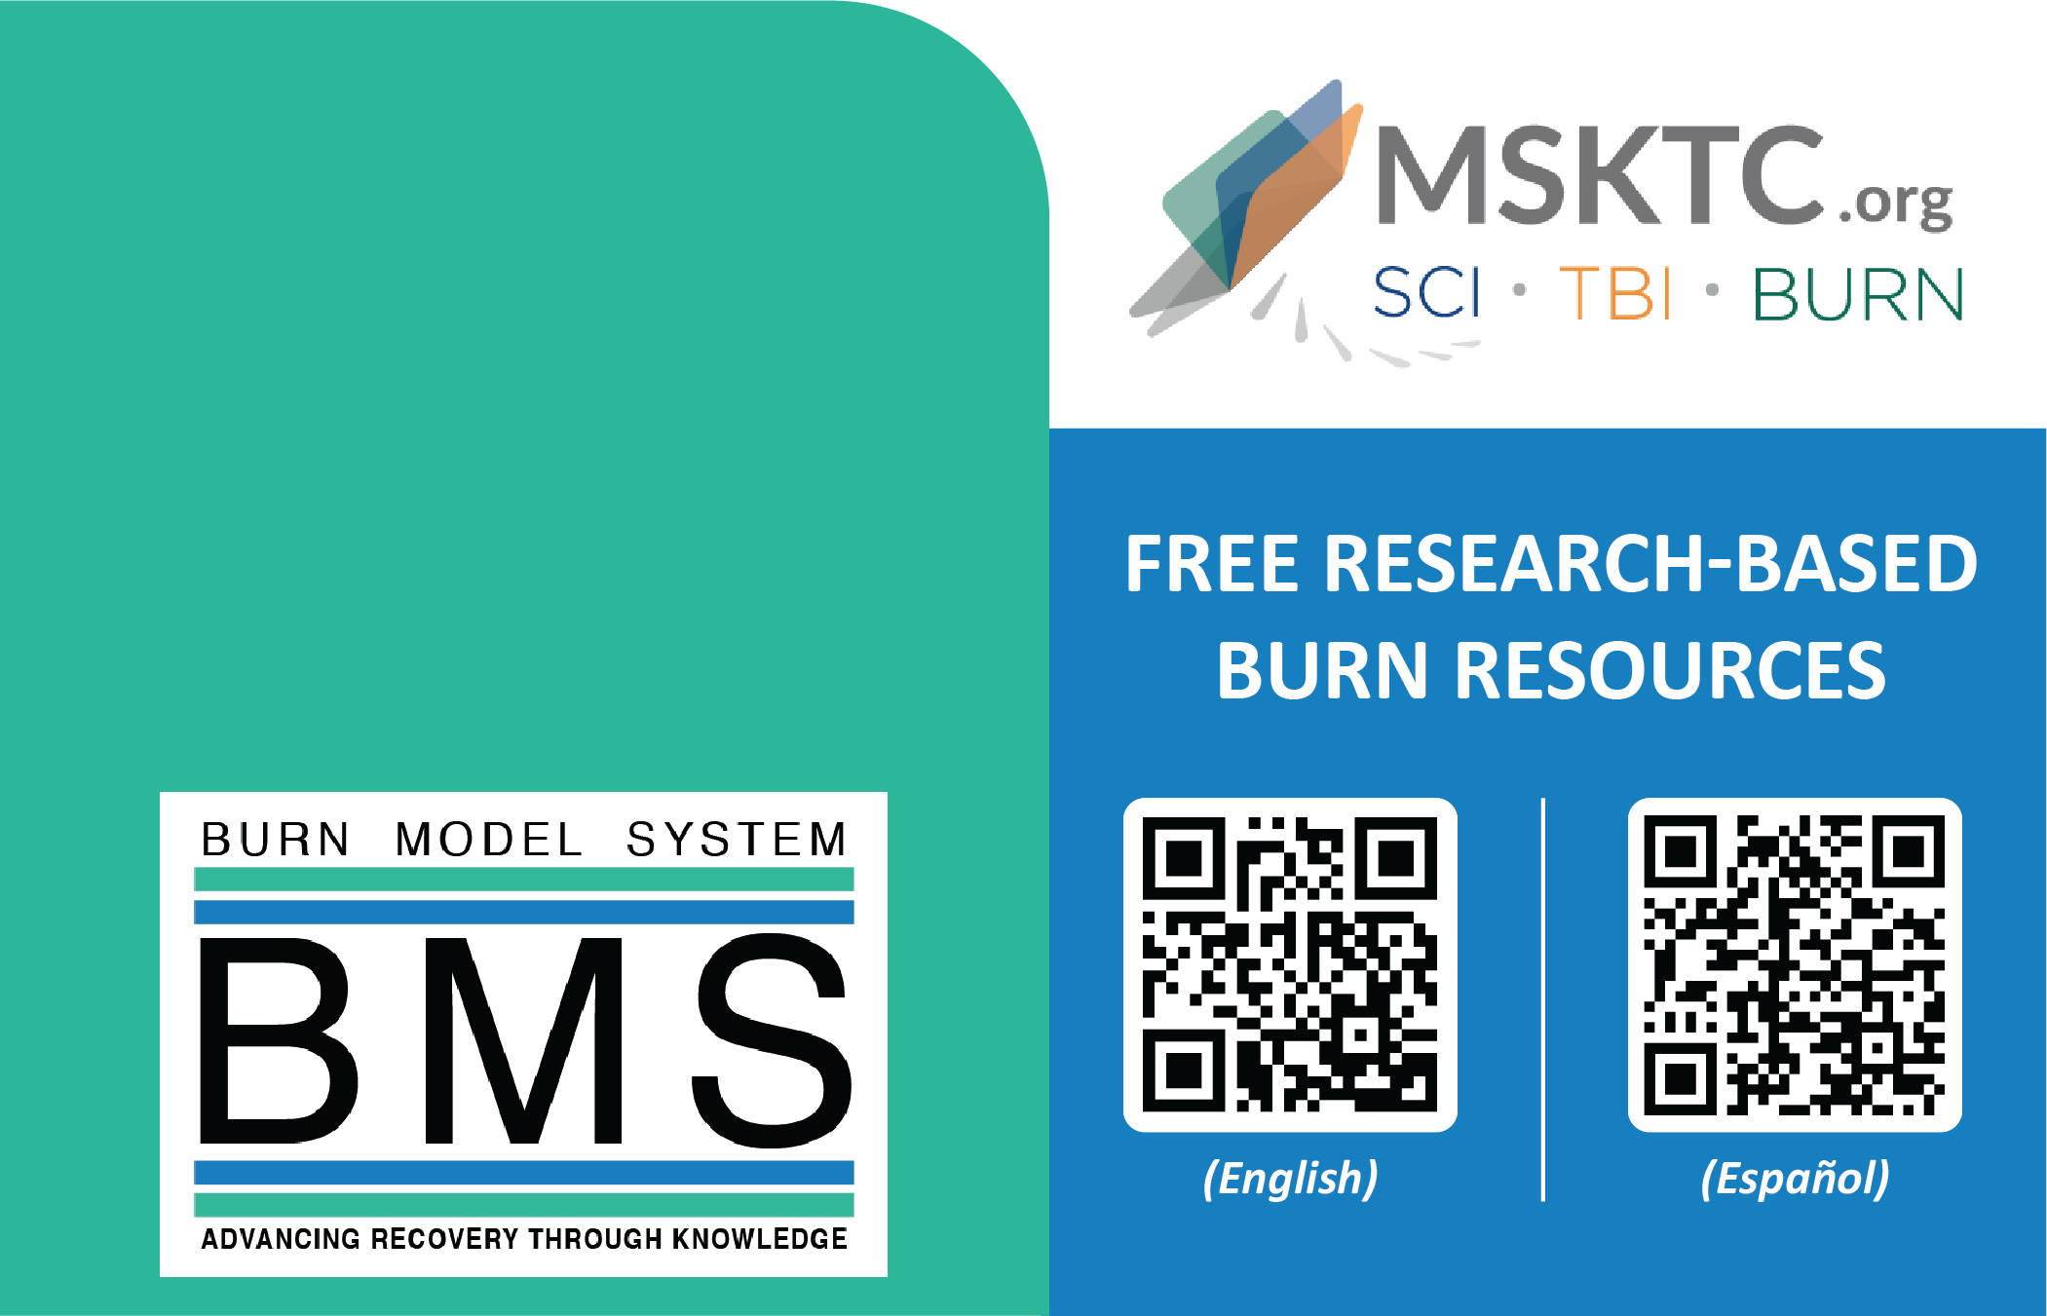
BMS staff can use customizable name tags to promote the use of MSKTC burn resources. The name tags have different sizes that you can choose based on your preference and/or the size of the name tag holder you already have. You can download the customizable name tags here: https://msktc.org/node/4608.

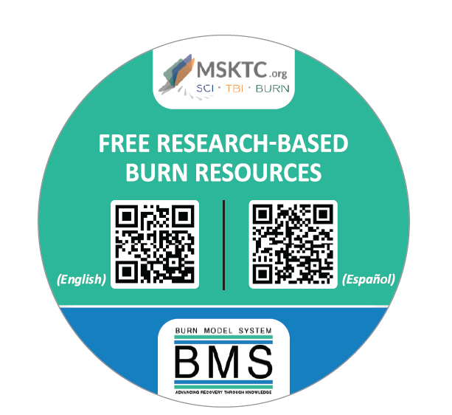
BMS and MSKTC Buttons
You can wear the BMS and MSKTC buttons in the clinic, at conferences, and at other events to share MSKTC burn resources. To request buttons, please email MSKTC@air.org.

Virtual Meeting Backgrand
Enhance your virtual meetings with our BMS virtual meeting background.  Download the graphic from the MSKTC website to your computer and upload when using your preferred virtual meeting platform. Visit https://msktc.org/node/5361. | 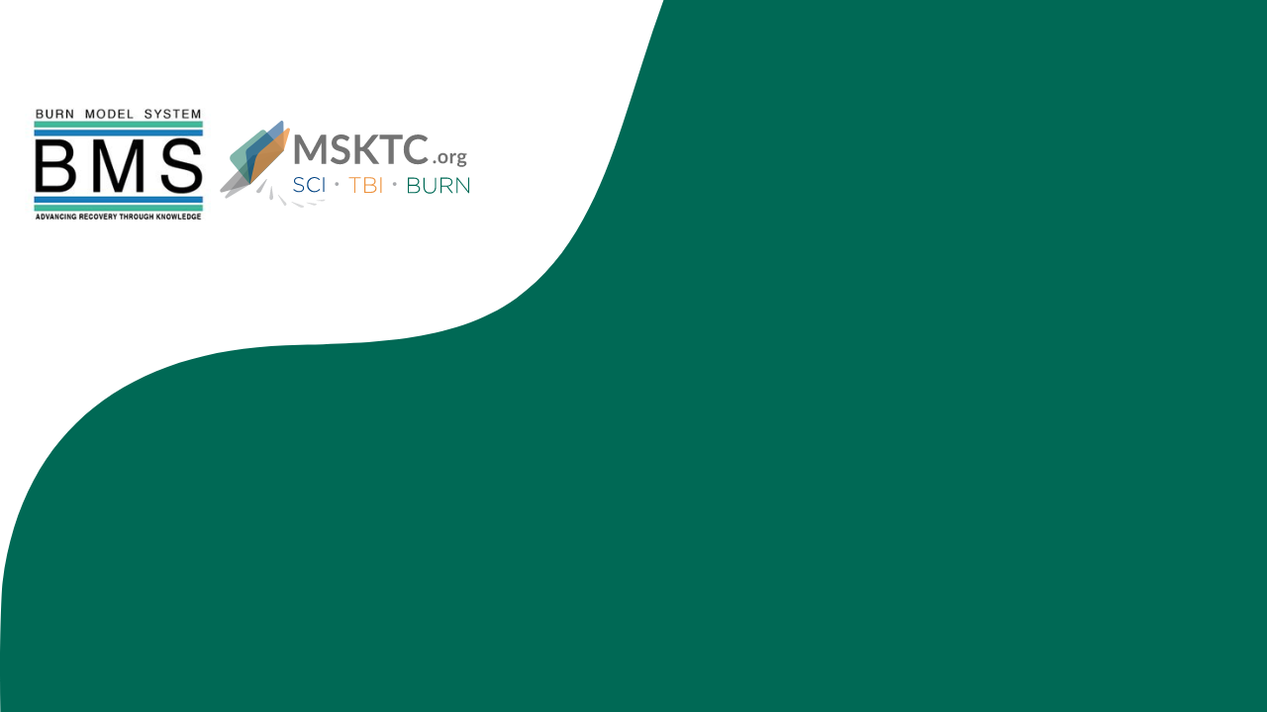

MSKTC Resource Slides for Conference Presentations
Help promote BMS program, BMS database, and MSKTC resources using the MSKTC resource slides at conferences.  The MSKTC updates the slides when new resources are available. Please make sure to check the website for most updated slides here. | 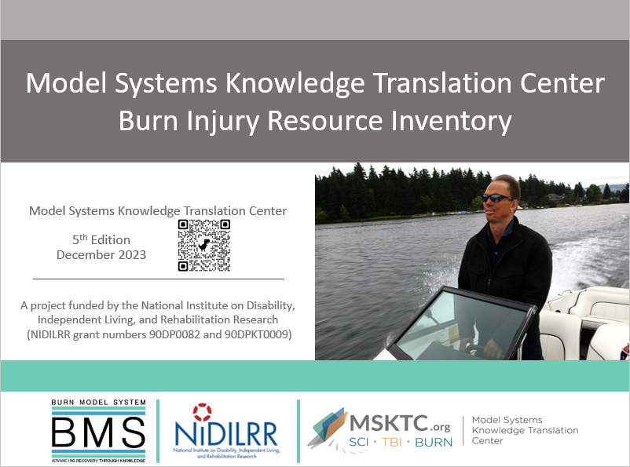

Posters
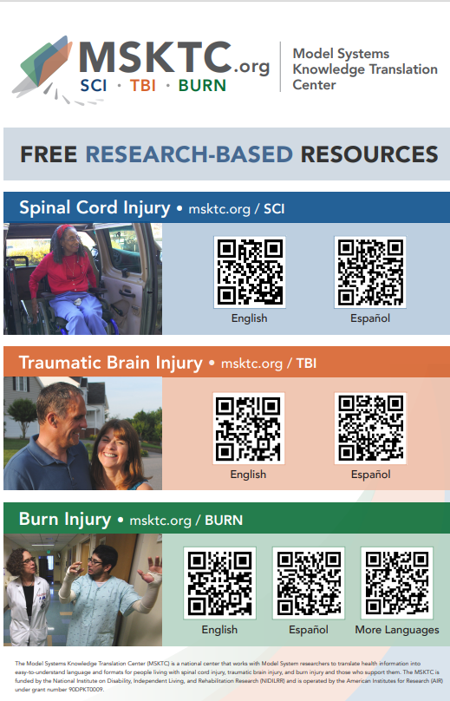 | 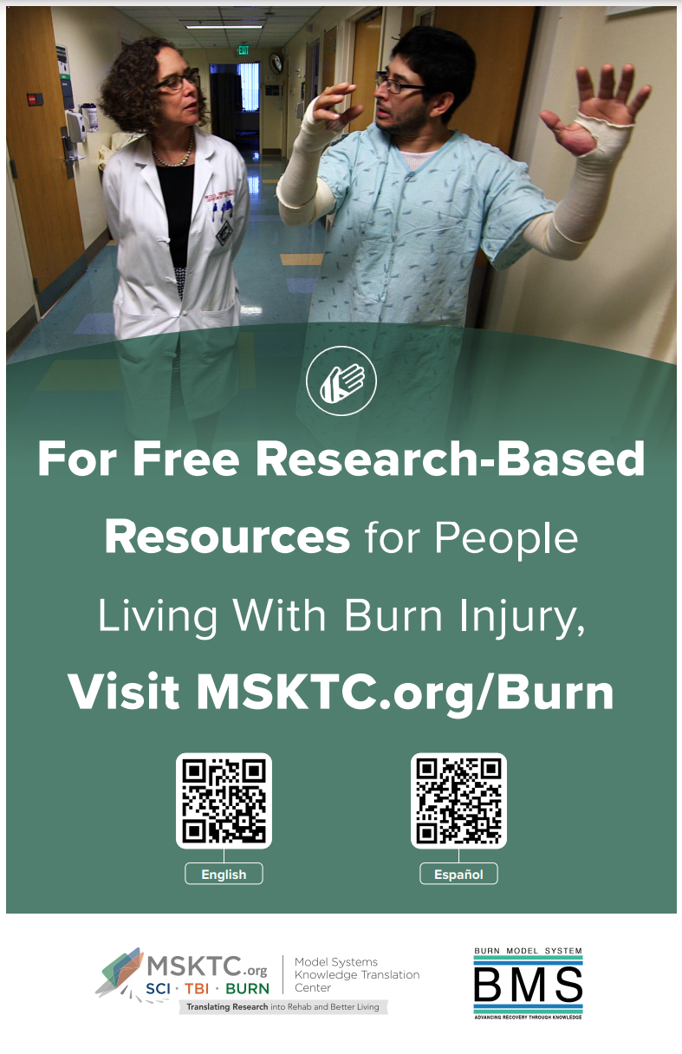
The MSKTC has developed a poster to promote the use of free research-based resources for people living with spinal cord injury (SCI), traumatic brain injury (TBI) and burn injury. The poster size is 11x17 inches. You can print the poster using a regular printer or a professional printer.  Download the poster and view printing instructions: https://msktc.org/node/5361 | The MSKTC has developed a poster to promote the use of our free research-based resources for people living with burn injuries.  The poster size is 11x17 inches with both English and Spanish resource QC codes. You can print the poster using a regular printer or a professional printer.  Download the poster and view printing instructions: https://msktc.org/node/4698.

Sample Newsletter Story

Title: Free, Research-Based, User-friendly Resources for People Living With Burn Injury, Spinal Cord Injury, and Traumatic Brain Injury
The Model Systems Knowledge Translation Center (MSKTC; https://msktc.org/) offers free, research-based, user-friendly information resources to support individuals living with burn injury (https://msktc.org/burn) as well as spinal cord injury (SCI; https://msktc.org/sci) or traumatic brain injury (TBI; https://msktc.org/tbi). MSKTC collaborates with researchers from the Burn Model System centers and from SCI and TBI Model System centers to develop resources that cover a wide variety of topics and are available in various formats, such as factsheets, infocomics, videos, and podcasts and in English, Spanish and more languages. MSKTC resources may be reproduced and distributed freely with appropriate attribution; prior permission must be obtained for inclusion in fee-based materials. Both the MSKTC and Model System centers are funded by the National Institute on Disability, Independent Living, and Rehabilitation Research, Administration for Community Living, U.S. Department of Health and Human Services. For questions about MSKTC resources, please contact msktc@air.org.

Tips for Sharing MSKTC Resources in Your Model Systems Centers
- Include MSKTC resources in patient discharge packages.
- Display MSKTC QR code and print resources in patient waiting rooms.
- Include MSKTC resources in clinician education.
- Use MSKTC resources for patient education.
- Share MSKTC resources with support groups.
- Wear BMS and MSKTC buttons in clinics, at conferences, and at any other events.
- Include MSKTC resources in your presentations using slides with MSKTC burn resource inventory.
- Integrate MSKTC resources in burn camps.
- Use MSKTC resources for social media content.
- Adapt MSKTC resources for newsletters.
- Include MSKTC resources in an electronic medical record system.
- Sign up for the MSKTC newsletter (the newsletter sign-up box is located in the footer section of all pages on https://msktc.org/).
- Become an MSKTC ambassador by applying at https://msktc.org/burn/ambassador-program.
- Link to MSTKC resources on your website: https://msktc.org/share-and-promote.
- Be creative and develop other ways to share MSKTC resources.

Additional Knowledge Translation Resources
MSKTC has developed knowledge translation (KT) tools to help researchers engage with the media and use social media. Please access our KT tools using the links below.
- Engage the Media – MSKTC Online Knowledge Translation Toolkit:
  - Developing Key Messages for Effective Communication
  - Press Release Template and Instructions
  - Responding to Media Requests
  - Working with Your Communications/Public Affairs Office
- Use Social Media – MSKTC Online Knowledge Translation Toolkit:
  - Getting Started with Social Media Advertising: Facebook & Instagram Ads
  - Guide for Developing an MSKTC Social Media Plan
  - How to Use Social Media Advertising for Research
  - MSKTC Social Media Development Workbook
  - Social Media Development Content Calendar
  - Using Social Media to Promote Research
  - Web Clinic: Social Media Analytics

The contents of this resource were developed with funding from the National Institute on Disability, Independent Living, and Rehabilitation Research (NIDILRR grant number 90DPKT0009). NIDILRR is a Center within the Administration for Community Living (ACL), U.S. Department of Health and Human Services (HHS). The contents of this resource do not necessarily represent the policy of NIDILRR, ACL, or HHS, and you should not assume endorsement by the federal government.

