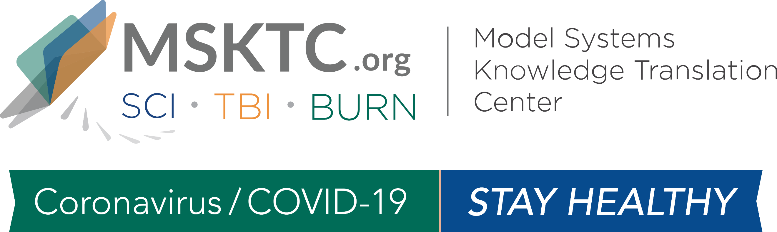

COVID-19 Dissemination Toolkit for
TBI Model System Researchers

Dear TBIMS Researchers,
The Model Systems Knowledge Translation Center (MSKTC) has developed this toolkit to help individuals with TBI to stay healthy during the coronavirus/COVID-19 pandemic. Please use the sample language below to send social media messages and newsletter stories to your network to make others aware of the MSKTC resources available.

Section 1: Sample Social Media Messages
- In these unprecedented times, #MSKTC resources can help people with #TBI to #stayhealthy. https://bit.ly/2XhXESu

- #MSKTC’s free, #researchbased resources can help people with #TBI and their families #stayhealthy during #COVID19. https://bit.ly/2XhXESu

- Drinking after a #TBI injury increases the chances of getting injured again. During #COVID19, #stayhealthy with this #research-based #MSKTC info in English and Spanish: https://bit.ly/39X7fRp

- In these uncertain times, staying active can help alleviate depression in people with a #TBI injury. Learn more with this suite of #MSKTC resources: https://bit.ly/2VgmuQ4 #stayhealthy

- #TBI #patients and their caregivers can help #stayhealthy during #COVID19 by knowing what to do in case of a seizure. Share this free #MSKTC resource with them: https://bit.ly/2JS96MB

- #DYK 30-65% of people with #TBI report dizziness during their recovery? Help them prevent falls and #stayhealthy w/ this #MSKTC info: https://bit.ly/2xiLWMF

- Many people with #TBI have sleep issues, which can exacerbate depression and anxiety. During #COVID19, help support better sleep with this free #MSKTC resource: https://bit.ly/3e7RxGj #stayhealthy

- #TBIs can change the way people express feelings or emotions. Help #patients #stayhealthy with this #MSKTC factsheet in English and Spanish: https://bit.ly/3eioQXo

- #Providers –help people with #TBI and their caregivers understand their injury and help them #stayhealthy during #COVID19 with this #MSKTC fact sheet: https://bit.ly/3c6gyzW

- What’s the difference b/w depression vs. situation sadness in someone with #TBI? These #MSKTC resources can help you understand and #stayhealthy: https://bit.ly/2XoYlt1

Section 2: Sample Newsletter Message

The Model Systems Knowledge Translation Center (MSKTC) is supporting people living with traumatic brain injury (TBI) to help them stay healthy during the coronavirus/COVID-19 pandemic. People living with TBI can continue to improve their health and wellbeing during these unprecedented times using a variety of MSKTC’s free, online resources. For example MSKTC TBI resources ranging from alcohol use to managing depression and emotions to fall prevention, please visit https://msktc.org/tbi. In addition to TBI resources, MSKTC has resources on spinal cord injury (https://msktc.org/sci) and burn injury (https://msktc.org/burn). The MSKTC is funded by the National Institute on Disability, Independent Living, and Rehabilitation Research, Administration for Community Living, U.S. Department of Health and Human Services.

