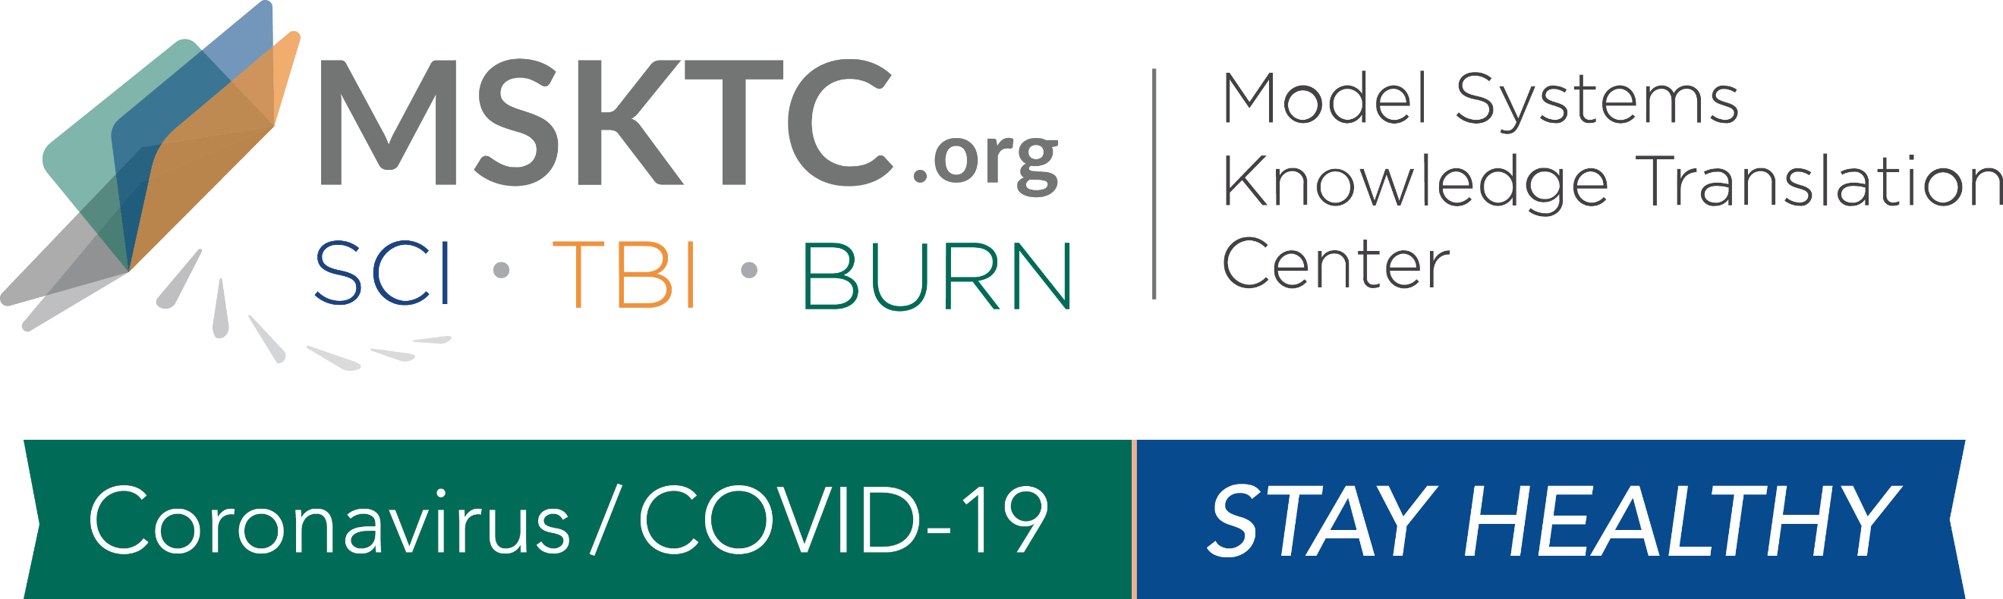

COVID-19 Dissemination Toolkit for
SCI Model System Researchers

Dear SCI Model System Researchers,
The Model Systems Knowledge Translation Center (MSKTC) has developed this toolkit to help individuals with SCI to stay healthy during the coronavirus/COVID-19 pandemic. Please use the sample language below to send social media messages and newsletter stories to your network to make others aware of the MSKTC resources available.

Section 1: Social Media Messages
- In these unprecedented times, #MSKTC resources can help people with #SCI to #stayhealthy. https://bit.ly/2y1N4Vb

- #MSKTC’s free, #researchbased resources can help people with #SCI and their families #stayhealthy during #COVID19. https://bit.ly/2y1N4Vb

- Bowel function can be a challenge for people with #SCI. Help them #stayhealthy right now with this #MSTKC suite of multi-media and print resources: https://bit.ly/2JT2Cx6

- #Providers – this #MSKTC factsheet in English and Spanish has a checklist to help people #SCI maintain good respiratory health: https://bit.ly/3c66Q0g #stayhealthy

- Help people with #SCI #stayhealthy during #COVID19. Check out this #MSKTC bladder management resource in English and Spanish: https://bit.ly/39Z4Rtc

- Exercise can be therapeutic for people with #SCI, especially in uncertain times like these. #MSKTC has a suite of SCI exercise and fitness resources: https://bit.ly/34nDUyh #stayhealthy

- Depression is common, but especially in people with #SCI. This #MSKTC factsheet in English and Spanish has info on steps you can take to #stayhealthy. https://bit.ly/39PHfHy

- #Providers – help people with #SCI and their caregivers know the causes of and steps they can take to prevent AD and #stayhealthy during #COVID19 with this #MSKTC fact sheet: https://bit.ly/2VmgQvU

- #DYK #MSKTC has numerous factsheets in English and Spanish on skin care and pressure sores? Please share these with people with #SCI so they can #stayhealthy during #COVID19: https://bit.ly/39VW3UX

- Share these #researchbased #MSKTC safe transfer resources with your #SCI patients to help them #stayhealthy and out of the hospital: https://bit.ly/3c6L6BC

Section 2: Sample Newsletter Message

The Model Systems Knowledge Translation Center (MSKTC) is supporting people living with spinal cord injury (SCI) to help them stay healthy during the coronavirus/COVID-19 pandemic. People living with SCI can continue to improve their health and wellbeing during these unprecedented times using a variety of MSKTC’s free, online resources. For example MSKTC SCI resources range from managing bladder function, to ensuring respiratory health, to the importance of exercise and fitness, please visit https://msktc.org/sci. In addition to SCI resources, MSKTC has resources on traumatic brain injury (https://msktc.org/tbi) and burn injury (https://msktc.org/burn). The MSKTC is funded by the National Institute on Disability, Independent Living, and Rehabilitation Research, Administration for Community Living, U.S. Department of Health and Human Services.

