Communication Toolkit for MSKTC SCI Ambassadors

This Communication Toolkit supports ambassadors in the sharing of free, research-based spinal cord injury (SCI) resources from the Model Systems Knowledge Translation Center (MSKTC). It includes MSKTC social media platform info, sample social media posts and graphics, an email message, email signature badge, a virtual meeting background, QR codes, SCI and MSKTC resource badges, a SCI and MSKTC button, a SCI and MSKTC resource magnet, a SCI and MSKTC sticker, a MSKTC resource brochure, a wall and tabletop resource poster, a newsletter story that ambassadors can modify and share with people who may benefit from MSKTC resources, and tips for sharing MSKTC resources.
Please contact the MSKTC at MSKTC@air.org if you have any questions or need resources to support your work as an ambassador.

With these tools, we hope to empower you to spread the word of MSKTC resources and make a significant impact on people with spinal cord injuries. Together, we can help people find the information they need to live well, one share, post, and email at a time. Thank you for your dedication and support!

MSKTC Social Media Platforms
MSKTC is active on several social media platforms, including Facebook, Instagram, X (formerly Twitter), and LinkedIn. Be sure to follow us, interact with our posts, and tag us when you share MSKTC resources.
 |  |  | 
- Spinal Cord Injury Model Systems | - @msktc_insights | - Spinal Cord Injury Model Systems | - Model Systems Knowledge Translation Center

Social Media
As an ambassador, you can help to promote MSKTC’s SCI resources on social media by interacting with our existing posts and by clicking reactions, commenting, or sharing any of our published social media posts. We also encourage you to activate your own social media channels by using the sample graphics and message below. Please feel free to personalize and modify to meet the needs of your networks.
Be Recognized: Add Your Ambassador Role to Your LinkedIn
Add your experience as a MSKTC Ambassador to your LinkedIn profile! At the top of your profile, click ‘add profile section’ then expand the ‘additional’ tab to find the ‘add volunteer experience’ option if you don’t already have volunteer experience added to your profile.
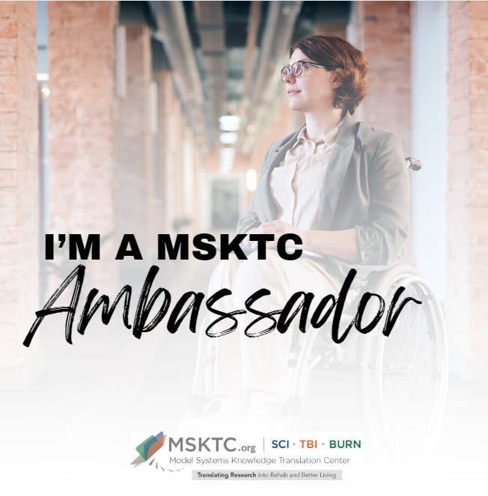 |  | I am a #MSKTC ambassador supporting people with spinal cord injuries.  #MSKTC has provided me with a wide range of #researchbased resources that have helped [my/family member’s] recovery process.  #MSKTC can benefit you. Learn more here https://msktc.org/sci
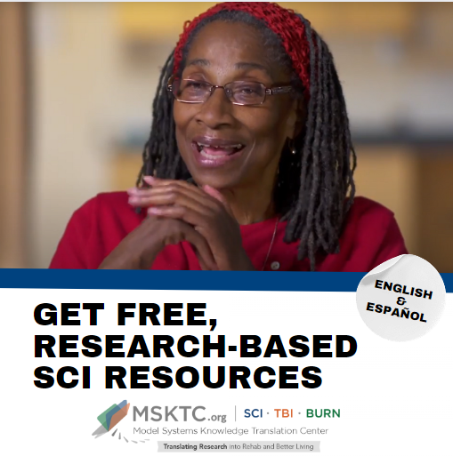 |  | [TAG MSKTC] has a wide range of #researchbased resources to help those #livingwithSCI. To learn more about ways to manage bowel, bladder, pressure injuries, etc., visit https://msktc.org/sci
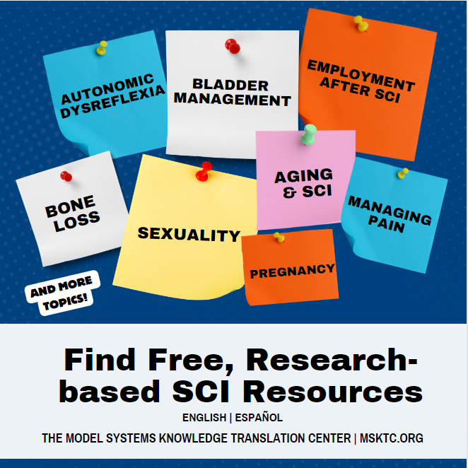 |  | Do you have questions about [insert topic from MSKTC website] after #SCI?  #MSKTC has a wide range of #researchbased resources to help those with #spinalcordinjury. Check out [name of the resource]: [insert link to resource on MSKTC.org]
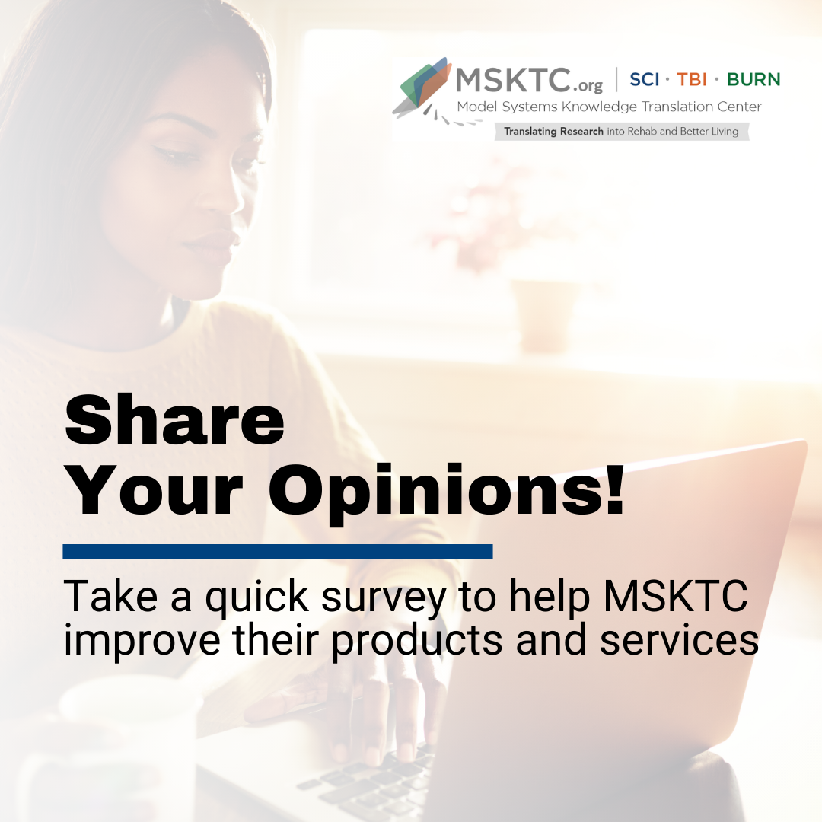 |  | If you're living with a spinal cord injury (SCI), a caregiver, clinician, or policymaker, please provide your input! Take part in MSKTC’s survey to let them know what info you need to better serve the #SCI community. #MSKTC https://bit.ly/MSKTCUserSurvey
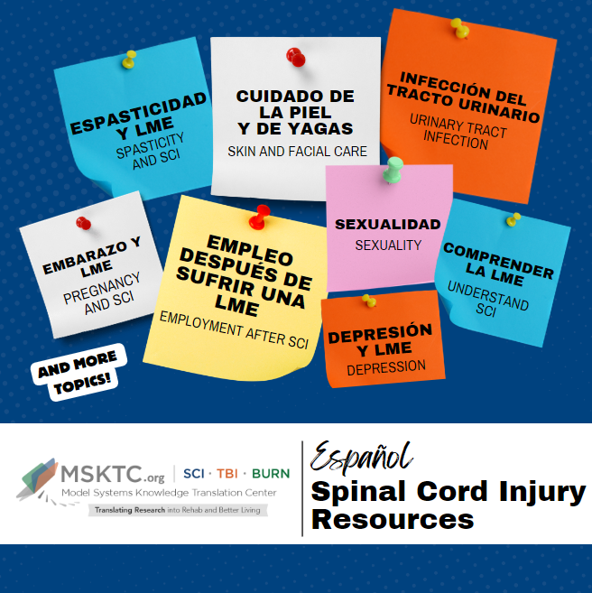 |  | The Model Systems Knowledge Translation Center offers resources in Spanish to help you support people with spinal cord injuries and their families. #SCI #MSKTC https://msktc.org/sci/recursos-en-espanol
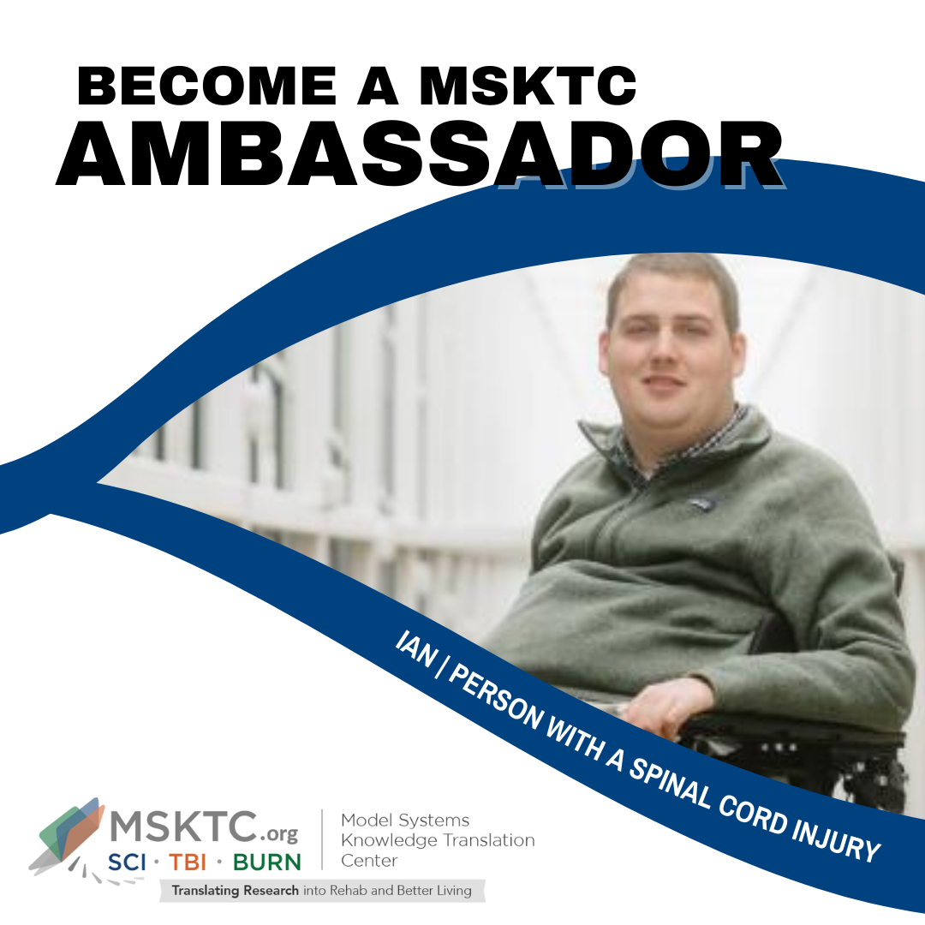 |  | As a #MSKTC ambassador, I’d like to invite you to become a champion for the spinal cord injury (SCI) community!  #MSKTC invites individuals living with spinal cord injuries, caregivers, clinicians, and policymakers to become ambassadors for change! https://msktc.org/sci/ambassador-program

Sample Email Blast Template
Dear [NAME],
I recently became an ambassador for the federally funded Model Systems Knowledge Translation Center (MSKTC: http://msktc.org/), which offers free, research-based resources for people living with SCI and their families. MSKTC covers over 20 rehabilitation topics (https://msktc.org/sci). Tailored to the diverse learning styles of individuals with SCI and their families, these resources are in multiple formats (print, audio, and video) including factsheets, infocomics (information presented in a comic-styled storyboard format), infographics, videos, podcasts, narrated slideshows, and quick reviews. MSKTC factsheets and infocomics are available in both English and Spanish. MSKTC is funded by the National Institute on Disability, Independent Living, Administration for Community Living, U.S. Department of Health and Human Services. I am including links to these resources below. Please feel free to share with others who may benefit from them.
MSKTC SCI Resources
- The MSKTC SCI resources cover a wide range of topics. Currently, the MSKTC provides resources close to 30 rehabilitation topics to support individuals with SCI and their families such as adaptive sports and recreation, adjusting to life, aging & SCI, autonomic dysreflexia, bladder management, bone loss after SCI, depression & SCI, driving, employment after SCI, exoskeletal assisted walking, exercise & fitness after SCI, gait training & SCI, managing bowel function, managing pain after SCI, opioids and SCI, personal care attendants, pregnancy and SCI, PTSD, respiratory health, safe transfer techniques, sexuality, skin care & pressure sores, spasticity & SCI, surgical & reconstructive treatment, understanding SCI, urinary tract infection, and wheelchair information.
- SCI resources in Spanish
  - https://msktc.org/sci/recursos-en-espanol
- Factsheets on topics ranging from acute inpatient rehabilitation to returning to school in both English and Spanish
  - https://msktc.org/sci/factsheets
- Videos
  - https://msktc.org/sci/videos
- Infocomics
  - https://msktc.org/sci/infocomics
- Infographics
  - https://msktc.org/sci/infographics
- Slideshows
  - https://msktc.org/sci/slideshows
- Hot Topic Modules
  - https://msktc.org/sci/Hot-Topics
- Plain Language Summaries of Research
  - https://msktc.org/sci/quick-reviews
- SCI Model System Directory: https://msktc.org/sci/model-system-centers
- SCI Model System Publications Database: https://msktc.org/sci/publications
- Model System and Model System Database
  - https://msktc.org/about-model-systems/sci
- Knowledge Translation Toolkit
  - https://msktc.org/knowledge-translation
- Learn about the MSKTC SCI ambassador program
  - https://msktc.org/sci/ambassador-program
- Share and promote MSKTC.org resources using website's HTML codes
  - https://msktc.org/share-and-promote
- Learn about MSKTC awards
  - https://msktc.org/share-and-promote

*Please note that the MSKTC resources may be reproduced and distributed freely with appropriate attribution. Prior permission must be obtained for inclusion in fee-based materials.

Please take a quick survey and share thoughts to help the MSKTC better serve you: https://websurveyor2.airws.org/se/2511374533213674.
Sincerely,
[SIGNER’S NAME]

Email Signature Badge
Stand out in every inbox with our exclusive email signature badge! Showcase your commitment to raising awareness of TBI with every message you send. Download the image below to your computer and upload the image to your email signature in your preferred email platform.
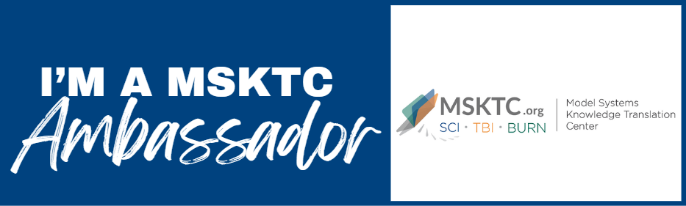

Virtual Meeting Background

Enhance your virtual meetings with our exclusive MSKTC Ambassador virtual meeting background. Download the graphic below to your computer and use when using your preferred virtual meeting platform. | 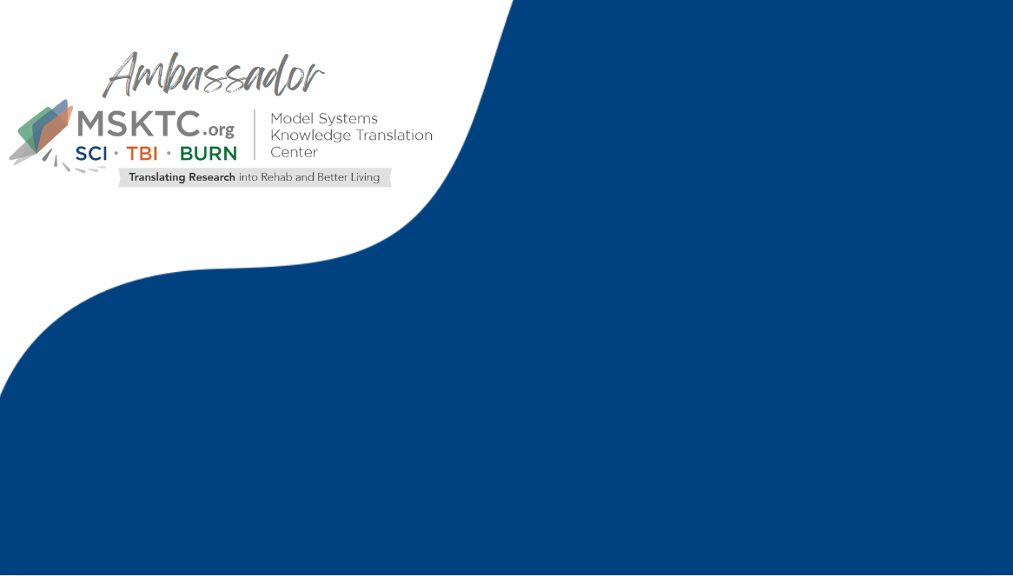

MSTKC SCI Resource QR Codes
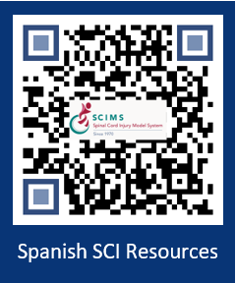
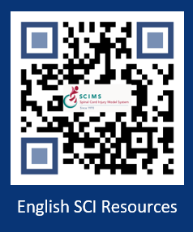

SCIMS/MSKTC Resource Badge
Use this resource badge to easily promote SCI resources while in clinics and/or at events. To request badges, please contact MSKTC@air.org. | 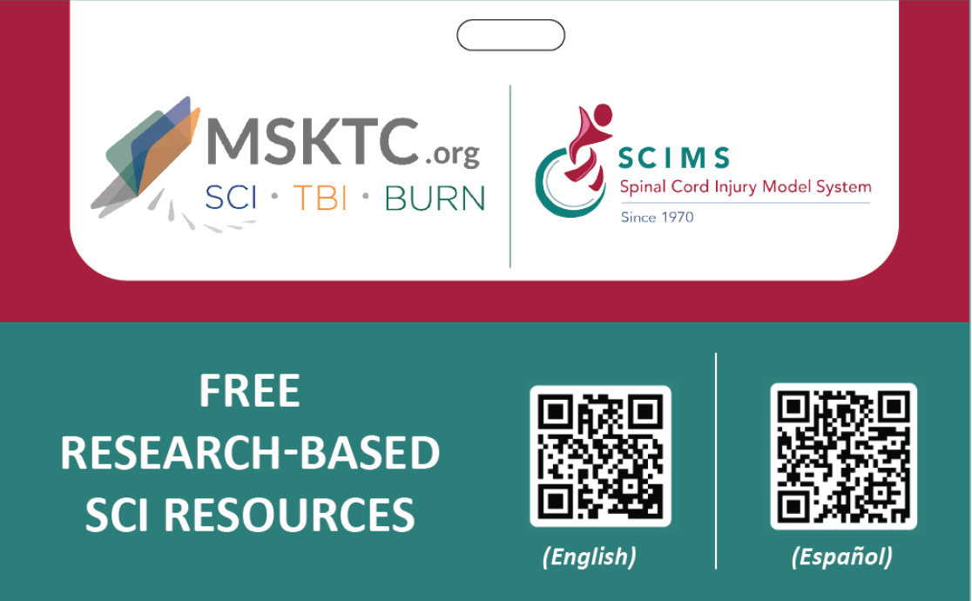


SCI, TBI, and Burn Resource Badge
Use this resource badge to easily promote spinal cord injury (SCI), traumatic brain injury (TBI), and burn injury resources while in clinics or at events. To request badges, please email MSKTC@air.org. | 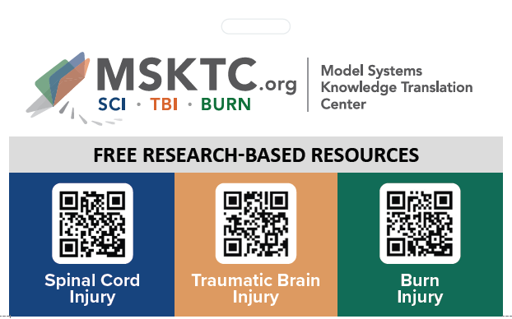

SCIMS and MSKTC Resource Button

You can wear the SCIMS and MSKTC buttons in the clinic, at conferences, and at other events to share MSKTC SCI resources. To request buttons, please email MSKTC@air.org. | 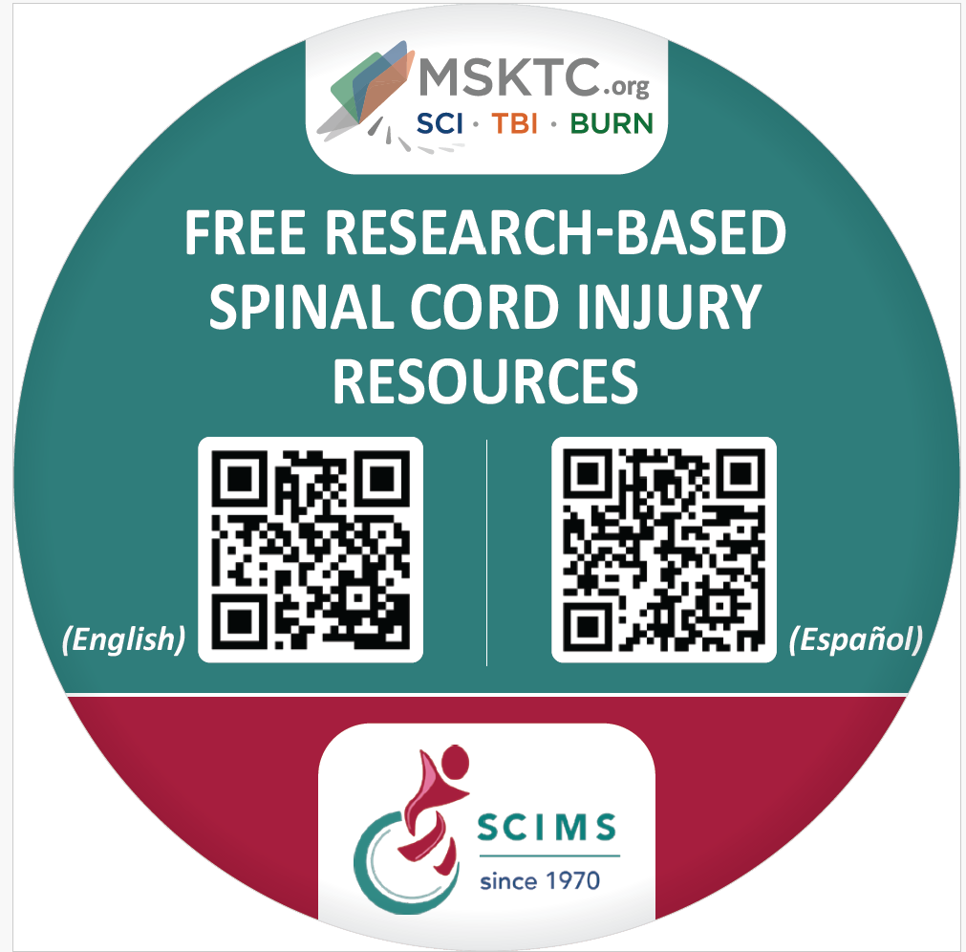

SCIMS and MSTKC Resource Magnet
You can distribute the SCIMS and MSKTC magnets to patients, families, and other stakeholders to share the MSKTC SCI resources. To request magnets, please email MSKTC@air.org. | 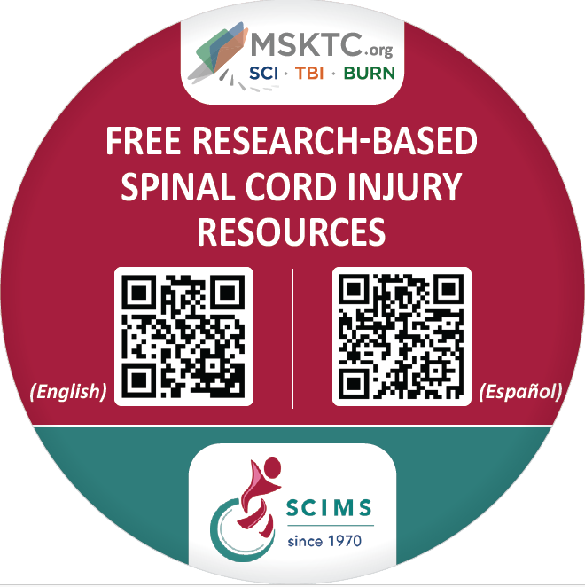

SCIMS and MSKTC Resource Sticker

Use the SCIMS and MSKTC sticker on your laptop, mugs, car bumper or other places to share MSKTC SCI resources. To request stickers, please email MSKTC@air.org.

MSKTC Resource Brochure in English and Spanish
You can print and distribute the brochure to share the free research-based MSKTC resources to help people living with spinal cord injury, traumatic brain injury, and burn injury. The brochure describes the types of resources MSKTC offers and opportunities to engage with us. The brochure is in English and Spanish. The size of the brochure is 8.5x11 inches. Download at https://msktc.org/node/5394. | 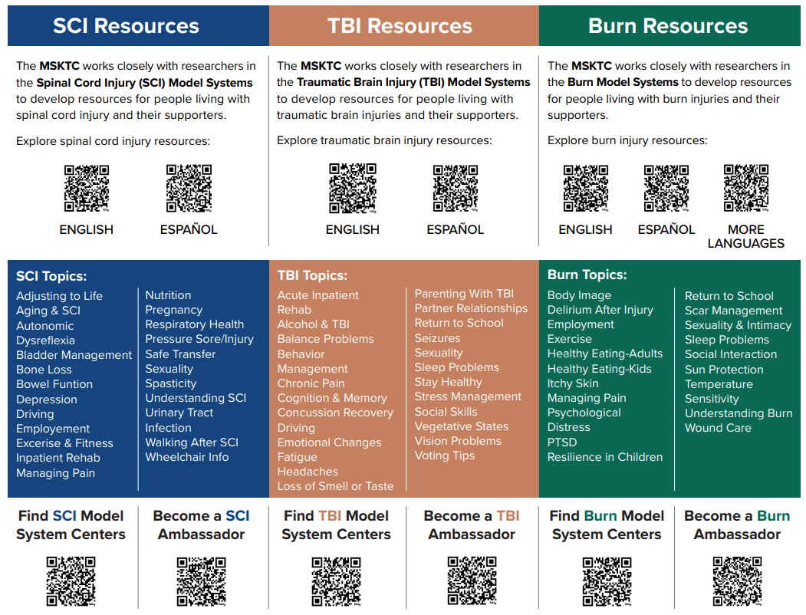  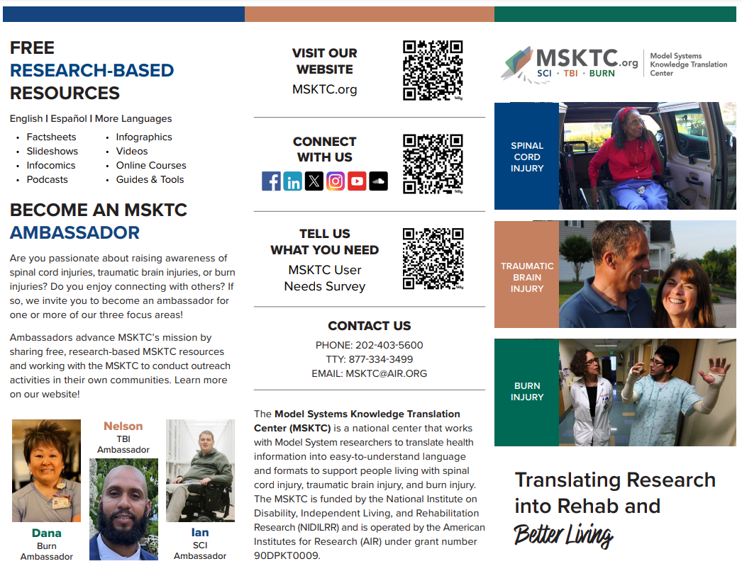

Wall and Desktop Resource Posters
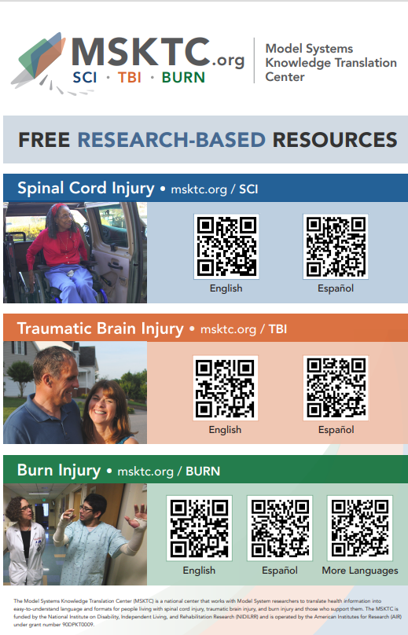 | 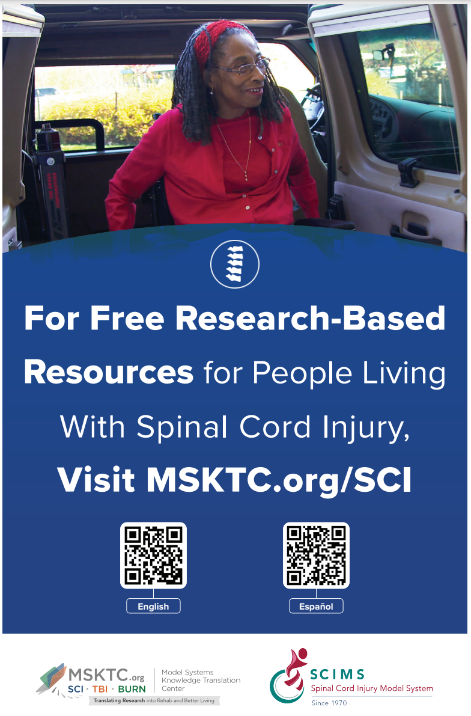
The MSKTC has developed a poster to promote the use of free research-based resources for people living with spinal cord injury (SCI), traumatic brain injury (TBI) and burn injury. The wall poster size is 11x17 inches and the tabletop poster size is 8.5x11 inches. You can print the post using a regular printer or a professional printer.  To download the poster and view printing instructions, please visit: https://msktc.org/node/5361 | The MSKTC has developed a poster to promote the use of our free research-based resources for people living with SCI. The wall poster size is 11x17 inches and the tabletop poster size is 8.5x11 inches with English and Spanish resource QR codes. You can print the poster using a regular printer or a professional printer.  To download the poster and view printing instructions, please visit: https://msktc.org/node/4697.

Sample Newsletter Story

Title: Free, Research-based Resources for People Living With Spinal Cord Injury, Traumatic Brain Injury, and Burn Injury

The Model Systems Knowledge Translation Center (MSKTC; https://msktc.org/) offers free research-based user-friendly information resources to support individuals living with spinal cord injury (SCI; https://msktc.org/sci), traumatic brain injury (TBI; https://msktc.org/tbi), and burn injury (https://msktc.org/burn). MSKTC collaborates with researchers from the SCI, TBI and Burn Model System Programs to develop resources that cover a wide range of topics and are available in various formats such as factsheets (in both English and Spanish), infocomics, videos, and podcasts. MSKTC resources may be reproduced and distributed freely with appropriate attribution; prior permission must be obtained for inclusion in fee-based materials. Both the MSKTC and Model System Programs are funded by the National Institute on Disability, Independent Living, and Rehabilitation Research, Administration for Community Living, US Department of Health and Human Services. For questions about MSKTC resources, please contact msktc@air.org.

Tips for Sharing MSKTC Resources
All Ambassadors
- Share MSKTC resources with support groups
- Use MSKTC resources for social media content
- Adapt MSKTC resources for newsletters
- Share MSKTC resources with your healthcare providers
- Drop off MSTKC resources at your local clinics and/or hospitals
- Share MSKTC resources at resources fairs or conferences
- Wear TBIMS and MSKTC buttons at conferences, and at any other events
- Include MSKTC TBI resources in your presentations using slides with MSKTC SCI resources
- Integrate MSKTC resources into camps
- Sign up for the MSKTC newsletter (the newsletter sign-up box is located in the footer section of all pages on https://msktc.org/)
- Encourage others to become MSKTC ambassadors
- Link to MSTKC resources on your website if applicable: https://msktc.org/share-and-promote
- Be creative and develop other ways to share MSKTC resources
Clinician Ambassadors
- Link MSKTC website on your organization’s website as a resource for patients
- Wear MSTKC resource badges at clinics
- Share MSKTC resources with your clinician colleagues
- Include MSKTC resources in patient discharge packages
- Include MSKTC resources in an electronic medical record system
- Display MSKTC QR code and print resources in patient waiting rooms
  - Play MSKTC videos in patient waiting rooms
- Include MSKTC resources in clinician education
- Use MSKTC resources for patient education
- Display MSKTC resource posters in clinics
- Be creative and develop other ways to share MSKTC resources in clinical settings.

The contents of toolkit were developed under grant number 90DPKT0009 from the National Institute on Disability, Independent Living, and Rehabilitation Research (NIDILRR). NIDILRR is a Center within the Administration for Community Living (ACL), Department of Health and Human Services (HHS). The contents of this toolkit do not necessarily represent the policy of NIDILRR, ACL, HHS, and you should not assume endorsement by the federal government.

