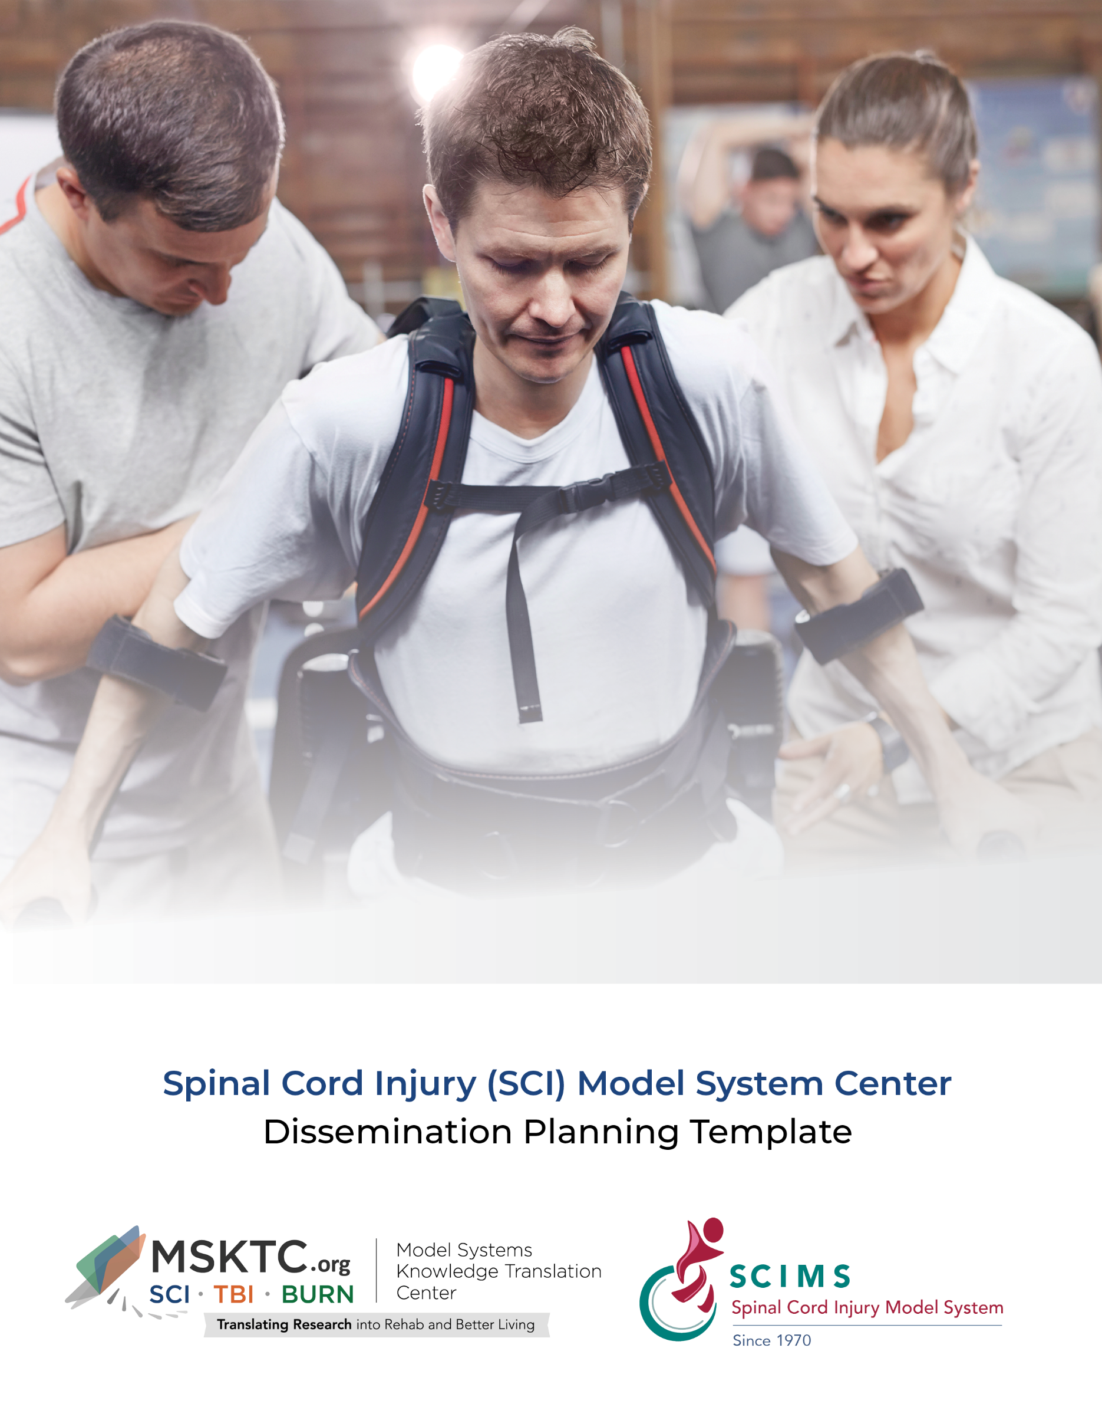

Background
This section should include information that will be helpful to the individual who will execute the dissemination plan. This might be a knowledge translation specialist, researcher, research assistant, an organization’s communications expert, or another colleague. This information is especially important for colleagues who are new to Model Systems research, as it will increase their general understanding of your Model System and your collaborating partners.
The [insert name of Model System] is one of 18 SCI Model System Centers funded by the National Institute on Disability, Independent Living, and Rehabilitation Research (NIDILRR). Each Center provides the highest level of comprehensive and multidisciplinary care from point of injury through rehabilitation and full community re-entry. In addition to these 18 Centers, the Spinal Cord Injury Model Systems Data Center directs the collection, management, and analysis of a longitudinal national SCI database.
[Insert a paragraph about your Model System, including the name of principal investigator(s), facility in which Model System operates, collaborating organizations, research projects funded by the SCI Model Systems program, etc.]

Dissemination Objectives
Revisit your proposal to identify your Center’s dissemination objectives and insert them in this section. If you need to rethink your objectives, consider the importance of your dissemination activities and what you wish to accomplish. Write down one to three objectives that reflect why you want to disseminate resources and information about events. Consider the following questions as you develop dissemination objectives, such as:
• What do we want to accomplish by disseminating products or increasing awareness?
• What action do we want the target audiences to take when they receive resources or information?
The dissemination objectives of the [Insert name of Model System] are to:
- [Example 1: Provide ongoing access to resources for people with SCI, their supporters, and their service providers.]
- [Example 2: Ensure that resources developed and co-developed by our Center benefit people with SCI, their supporters, and their health care providers.]

Target Audiences
Identify the groups of audiences or stakeholders that will benefit from the work of your Model System. Consider the categories below to create your plan’s target audiences. Include as many as appropriate and add to or delete them as needed.
People Living with SCI and Their Supporters
- Individuals with SCI who are newly injured and receiving inpatient care
- Individuals with SCI who receive outpatient care
- Individuals with SCI who do not receive services through your institution
- Family and friends of people with SCI
Health Care and Allied Health Service Professionals
- SCI specialists in need of the most advanced research to inform practice
- General health care practitioners who provide care for individuals with SCI
- Physical and occupational therapists
- Home health care assistants

Resources and Information to Disseminate
Identify resources developed or co-developed by your Model System Center, and those offered through the MSKTC that you will disseminate. Confirm that products developed through your Model System Center are accessible to people with disabilities. Also identify upcoming programs/events that you want to promote. Use the list below to get started (keep all that apply, delete those that do not, and add resources and information about events).
Resources
- Factsheets
- Infocomics
- Infographics
- Slideshows
- Videos
- Online course
- Hot topic modules
- Patient tip sheets
- Questions to ask your health care provider
- Research summaries
- Peer-reviewed journal article
- Other:
Information About the Following Programs and Events
- Peer support groups
- Educational seminars
- Webinars
- Other:

Dissemination Tactics
Once you have identified the resources and programs to disseminate or promote, you will want to determine the most efficient and effective paths or channels to disseminate or promote them. Consider disseminating your materials through several channels that will reach your audience multiple times and in multiple places, such as in their homes; at their health care provider’s office; in a rehabilitation clinic or center; or on their phones, computers, or online. There is no specific number of tactics you must employ. Pick the tactics based on your resources to actually implement them. If you have identified several resources and services to be disseminated, you may need to identify a set of channels for each resource and program.
[Example tactics:
- Make printed copies of the product available at check-in windows or as part of patient and family education materials.
- Show videos on waiting room TV or digital screens.
- Display posters or flyers on waiting room bulletin boards (if available).
- Supply printed materials to physical and occupational therapists to distribute during therapy sessions.
- Distribute printed materials at support group sessions, and during patient and family education programs, provider medical education grand rounds, webinars, lunch-and-learns, or trainings.]
Dissemination Partners
Consider engaging other organizations to help disseminate products so you can broaden your reach. Dissemination activities may be similar to those of the Model System Center. Discuss with potential partners what they are willing to do to help share information about your resources or events. Keep in mind, however, that some organizations will expect you to reciprocate and help disseminate their products. Therefore, it is essential to understand restrictions associated with promoting the work of third parties before you enter into an agreement. In this sub-section, list organizations that you may want to engage as dissemination partners (see Appendix A for a list of potential dissemination partners).

Utilization
Dissemination tactics describe how your Center actively shares information with target audiences, whereas utilization reflects how your audiences use information. Modify the list below to identify steps that will help your Center understand how your audience uses resources that you disseminate.
To understand audience engagement with resources disseminated by the Center, project staff will:
- Track the number of social media followers and their reactions to content each month.
- Monitor website analytics, including views on products posted.
- Issue brief surveys about products and events.
- Capture feedback from users at conference presentations and exhibits.

Planning Chart
Populate the chart below to plan and track your approach to disseminating each product.
Product/Event | Audience | Tactics | Utilization | Timeline
blank | blank | blank | blank | blank
blank | blank | blank | blank | blank
blank | blank | blank | blank | blank
blank | blank | blank | blank | blank

Appendix A: Potential Dissemination Partners
Organization | Website | Type
American Association of People with Disabilities | http://www.aapd.com/ | Advocacy
American Spinal Injury Association | http://www.asia-spinalinjury.org/ | Research/professional organization
Academy of Spinal Cord Injury Professionals | http://www.academyscipro.org/ | Professional organization
Arizona Spinal Cord Injury Association | http://www.azspinal.org | Advocacy/resources
BACKBONES | http://backbonesonline.com/ | Promotes community engagement
Christopher & Dana Reeve Foundation | http://www.christopherreeve.org | Foundation/resources
Friends for Michael, Inc. | http://www.friendsformichael.org/ | Foundation
SCIboston | http://www.sciboston.com/ | Advocacy/resources
Kentucky Spinal Cord Injury Research Center | http://louisville.edu/kscirc/ | Research
Michigan Spinal Cord Injury Association | http://www.mispinalcord.org/ | Advocacy
Mike Utley Foundation | http://www.mikeutley.org/ | Foundation
National Rehabilitation Information Center (NARIC) News and Notes | http://www.naric.com/?q=en/news-and-notes | NIDILRR-funded Center
National Council on Independent Living | http://www.ncil.org/ | Advocacy
National Spinal Cord Injury Association–Southeastern Wisconsin Chapter | http://www.spinalcordwi.org/ | Support/advice/advocacy
Spinal Cord Injury Association of Connecticut | http://www.sciact.org/ | Advocacy
North Carolina Spinal Cord Injury Association | http://www.ncscia.org/ | Advocacy/resources
Paralyzed Veterans of America | http://www.pva.org/ | Advocacy/support/ resources
SCI Guide | http://www.bu.edu/sciguide/index.html | Foundation
South Carolina Spinal Cord Injury Association (Chapter of USA) | http://www.scspinalcord.org/ | Advocacy/resources/support
United Spinal Association Illinois Chapter | http://www.sci-illinois.org/ | Resources/support
Spinal Cord Injury Support Group | http://www.scisg.org/ | Support/advocacy/ information
Spinalpedia | https://spinalpedia.com/ | Community engagement
Travis Roy Foundation | http://www.travisroyfoundation.org | Foundation
Unite2FightParalysis | http://www.u2fp.org/ | Advocacy
United Spinal Association | http://www.unitedspinal.org/ | Advocacy

The contents of this tool were developed under National Institute on Disability, Independent Living, and Rehabilitation Research (NIDILRR), grant number 90DP0082 and was updated under NIDILRR grant (grant number: 90DPKT0009). NIDILRR is a Center within the Administration for Community Living (ACL), U.S. Department of Health and Human Services (HHS). However, contents do not necessarily represent the policy of the U.S. Department of Education, and you should not assume endorsement by the Federal Government.
Copyright © 2025 Model Systems Knowledge Translation Center (MSKTC). May be reproduced and distributed freely with appropriate attribution. Prior permission must be obtained for inclusion in fee-based materials.

