Social Media Editorial Calendar 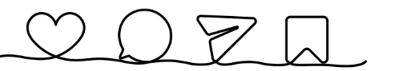
Month/year: __________________________________
Day/time | Goal/call to action | Message/caption | Media (image, video, gif, etc.) | Link | Channel
Day of the week, date, and time
Ex. Monday, December 2 at 11 a.m.
The contents of this tool were originally developed in 2015 under a grant from the National Institute on Disability and Rehabilitation Research (NIDRR), Department of Education (ED grant number H133A110004). It was reviewed and updated in 2025 under a grant from the National Institute on Disability, Independent Living, and Rehabilitation Research (NIDILRR; grant number 90DPKT0009). NIDILRR is a Center within the Administration for Community Living (ACL), U.S. Department of Health and Human Services (HHS).
The contents of this tool do not necessarily represent the policy of NIDILRR, ED, NIDILRR, ACL, or HHS, and you should not assume endorsement by the federal government.
Recommended citation: Model Systems Knowledge Translation Center. (2025). Social media editorial calendar.
https://msktc.org/knowledge-translation/use-social-media/social-media-development-content-calendar
Copyright © 2025 Model Systems Knowledge Translation Center (MSKTC). May be reproduced and distributed freely with appropriate attribution.
Prior permission must be obtained for inclusion in fee-based materials.

