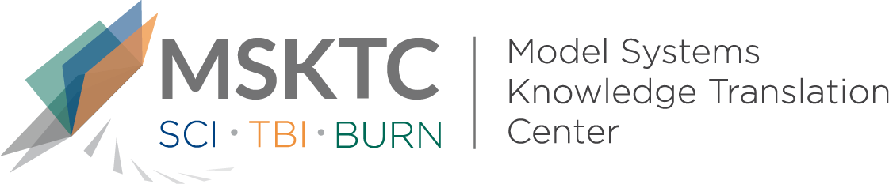

` Quick Review of
Model System Research

Preliminary Exploration of Long-Term Patient Outcomes After Tracheostomy in Burns: A Burn Model System Study

What is the study about?
The study looked at burn patients who had a tracheostomy and those who did not to see if it affects their quality of life. A tracheostomy is a procedure where doctors make a small hole in the neck to help someone breathe when they cannot do it normally due to an injury or illness.

What did the study find?
The study found that burn patients with a tracheostomy recover just as well physically and mentally, and go back to work, just like those who do not have one. But more research with more people is needed to fully understand how tracheostomy affects long-term quality of life.

Who participated in the study?
The study included 714 burn patients—39 had a tracheostomy, and 675 did not. Both groups were similar in age and other characteristics.

How was the study conducted?
Researchers used data from the Burn Model Systems Database from 2013 to 2022. They compared the medical and personal information of patients with and without tracheostomies.

How can people use the results?
Burn patients and their families can use this study to help them decide if a tracheostomy is right for them and how it might affect their long-term quality of life.

Reference

Galicia, K. E., Mehta, A., Kowalske, K. J., Gibran, N. S., Stewart, B. T., McMullen, K., Wolf, S. E., Ryan, C. M., Kubasiak, J., & Schneider, J. C. (2023). Preliminary exploration of long-term patient outcomes after tracheostomy in Burns: A burn model system study. Journal of Surgical Research, 291, 221–230. https://doi.org/10.1016/j.jss.2023.06.005
Disclaimer
The contents of this quick review were developed under a grant from the National Institute on Disability, Independent Living, and Rehabilitation Research (NIDILRR grant number 90DPKT0009). NIDILRR is a Center within the Administration for Community Living (ACL), Department of Health and Human Services (HHS). The contents of this quick review do not necessarily represent the policy of NIDILRR, ACL, HHS, and you should not assume endorsement by the Federal Government.

