Communication Toolkit for Ambassadors
Model Systems Knowledge Translation Center

Introduction
This Communication Toolkit supports ambassadors in the sharing of free, research-based traumatic brain injury (TBI) resources from the Model Systems Knowledge Translation Center (MSKTC; https://msktc.org/). It includes sample social media posts, QR codes, an email message, and a newsletter story that ambassadors can modify and share with people who may benefit from MSKTC resources. MSKTC is funded by the National Institute on Disability, Independent Living, and Rehabilitation Research (NIDILRR grant number 90DPKT0009), Administration for Community Living, U.S. Department of Health and Human Services.

Part 1: Sample Social media messages
We have provided example posts, but you likely know what resources people within your network are looking for. We encourage you to look through the MSKTC’s resources and create other posts highlighting different topics. We have included a basic template that you can use as to get you going.
- Social Media Handles
  - Facebook: @MSKTCTBI
  - Twitter: @TBI_MS

- Sample Social Media Posts
  - The [Facebook: @MSKTCTBI / Twitter: @TBI_MS] has a wide range of #researchbased resources to help those #livingwithTBI. To learn more about the ways #TBI impacts alcohol use, memory loss, depression, etc., visit https://msktc.org/tbi
  - Looking for free, #researchbased tools about #TBI available in Spanish? [Facebook: @MSKTCTBI / Twitter: @TBI_MS] has many resources that explain different aspects of living with #brainInjury and how to #stayhealthy here: https://msktc.org/tbi-resources-spanish
  - #memoryloss is very common in those with moderate to severe #TBI. Check out hot topic module ‘Changes in Memory After TBI’ to learn more https://msktc.org/tbi/Hot-Topics/Memory/TBI_and_Memory

- Social Media Message Templates
  - Do you have questions about [insert topic from MSKTC website] after #TBI? The [Facebook: @MSKTCTBI / Twitter: @TBI_MS] has a wide range of #researchbased resources to help those with #braininjury. Check out [name of the resource]: [insert link to resource]
  - [PERSONALIZE AS NEEDED] As many of you know, I am an advocate for people with #TBI. [Facebook: @MSKTCTBI / Twitter: @TBI_MS] has provided me with a wide range of #researchbased resources that have helped [my/family member’s] recovery process. Learn more here https://msktc.org/tbi
  - [ADJUST ACCORDING TO EVENT SENT TO YOU BY MSKTC] [Last week], [Facebook: @MSKTCTBI / Twitter: @TBI_MS] attended [handle for conference] hosted by [handle of organization]. The event explored [brief description of topics covered]. A recording of the event can be accessed here: [link]

- Useful hashtags
  - #braininjuryawareness
  - #braininjuryawarenessmonth
  - #BIAmonth
  - #TBImonth
  - #morethanmybraininjury
  - #braininjuryresearch
  - #TBI

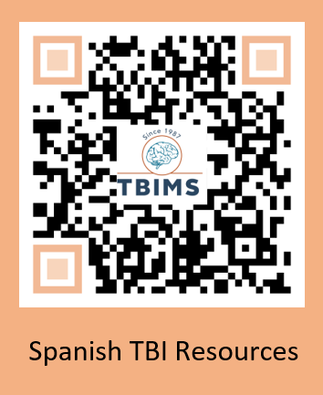
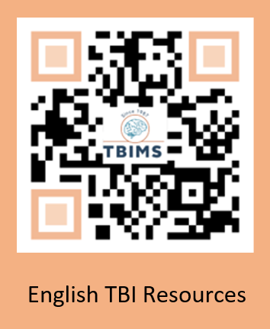

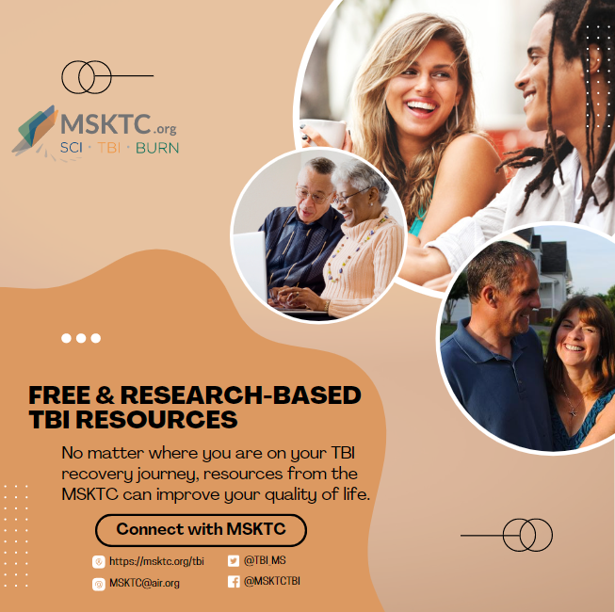

Part 2: Sample email message
Dear [NAME],
[ADJUST WORDING BASED ON RECIPIENT] I recently became an ambassador for the federally funded Model Systems Knowledge Translation Center (MSKTC: http://msktc.org/), which offers free, research-based resources for people living with TBI and their families. MSKTC covers close to 30 rehabilitation topics (http://msktc.org/tbi). Tailored to the diverse learning styles of individuals with TBI and their families, these resources are in multiple formats (video, audio, and print) including factsheets, infocomics (information presented in a comic-styled storyboard format), videos, podcasts, narrated slideshows, and quick reviews. MSKTC factsheets and infocomics are available in both English and Spanish. MSKTC is funded by the National Institute on Disability, Independent Living, Administration for Community Living, U.S. Department of Health and Human Services. I am including links to these resources below. Please feel free to share with others who may benefit from them.
*MSKTC TBI Resources*
- The MSKTC TBI resources cover a wide range of topics. Currently, the MSKTC provides resources on 30 rehabilitation topics to support individuals with TBI and their families such as: understanding a TBI, alcohol use after TBI, memory, couples’ relationship after TBI, acute inpatient rehabilitation, balance problems, behavior changes, chronic pain, cognitive problems, concussion recovery, depression, driving, emotional problems, fatigue, headaches, irritability, anger and aggression, loss of smell or taste, obstructive sleep apnea, parenting with TBI, returning to school, seizures, severe TBI, sexuality, sleep, social skills, spasticity, stress management for TBI caregivers, vegetative and minimally conscious states, vision problems, and voting tips.
- Factsheets on topics ranging from acute inpatient rehabilitation to returning to school in both English and Spanish
  - http://www.msktc.org/tbi/factsheets
- Videos
  - http://www.msktc.org/tbi/videos
- Infocomics
  - https://msktc.org/tbi/infocomics
- Slideshows
  - http://www.msktc.org/tbi/slideshows
- Hot Topic Modules
  - http://www.msktc.org/tbi/Hot-Topics
- Plain Language Summaries of Research
  - http://www.msktc.org/tbi/Quick-Reviews
- Research Resources
  - TBI Systematic Reviews: http://www.msktc.org/tbi/research/systematic-reviews
  - TBI Model System Directory: http://www.msktc.org/tbi/model-system-centers
  - TBI Model System Publications Database: http://www.msktc.org/publications?sys=T
- Model System and Model System Database
  - https://msktc.org/about-model-systems/tbi

*Please note that the MSKTC resources may be reproduced and distributed freely with appropriate attribution. Prior permission must be obtained for inclusion in fee-based materials.

Please take a quick survey and share thoughts to help the MSKTC better serve you: https://websurveyor2.airws.org/se/2511374533213674.
Sincerely,
[SIGNER’S NAME]

Part 3: Sample newsletter story

Title: Free Research-based User-friendly Resources for People Living With Spinal Cord Injury, Traumatic Brain Injury, and Burn Injury

The Model Systems Knowledge Translation Center (MSKTC; https://msktc.org/) offers free research-based user-friendly information resources to support individuals living with spinal cord injury (SCI; https://msktc.org/sci), traumatic brain injury (TBI; https://msktc.org/tbi), and burn injury (https://msktc.org/burn). MSKTC collaborates with researchers from the SCI, TBI and Burn Model System Programs to develop resources that cover a wide range of topics and are available in various formats such as factsheets (in both English and Spanish), infocomics, videos, and podcasts. MSKTC resources may be reproduced and distributed freely with appropriate attribution; prior permission must be obtained for inclusion in fee-based materials. Both the MSKTC and Model System Programs are funded by the National Institute on Disability, Independent Living, and Rehabilitation Research, Administration for Community Living, US Department of Health and Human Services. For questions about MSKTC resources, please contact msktc@air.org.

Disclaimer: The contents of this resource were developed with funding from the National Institute on Disability, Independent Living, and Rehabilitation Research (NIDILRR grant number 90DPKT0). NIDILRR is a Center within the Administration for Community Living (ACL), U.S. Department of Health and Human Services (HHS). The contents of this resource do not necessarily represent the policy of NIDILRR, ACL, or HHS, and you should not assume endorsement by the federal government.

