Communication Toolkit for Ambassadors
Model Systems Knowledge Translation Center

Introduction
This Communication Toolkit supports ambassadors in the sharing of free, research-based burn injury (burn) resources from the Model Systems Knowledge Translation Center (MSKTC; https://msktc.org/). It includes sample social media posts, QR codes, an email message, and a newsletter story that ambassadors can modify and share with people who may benefit from MSKTC resources.

Part 1: Sample Social media messages
We have provided example posts, but you likely know what resources people within your network are looking for. We encourage you to look through the MSKTC’s resources and create other posts highlighting different topics. We have included a basic template that you can use as to get you going.

- Social Media Handles
  - Facebook: @MSKTCBURN
  - Twitter: @BURN_MS

- Sample Social Media Posts
  - The [Facebook: @MSKTCBURN / Twitter: @BURN_MS] has a wide range of #researchbased resources to help #burnsurvivors. To learn about the ways #burninjury impacts healthy eating, exercise, mental health, and more, visit https://msktc.org/burn
  - Looking for free, #researchbased tools about #burninjury available in Spanish? [Facebook: @MSKTCBURN / Twitter: @BURN_MS] has many resources that explain different aspects of living with burn injury and how to #StayHealthy here: https://msktc.org/burn-resources-spanish
  - Proper nutrition is very important as you recover and heal from #BurnInjury. Learn more using [Facebook: @MSKTCBURN / Twitter: @BURN_MS]’s wide range of multi-media and print resources available here https://msktc.org/burn/factsheets

- Social Media Message Templates
  - Do you have questions about [insert topic from MSKTC website] after #burninjury? The [Facebook: @MSKTCBURN / Twitter: @BURN_MS] has a wide range of #researchbased resources to help those with burn injury. Check out [name of the resource]: [insert link to resource]
  - [PERSONALIZE AS NEEDED] As many of you know, I am an advocate for burn injury supports. [Facebook: @MSKTCBURN / Twitter: @BURN_MS] has provided me with a wide range of #researchbased resources that have helped [my/family member’s] recover process. Learn more here https://msktc.org/burn
  - [ADJUST ACCORDING TO EVENT SENT TO YOU BY MSKTC] [Last week], [Facebook: @MSKTCBURN / Twitter: @BURN_MS] attended [name of conference] hosted by [name of organization]. The event explored [brief description of topics covered]. A recording of the event can be accessed here: [link]

- Useful hashtags
  - #burninjury
  - #burninjuryawareness
  - #burnsurvivors
  - #burnresearch
  - #burncareresearch

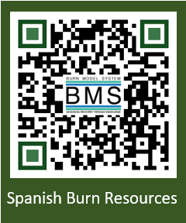
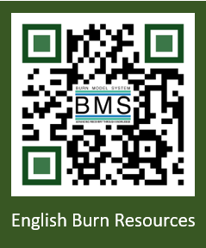
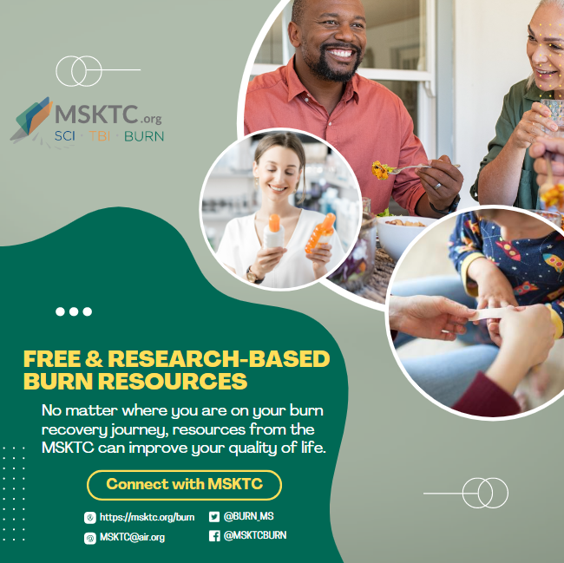

Part 3: Sample email message
Dear [NAME],
[ADJUST WORDING BASED ON RECIPIENT] I recently became an ambassador for the federally funded Model Systems Knowledge Translation Center (MSKTC: http://msktc.org/), which offers free, research-based resources for people living with burn injury and their families. MSKTC covers 20 rehabilitation topics (https://msktc.org/burn). Tailored to the diverse learning styles of individuals with burn injury and their families, these resources are in multiple formats (print, audio, and video) including factsheets, videos, podcasts, narrated slideshows, and quick reviews. MSKTC factsheets and infocomics are available in both English and Spanish. I am including links to these resources below. Please feel free to share with others who may benefit from them.
*MSKTC Burn Resources*
- The MSKTC burn resources cover a wide range of topics. Currently, the MSKTC provides resources on 20 rehabilitation topics to support individuals with burn injury and their families such as delirium after burn injury, employment after burn injury, exercise after burn injury, healthy eating-adults, healthy eating-kids, itchy skin after burn injury, managing pain, outpatient opioid management for adult burn survivors, psychological distress, PTSD, resilience, return to school, scar management, sexuality and intimacy, sleep problems, social interaction after burn injury, sun protection after burn injury, understanding and improving body image after burn injury, understanding burn injury, and wound care.
- Factsheets on topics ranging from acute inpatient rehabilitation to returning to school in both English and Spanish
  - https://msktc.org/burn/factsheets
- Videos
  - https://msktc.org/burn/videos
- Slideshows
  - https://msktc.org/burn/slideshows
- Hot Topic Modules
  - https://msktc.org/burn/Hot-Topics
- Plain Language Summaries of Research
  - https://msktc.org/burn/quick-reviews
- Research Resources
  - Burn Systematic Reviews: https://msktc.org/burn/research/systematic-reviews
  - Burn Model System Directory: https://msktc.org/burn/model-system-centers
  - Model System Publications Database: https://msktc.org/burn/publications
- Model System and Model System Database
  - https://msktc.org/about-model-systems/burn

*Please note that the MSKTC resources may be reproduced and distributed freely with appropriate attribution. Prior permission must be obtained for inclusion in fee-based materials.
Sincerely,
[SIGNER’S NAME]

Part 3: Sample newsletter story

Title: Free Research-based User-friendly Resources for People Living With Spinal Cord Injury, Traumatic Brain Injury, and Burn Injury

The Model Systems Knowledge Translation Center (MSKTC; https://msktc.org/) offers free research-based user-friendly information resources to support individuals living with spinal cord injury (SCI; https://msktc.org/sci), traumatic brain injury (TBI; https://msktc.org/tbi), and burn injury (https://msktc.org/burn). MSKTC collaborates with researchers from the SCI, TBI and Burn Model System Programs to develop resources that cover a wide range of topics and are available in various formats such as factsheets (in both English and Spanish), infocomics, videos, and podcasts. MSKTC resources may be reproduced and distributed freely with appropriate attribution; prior permission must be obtained for inclusion in fee-based materials. Both the MSKTC and Model System Programs are funded by the National Institute on Disability, Independent Living, and Rehabilitation Research, Administration for Community Living, US Department of Health and Human Services. For questions about MSKTC resources, please contact msktc@air.org.

