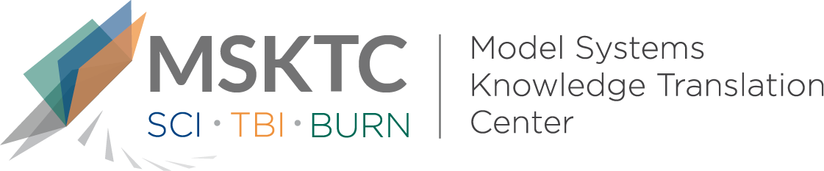

Quick Review of
Model System Research

A pilot test of the GoWoman weight management intervention for women with mobility impairments in the online virtual world of Second Life®

What is the study about?
This study was a pilot test of GoWoman, a small-group weight management intervention — delivered in the online virtual world of Second Life® — for women with mobility impairments. This was modeled after the Diabetes Prevention Program but substantially modified to meet the needs of women with impaired mobility. The study’s objectives were to examine changes in weight, waist circumference, diet, physical activity, self-efficacy for diet and physical activity, nutrition knowledge, and social support for weight management before and after the intervention. The authors also examined the practicality of GoWoman in real world settings.

What did the study find?
The authors found decreases in participants’ weight and waist circumference after the intervention compared to measurements before the intervention. They also found significant improvements in participants’ physical activity, diet and motivation for diet and physical activity. All targets for real world application were met, and participant feedback about the intervention was positive.

Who participated in the study?
Participants (n=13) included women who had a mobility impairment and a body mass index between 25 and 40. Participants also had the ability to download the Second Life® virtual platform and use its basic features.

How was the study conducted?

This study used a quasi-experimental design. Evaluations were conducted before and after the intervention. The 16 week intervention addressed issues of diet, food preparation and planning, increasing physical activity, managing stress and staying motivated. It was delivered through the online virtual world of Second Life®, which can be downloaded for free (www.secondlife.com), which participants accessed from their personal computers.

How can people use the results?
Practitioners and researchers can use the results of this study to guide development of interventions to meet the unique weight management needs of women with mobility impairments. Individuals with mobility impairments, their caregivers, and families can use the information in this study to seek out new weight management opportunities that do not involve dealing with environmental barriers and health challenges that often prevent them from participating in traditional, face-to-face programs.

Reference
Nosek, M. A., Robinson-Whelen, S., Ledoux, T. A., Hughes, R. B., O’Connor, D. P., Lee, R. E., Goe, R., Silveira, S. L., Markley, R., Nosek, T. M., & the GoWoman Consortium. (2018). A pilot test of the GoWoman weight management intervention for women with mobility impairments in the online virtual world of Second Life®. Disability and Rehabilitation, 41(22). DOI: 10.1080/09638288.2018.1473511
Disclaimer
The contents of this quick review were developed under a grant from the National Institute on Disability, Independent Living, and Rehabilitation Research (NIDILRR grant number 90DP0082). NIDILRR is a Center within the Administration for Community Living (ACL), Department of Health and Human Services (HHS). The contents of this quick review do not necessarily represent the policy of NIDILRR, ACL, HHS, and you should not assume endorsement by the Federal Government.

