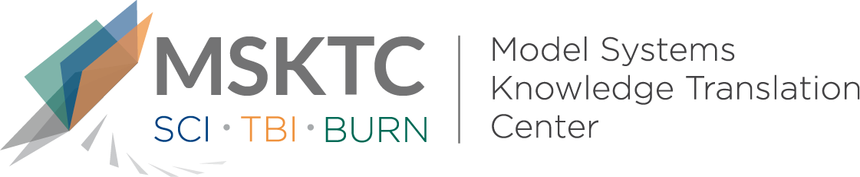

` Quick Review of
Model System Research

Outcomes 1 and 2 Years After Moderate to Severe Traumatic Brain Injury: An International Comparative Study

What is the study about?

This study aims to compare traumatic brain injury (TBI) outcomes from 2 cohorts: the National Institute on Disability, Independent Living, and Rehabilitation Research Traumatic Brain Injury Model Systems (TBIMS) in the United States and Longitudinal Head Injury Outcome Study conducted in Victoria, Australia, by the Monash Epworth Rehabilitation Research Centre (MERRC).

What did the study find?
This study found at 2 years post injury, MERRC participants were more likely to be competitively employed. At both 1 and 2 years post injury, MERRC participants were more likely to be married and living independently. On GOS-E, the TBIMS group had higher percentages of patients in Lower Severe Disability/Vegetative State and Upper Good Recovery than MERRC participants. Whereas the MERRC cohort had higher percentages of Lower Moderate Disability than TBIMS. Results from this study may suggest that providing post-acute rehabilitation supports and services could affect outcomes for individuals with moderate to severe TBI.

Who participated in the study?
Individuals with moderate-severe TBI (N=1056) admitted in 2000-2012 to inpatient rehabilitation after motor vehicle-related collisions, to compare MERRC patients (n=352) with TBIMS patients (n=704).

How was the study conducted?
This study was a cohort study using data from the TBIMS-NDB. Outcomes were assessed 1 and 2 years post injury looking at employment, living situation, marital status, and Glasgow Outcome Scale-Extended (GOS-E) scores.

How can people use the results?

Individuals with TBI and their families can use the results of this study to better understand the effects that different community-based supports may have on long-term TBI recovery. Practitioners can use the results of this study to think about how to design future research studies on rehabilitation services for TBI to further explore the potential effects of community support on patient outcomes.

Reference
Ponsford, J., Harrison-Felix, C., Ketchum, J.M, Spitz, G., Miller, A.C., Corrigan, J.D. (2020). Outcomes 1 and 2 years after moderate to severe traumatic brain injury: An international comparative study. Archives of Physical Medicine and Rehabilitation 102(3), 371-377.
Disclaimer

The contents of this quick review were developed under a grant from the National Institute on Disability, Independent Living, and Rehabilitation Research (NIDILRR grant number 90DP0082). NIDILRR is a Center within the Administration for Community Living (ACL), Department of Health and Human Services (HHS). The contents of this quick review do not necessarily represent the policy of NIDILRR, ACL, HHS, and you should not assume endorsement by the Federal Government.

