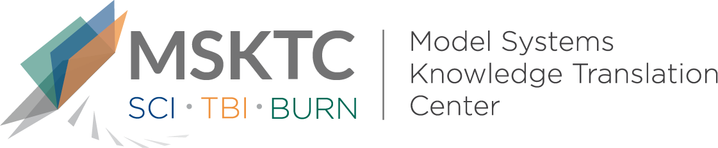

Quick Review of
Model System Research

Relationship Between Hispanic Nativity, Residential Environment, and Productive Activity Among Individuals With Traumatic Brain Injury: A TBI Model Systems Study

What is the study about?
The purpose of this study is to examine the influence of nativity and residential characteristics on productive activity among Hispanics at one year after traumatic brain injury (TBI).

What did the study find?
Among foreign-born individuals with TBI, those living in an area with a higher proportion of foreign language speakers were 2.8 times more likely to be productive than those living in areas with a lower proportion of foreign language speakers.

Who participated in the study?

Participants were individuals from the Traumatic Brain Injury Model Systems National Database and were included if they were younger than 65 years, responded to a question about their place of birth, had complete injury data and productive activity data at one-year follow-up, and provided their zip code. This study focused on individuals who identified as Hispanic on a survey question regarding race/ethnicity.

How was the study conducted?
Researchers obtained nativity, education level, and productivity through participant interviews. Residential areas were defined using zip codes reported from participants’ home addresses, while aggregate median household income was extracted from data collected for the US Census Bureau’s American Community Survey 5-year estimates obtained from 2011-2015. Additionally, proportion of foreign language speakers were calculated as the population estimates of Hispanic individuals speaking a foreign language divided by the total population of Hispanics in each zip code.

How can people use the results?
Researchers suggest that the environment in which a foreign language speaker (FLS) resides, namely a community with many FLS, will positively affect their productivity. This finding can be used to inform the design and development of vocational rehabilitation interventions for Hispanics after TBI, taking into account the communities to which they are being discharged after their inpatient rehabilitation Researchers can conduct similar investigations for other ethnicities/races to better inform culturally sensitive vocational rehabilitation interventions.

Reference
Lequerica, Anthony H., Botticello, Amanda, O’Neill, John, Lengenfelder, Jean, Krch, Denise, Chiaravalloti, Nancy D., Sander, Angelle M., Bushnik, Tamara, Ketchum, Jessica M., Hammond, Flora M., Dams-O’Connor, Kristen, Felix, Elizabeth, Johnson-Greene, Doug. (2018). Relationship Between Hispanic Nativity, Residential Environment, and Productive Activity Among Individuals With Traumatic Brain Injury: A TBI Model Systems Study. Journal of Head Trauma Rehabilitation, 34(1), 46-54. https://www.ncbi.nlm.nih.gov/pubmed/29863616.

Disclaimer
The contents of this quick review were developed under a grant from the National Institute on Disability, Independent Living, and Rehabilitation Research (NIDILRR grant number 90DP0082). NIDILRR is a Center within the Administration for Community Living (ACL), Department of Health and Human Services (HHS). The contents of this quick review do not necessarily represent the policy of NIDILRR, ACL, HHS, and you should not assume endorsement by the Federal Government.

