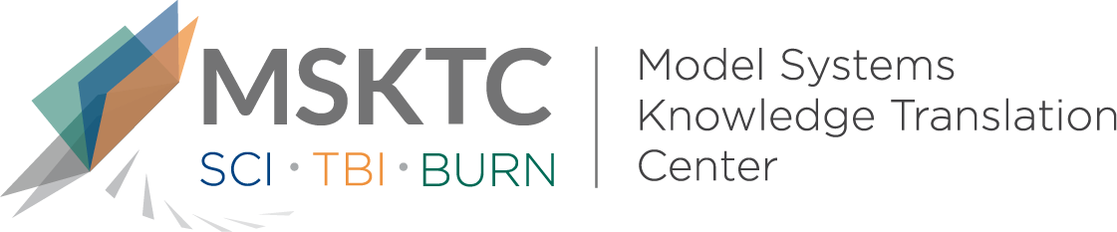

Quick Review of
Model System Research

Outcome prediction from post-injury resilience in patients with TBI

What is the study about?
This study investigated how resilience at 3 or 6 months following traumatic brain injury predicted quality of life outcomes of patients at 1 and 2 years after injury.

What did the study find?
The authors found that higher resilience scores predicted greater satisfaction with life, lower anxiety and depression, more frequent return to work, and less substance misuse at 1 and 2 years after injury. Resilience at 3 or 6 months after injury was more strongly associated with 1-year postinjury outcomes than with 2-year postinjury outcomes.

Who participated in the study?
Participants (n=158) included patients from five TBI Model Systems (TBIMS) with confirmed moderate or severe TBI who were admitted to a participating trauma center within 72 hours of injury and underwent inpatient rehabilitation at one of the participating TBIMS centers.

How was the study conducted?

This study used an observational, longitudinal design to evaluate participants’ responses to 1- and 2-year outcome assessments. The outcomes measured included anxiety, depression, life satisfaction, substance misuse, and return-to-work. Resilience was also assessed at 3 or 6 months after injury.

How can people use the results?
Practitioners and researchers can use this study to guide further research on resilience outcomes after TBI. Individuals with TBI, their caregivers, and families can use the results of the study to better understand how researchers are connecting resilience shortly after injury to quality of life outcomes 1 or 2 years after injury.

Reference
Sima, A. P., Yu, H., Marwitz, J. H., Kolakowsky-Hayner, S. A., Felix, E. R., Bergquist, T. F., Whiteneck, G., Kreutzer, J. S., & Johnson-Greene, D. (2019). Outcome prediction from post-injury resilience in patients with TBI. Rehabilitation Psychology, 64(3). DOI: 10.1037/rep0000263
Disclaimer
The contents of this quick review were developed under a grant from the National Institute on Disability, Independent Living, and Rehabilitation Research (NIDILRR grant number 90DP0082). NIDILRR is a Center within the Administration for Community Living (ACL), Department of Health and Human Services (HHS). The contents of this quick review do not necessarily represent the policy of NIDILRR, ACL, HHS, and you should not assume endorsement by the Federal Government.

