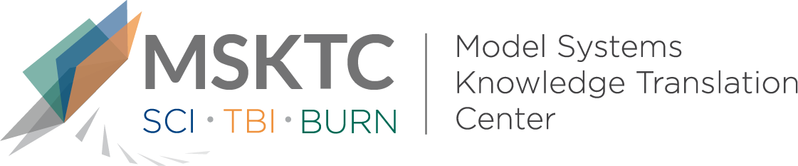

` Quick Review of
Model System Research

Return to Productivity Projections for Individuals With Moderate to Severe TBI Following Inpatient Rehabilitation: A NIDILRR TBIMS and CDC Interagency Collaboration

What is the study about?

This study examines the probability of returning to productivty, defined as engagement in school or work, over time up to 5 years following moderate-to-severe traumatic brain injury (TBI).

What did the study find?
This study found several factors associated with the likelihood of returning to work following a moderate-to-severe TBI, including: age of injury, race, level of education, occupation at the time of injury, disability rating at hospital discharge, substance abuse, and rehabilitation length of stay. This study also found that the probability of returning to productivity increased over time, especially for younger individuals with moderate-to -severe TBI.

Who participated in the study?
Individuals (n=2542) enrolled in the Traumatic Brain Injury Model Systems National Database (TBIMS-NDB).

How was the study conducted?
This study was a longitudinal observational study that conducted follow-up interviews at 1,2, and 5 years post injury.

How can people use the results?

Individuals with TBI and their families can use the results of this study to better understand the likelihood of returning to productivity after TBI among individuals in the TBIMS-NDB.

Reference
Pretz, C., Kowalski, R. G., Cuthbert, J. P., Whiteneck, G. G., Miller, A. C., Ketchum, J. M., & Dams-Oʼconnor, K. (2019). Return to Productivity Projections for Individuals With Moderate to Severe TBI Following Inpatient Rehabilitation. Journal of Head Trauma Rehabilitation, 1. doi: 10.1097/htr.0000000000000506
Disclaimer
The contents of this quick review were developed under a grant from the National Institute on Disability, Independent Living, and Rehabilitation Research (NIDILRR grant number 90DP0082). NIDILRR is a Center within the Administration for Community Living (ACL), Department of Health and Human Services (HHS). The contents of this quick review do not necessarily represent the policy of NIDILRR, ACL, HHS, and you should not assume endorsement by the Federal Government.

