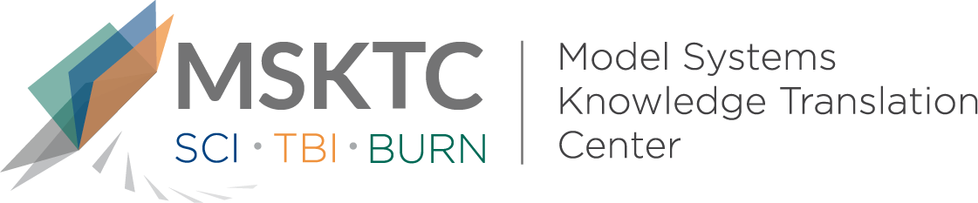

` Quick Review of
Model System Research

Employment Stability in the First 5 Years After Moderate-to-Severe Traumatic Brain Injury

What is the study about?

This study aims to identitfy the predictive factors of employment stability for individuals after moderate to severe traumatic brain injury (TBI). Employment stability, was considered a dynamic measure that assesses employment over time and is thought to be a more sensitive employment measure than those looking only at employment vs unemployment at a fixed moment in time.

What did the study find?
This study found several predictive factors of stable employment for individuals following moderate to severe TBI, including: younger age, white race, less severe injuries, preinjury employment, higher annual earnings, male sex, higher education, transportation independence, and no depression or anxiety at 1-year post injury. Examining employment stability in this way captures the variations in multiple relevant variables, including demographic information, mental health, cognitive limitations, and transportation independence as related to moderate-to-severe TBI.

Who participated in the study?
Individuals with employment data (n=5683) enrolled in the Traumatic Brain Injury Model Systems National Database (TBIMS-NDB).

How was the study conducted?
This study was a longitudinal observational study using data at 1,2, and 5 years post injury from the TBIMS-NDB.

How can people use the results?

Individuals with TBI and their families can use the results of this study to better understand the factors related to employment stability following a moderate -to-severe TBI. Practitioners can use the the employment stability factors indentified by this study as intervetion targets to improve employent outcomes post-injury. Facilitating transportation independence as well as screening for and treating anxiety and depression post-TBI deserve further study as effective strategies to improve employment stability after TBI

Reference
DiSanto, D., Kumar, R.G., Juengst, S.B., Hart, T., O’Neil-Pirozzi, T.M., Zasler, N.D., Novack, T.A., Dillahunt-Aspillaga, C., Graham, K.M., Cotner, B.A., Rabonowitz, A.R., Dikmen, S., Niemeier, J.P., Kesinger, M.R., Wagner, A.K. (2019). Employment stability in the first 5 years after moderate-to-severe traumatic brain injury. Archives of Physical Medicine and Rehabilitation 100 (3), 412-421.
Disclaimer
The contents of this quick review were developed under a grant from the National Institute on Disability, Independent Living, and Rehabilitation Research (NIDILRR grant number 90DP0082). NIDILRR is a Center within the Administration for Community Living (ACL), Department of Health and Human Services (HHS). The contents of this quick review do not necessarily represent the policy of NIDILRR, ACL, HHS, and you should not assume endorsement by the Federal Government.

