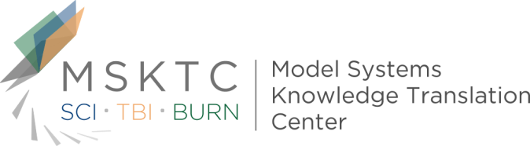

Quick Review of
Model System Research

The Association of Rehospitalization With Participation 5 Years After Traumatic Brain Injury¹

What is the study about?

This study aims to determine whether rehospitalization in the first two years after a moderate to severe traumatic brain injury (TBI) is associated with poorer societal participation at five years post-TBI.

Who participated in the study?

Participants (n=1940) for this study were identified using the Traumatic Brain Injury Model Systems (TBIMS) National Database (NDB). To be included in the TBIMS NDB, individuals must be sixteen years of age or older, received medical care in a TBIMS-affiliated trauma center within 72 hours of injury, and be transferred to an affiliated inpatient TBI rehabilitation program. Individuals included in the TBIMS NDB must also have a penetrating or nonpenetrating TBI that corresponds with one of the following characteristics: 1) a Glasgow Coma Scale score of less than thirteen on emergency admission, 2) loss of consciousness of more than thirty minutes, 3) posttraumatic amnesia longer than 24 hours, or 4) trauma-related abnormalities on neuroimaging. For this study, participants were community-dwelling individuals with complete rehospitalization and participation data.

How was the study conducted?

The assessment tool used to measure societal participation was the Participation Assessment with Recombined Tools-Objective.

What did the study find?
This study found that rehospitalization during the first two years after TBI is negatively associated with societal participation at five years post-TBI. Further, having multiple rehospitalizations, regardless of the reason, was associated with even lower levels of participation. Since societal participation is a key indicator of successful TBI rehabilitation, these findings suggest that the need for rehospitalization should be minimalized when possible by addressing well-being and health in the community setting for individuals with TBI.
¹ Erler, Kimberly and Juengst, Shannon and Whiteneck, Gale and Locascio, Joseph and Bogner, Jennifer and Kaminski, Jamie and Giacino, Joseph. (2018). The Association of Rehospitalization With Participation 5 Years After Traumatic Brain Injury. Journal of Head Trauma Rehabilitation. Volume published ahead of print.
The contents of this quick review were developed under a grant (number H133A110004) from the U.S. Department of Education, National Institute on Disability and Rehabilitation Research. However, these contents do not necessarily represent the policy of the U.S. Department of Education, and you should not assume endorsement by the Federal Government.

