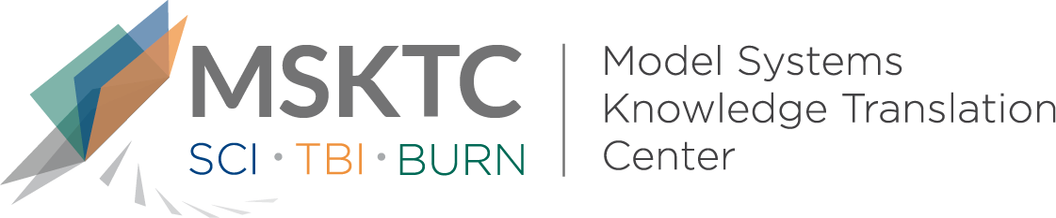

` Quick Review of
Model System Research

COVID-19 Pandemic and the Burn Survivor Community:

A Call for Action

What is the study about?

This letter to the editor discusses concerns about the effects of COVID-19 on burn survivors, and their ability to have successful burn recovery. Key components that help improve quality of life for burn survivors include: maintaining long-term burn center connection, follow-up in the community following discharge, and participation in support systems. Limited resources in this pandemic may create barriers to accessing the required inpatient and outpatient processes of care for burn survivors.

What did the study find?
This commentary addressed several key issues related to COVID-19 and burn survivor recovery. Some of the main issues discussed were: the clinical effectiveness of virtual telehealth is not yet proven in burn survivors; increased isolation and limited ability for social contact may worsen post-traumatic stress disorder and depression; and burn survivors needing advanced complex care if infected.
Several recommendations were made for the burn care community, including: extra effort to rapidly develop, test, and share standard templates for assessment of post-burn symptom complexes; efforts by clinic staff and therapists to connect with those needing services such as phones, computers and Internet connections with proper technological support and translation services; the development of technological solutions to measure garments and fit splints; and development of new, and gathering of existing, online therapeutic exercises for burn care therapy and outpatient rehabilitation.

Who participated in the study?
This is a letter to the editor, so there were no participants.

How was the study conducted?
This is a letter to the editor, so a study was not conducted.

How can people use the results?

Individuals with burn injuries and their families can use this commentary to better undersand the complex needs of burn survivors during the COVID-19 pandemic. Practitioners can use this commentary to think about how to better assess and address current needs of burn survivors, and how to best prepare for the potential surge in patient needs post-COVID.

Reference
Ryan, C.M., Stoddard, F.J., Kazis, L.E., Schneider, J.C. (2020). COVID-19 pandemic and the burn survivor community: A call for action. Burns. doi:10.1016/j.burns.2020.04.018
Disclaimer
The contents of this quick review were developed under a grant from the National Institute on Disability, Independent Living, and Rehabilitation Research (NIDILRR grant number 90DP0082). NIDILRR is a Center within the Administration for Community Living (ACL), Department of Health and Human Services (HHS). The contents of this quick review do not necessarily represent the policy of NIDILRR, ACL, HHS, and you should not assume endorsement by the Federal Government.
This version of the quick review has not been reviewed by the authors.

