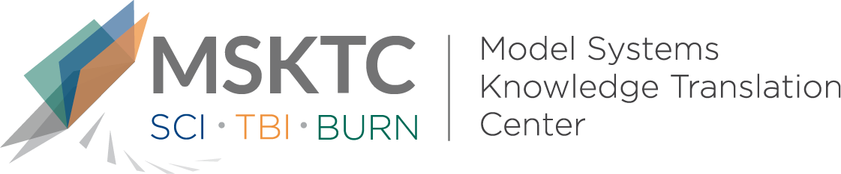

` Quick Review of
Model System Research

Improving Wellbeing After Traumatic Brain Injury Through Volunteering:

A Randomized Controlled Trial

What is the study about?

This study aims to evaluate the effectiveness of a new intervention that facilitates volunteer activitiy to improve well-being in individuals with traumatic brain injury (TBI). The new intervention, HOPE (Helping Others through Purpose and Engagement), involves orientation/training and a 3-month volunteer placement for the participant. Volunteer work has been found to have a postive effect on well-being in the general population including mental health, happiness, life satisfaction, self-esteem, and decreasing stress. It has also been found that individuals with disabilities who provide volunteer services benefit from volunteering.

What did the study find?
This study found that there were significantly greater improvements in life satisfaction and self-perceived success in the intervention group compared to the control group. There were no significant treatment effects on the secondary measures of well-being. This study also suggests that a structured intervention can facilitate the process of volunteering for the TBI population.

Who participated in the study?
Community-dwelling individuals (total n=74, intervention n = 38, control n = 36) at least 1-year post-TBI who had completed inpatient or outpatient TBI rehabilitation.

How was the study conducted?
This study was a randomized two-arm controlled trial of an 18-week intervention, with a wait-list control condition (i.e., after the study, the intervention was offered to the control group). Participants were assessed at baseline, and at 18, 30, and 42 weeks post-baseline testing.

How can people use the results?

Individuals with TBI and their families can use the results of this study to better understand that volunteering may help improve the health and life satisfaction of individuals with TBI. Practitioners can incorporate these findings into their treatment protocol for individuals with TBI who cannot work as a viable alternative for pursuing meaningful social connection and life satisfaction.

Reference
Payne, L., Hawley, L., Morey, C., Ketchum, J.M., Philippus, A., Sevigny, M., Harrison-Felix, C., & Diener, E. (2020). Improving well-being after traumatic brain injury through volunteering: A randomized controlled trial. Brain Injury, 34(6), 697-707. doi: 10.1080/02699052.2020.1752937.
Disclaimer
The contents of this quick review were developed under a grant from the National Institute on Disability, Independent Living, and Rehabilitation Research (NIDILRR grant number 90DP0082). NIDILRR is a Center within the Administration for Community Living (ACL), Department of Health and Human Services (HHS). The contents of this quick review do not necessarily represent the policy of NIDILRR, ACL, HHS, and you should not assume endorsement by the Federal Government.

