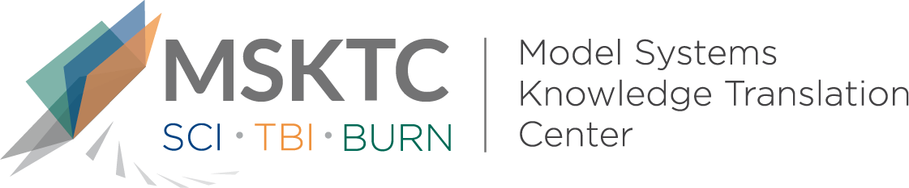

` Quick Review of
Model System Research

Measuring the Impact of Burn Injury on the Parent-Reported Health Outcomes of Children 1- to 5- Years: A Conceptual Framework for Development of the Preschool Life Impact Burn Recovery Evaluation (LIBRE) Profile CAT

What is the study about?

This study reviews the development of a framework describing the key elements for evaluating preschool-aged children’s (ages 1- 5) recovery from burn injury using a parent-reported health outcomes assessment.

What did the study find?
This study found three health outcome domains that are most impacted by preschool-aged children’s burn injury, including: 1) symptoms, which describes children’s physical experiences of pain, skin-related discomfort, and fatigue; 2) functioning, which describes children’s physical motor functions, psychological well-being, communication and language development, and 3) family, which describes children’s psychological and routine functions with family members.

Who participated in the study?
Ninety-five pediatric (ages 1-5) assessments, two clinician focus groups, six parent interviews, and 23 clinician expert consultations.

How was the study conducted?
This study was a qualitative analysis that used several methods to inform the development of the framework including the analysis of similar frameworks, a literature review, clinician focus groups, and parent interviews.

How can people use the results?

Practitioners and researchers can use the model to develop family-centered, parent-reported outcome assessments. It can also guide the development and evaluation of therapeutic interventions for children and families. Individuals with burn injury, their caregivers, and families can use the results of the study to better understand how researchers are developing tools to assess burn injury in pre-school-aged children.

Reference
Brady, K.J.S., Grant, G., Stoddard, F.J., Meyer, W.J., Romanowski, K.S., Chang, P.H., Painting, L.E., Fowler, L.A., Nelson, J.K., Rivas, P., Epperson, K., Sheridan, R.L., Murphy, M., O’Donnell, E.H., Ceranoglu, T.A., Sheldrick, R.C., Ni, P., Slavin, M.D., Warner, P., Palmieri, T.L., Schneider, J.C., Kazis, L.E., & Ryan, C.M. (2019). Measuring the impact of burn injury on the parent-reported health outcomes of children 1- to 5- years: A conceptual framework for development of the Preschool Life Impact Burn Recovery Evaluation (LIBRE) Profile CAT. Archives of Physical Medicine and Rehabilitation, 100(3), 412-421.
Disclaimer
The contents of this quick review were developed under a grant from the National Institute on Disability, Independent Living, and Rehabilitation Research (NIDILRR grant number 90DP0082). NIDILRR is a Center within the Administration for Community Living (ACL), Department of Health and Human Services (HHS). The contents of this quick review do not necessarily represent the policy of NIDILRR, ACL, HHS, and you should not assume endorsement by the Federal Government.

