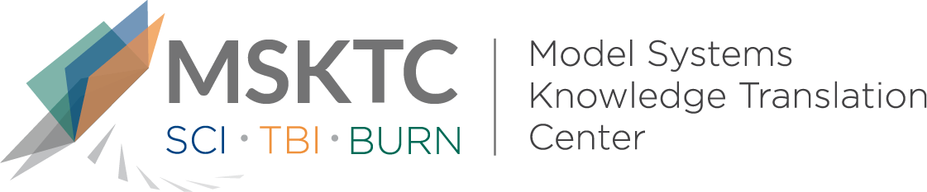

Quick Review of
Model System Research

Social Interactions and Social Activities After Burn Injury: A Life Impact Burn Recovery Evaluation (LIBRE) Study

What is the study about?
For individuals with burn injury, social interactions are a crucial step for social recovery. This study aimed to determine the predictors that influence social recovery.

What did the study find?
This study found that individuals with burn injury are less likely to engage in activities related to being outdoors, feel limited on activities with family members, and tire easily. These activities may be inhibited by chronic pain, fatigue, photosensitivity, and depression or anxiety. Chronic pain and fatigue were two commonly reported factors that may limit social interactions. Individuals with facial deformities as a result from burn injury reported problems with meeting new people, making friends, and intimate relationships. This study also found that individuals with burn injury who were younger, married, or living with a significant other had higher rates of social interaction.

Who participated in the study?

Participants for this study included 601 indivuduals with burn injury. Partcipants had to be 18 years and older with injuries covering more than 5% of total body surface area.

How was the study conducted?
The Life Impact Burn Recovery Evaluation-192 was administered to all participants to develop a profile. Multivariate linear regression analyses were then used to classify demographic and clinical predictors of the Social Activities and Social Interaction scores.

How can people use the results?
Clinicians can use the results of this study to identify patients who may struggle with social recovery. Individuals with burn injury and their family members can use the results of the study to become more informed on what predictors influence social interaction.

Reference
Ohrtman, E. A., Simko, L. C., Dore, E., Slavin, M. D., Saret, C., Amaya, F., . . . Ryan, C. M. (2018). 275 Social Interactions and Social Activities after Burn Injury: A Life Impact Burn Recovery Evaluation (LIBRE) Study. Journal of Burn Care & Research, 39(Suppl_1). doi:10.1093/jbcr/iry006.197

Disclaimer

The contents of this quick review were developed under a grant from the National Institute on Disability, Independent Living, and Rehabilitation Research (NIDILRR grant number 90DP0082). NIDILRR is a Center within the Administration for Community Living (ACL), Department of Health and Human Services (HHS). The contents of this quick review do not necessarily represent the policy of NIDILRR, ACL, HHS, and you should not assume endorsement by the Federal Government.

