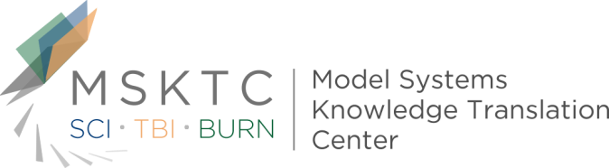

Quick Review of
Model System Research

Groupings of Persons With Traumatic Brain Injury: A New Approach to Classifying Traumatic Brain Injury in the Post-Acute Period

What is the study about?

Traumatic brain injury (TBI) survivors are typically classified by injury severity using a measure that relies heavily on level of consciousness. The most common measure is the Glasgow Coma Scale (GCS) and is very helpful in planning early treatment. It is often used to establish prognosis, as well. However, TBI survivors often have a wide range of symptoms despite having similar scores on the GCS. The injury severity, as rated by GCS, does not always relate to longer term outcomes. This study aims to develop a new approach to classifying TBI survivors in the period after injury in order to better gauge what problems they might have in their ability to function cognitively (think, recall, process new information etc), physically and emotionally.

Who participated in the study?

Participants (n=504) were TBI survivors living in the community, were an average of 6.8 years post injury, had the ability to provide consent, and were able to complete all study measures.

How was the study conducted?
Thirty-six questionnaires or tests were administered to the participants in order to develop the 12 dimensions for evaluation. The 12 dimensions developed included: Memory, Cognitive Processing Speed, Verbal Fluency, Self-reported Cognitive Symptoms, Independence and Self-esteem, Resilience, Emotional Distress, Postconcussive Symptoms, Physical Symptoms, Physical Functioning, Economic and Family Support, and Performance Validity. A cluster analysis was performed to categorize participants into groups using the scores from the twelve dimensions.

What did the study find?
Five groups of TBI survivors were identified who differed from each other in clinically meaningful ways on the twelve-dimension scores. The ability to cluster scores and identify specific/distinct groups of patients implies to this group of researchers that this approach could help clinicians conceptualize individual cases in a way that predicts outcomes and informs treatment plans.

¹Sherer, M., Nick, T. G., Sander, A. M., Melguizo, M., Hanks, R., Novack, T. A., . . . Tang, X. (2017). Groupings of Persons With Traumatic Brain Injury. Journal of Head Trauma Rehabilitation, 32(2), 125-133. doi:10.1097/htr.0000000000000207
The contents of this quick review were developed under a grant (number H133A110004) from the U.S. Department of Education, National Institute on Disability and Rehabilitation Research. However, these contents do not necessarily represent the policy of the U.S. Department of Education, and you should not assume endorsement by the Federal Government.

