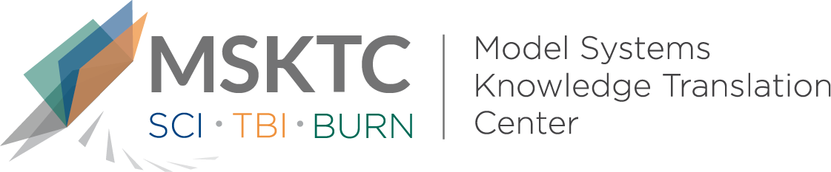

` Quick Review of
Model System Research

Recovery of Consciousness and Functional Outcome

in Moderate and Severe Traumatic Brain Injury

What is the study about?

This study aims to measure recovery of consciousness in individuals with disorders of consciousness (DOC) caused by acute traumatic brian injury (TBI). The study also looks at factors associated with recovery from DOC and return to functional independence.

What did the study find?
This study found that most individuals who became comatose after moderate or severe TBI recovered consciousness in the short term. Almost half of the participants recovered functional independence by the time they completed inpatient rehabilitation. Those with ongoing DOC at the time they started inpatient rehabilitation were younger; had more high-velocity injuries (injuries at high speed); intracranial mass effect (collection of blood or fluid, swelling or other abnormal mass inside the skull), intraventricular hemorrhage (bleeding in the ventricles in the brain), and subcortical contusion (injury in structures beneath the cerebral cortex of the brain); and had longer acute care than patients without persisting DOC.

Who participated in the study?
Individuals (N=17,470) with moderate or severe TBI who were discharged from acute hospitalization and admitted to inpatient rehabilitation from January 1989 to June 2019.

How was the study conducted?
This study was a cohort study that analyzed patients with TBI who participated in the Traumatic Brain Injury Model Systems National Database. The main outcome measures included the Glasgow Coma Scale, Disability Rating Scale, posttraumatic amnesia, and the Functional Independence Measure. Patient- and injury related measures included demographic characteristics (e.g., sex, age), injury cause, and brain computed tomography findings.

How can people use the results?

Individuals with TBI and their families can use the results of this study to learn about recovery of consciousness as it relates to TBI and short-term outcomes. Practitioners can use the results of this study to carefully consider decisions about whether to withdraw or withold treatments for individuals with a DOC.

Reference
Kowalski, R. G., Hammond, F. M., Weintraub, A. H., Nakase-Richardson, R., Zafonte, R. D., Whyte, J., & Giacino, J. T. (2021).Recovery of consciousness and functional outcome in moderate and severe traumatic brain injury. JAMA Neurology, 78(5):548-557. [https://pubmed.ncbi.nlm.nih.gov/33646273/]
Disclaimer
The contents of this quick review were developed under a grant from the National Institute on Disability, Independent Living, and Rehabilitation Research (NIDILRR grant number 90DPKT0009). NIDILRR is a Center within the Administration for Community Living (ACL), Department of Health and Human Services (HHS). The contents of this quick review do not necessarily represent the policy of NIDILRR, ACL, HHS, and you should not assume endorsement by the Federal Government.

